

Business Information Systems Faculty of Commerce and Business Administration Helwan University

Final Year (Graduation) Project

Second Era
Project No. (102)

Team Members

1. | Ali Yasser Ali Ali | 512292440
2. | Ahmed Mohamed Nasser Eldin Mohamed | 512292207
3. | Ziad Ramadan Abdelmaqsoud Ali | 512292201
4. | Abanoub Hanna Mikhail | 512292150
5. | George Wasim Malak Aziz | 512292255
6. | Mohamed Abdelkader Mohamed Elsayed | 512292439

Supervisors
( IT ) ( Business )
Prof. Dr. Ahmed El Seddawy Prof. Dr. Hanan Obayah

2025

DECLARATION

I / we hereby certify that this material is entirely my own work, that I have exercised reasonable care to ensure that the work is original and does not to the best of my knowledge breach any law of copyright and has not been taken from the work of others save and to the extent that such work has been cited and acknowledged within the text of my work.

Signed: Team Members
Registration No.:
Date: 15/06/2025

ABSTRACT

Our business idea is to collaborate with companies in the market to provide new graduates and final-year university students with the practical experience and knowledge that typical college courses often lack. We offer courses and hands-on assessments designed to enhance their skills, ultimately reducing both the duration and cost of internships at the companies they aspire to join.
Second Era is a leading provider of innovative educational and training solutions that aim to achieve excellence in skill development and empower young people to achieve their full potential. Founded with a clear vision to provide a distinguished and stimulating educational experience that helps young people grow personally and professionally,
Second Era is an innovative educational and training initiative that aims to empower young people to acquire the skills and knowledge necessary to enter the labor market and succeed in it. This platform is considered a comprehensive educational environment that combines specialized educational content with practical training, which enables young people to develop their personal and professional skills and achieve excellence in various fields.
Second Era also provides professional training and workshops, which are essential elements in the journey of skill development and performance improvement in multiple fields. These two processes are related to providing individuals with the knowledge and skills necessary to succeed in the competitive labor market.
Table of Contents
Chapter One: Introduction 12
1.1 Introduction (Aim of the Chapter) 12
1.2 Project Idea and Scope 12
1.3 System Objectives 13
1.4 System Features 13
1.5 Related Works (Analysis of Previous Works + Determination of the Existing Problem) 14
1.6 System Requirements 15
1.7 System Users 16
1.8 System Methodology 16
1.9 SDG Alignment and Contributions 17
1.9.1 SDG 4: Quality Education 17
1.9.2 SDG 8: Decent Work and Economic Growth 18
1.9.3 SDG 9: Industry, Innovation, and Infrastructure 18
1.9.4 SDG 10: Reduced Inequalities 18
1.9.5 SDG 17: Partnerships for the Goals 19
1.9.6 Our Vision for Sustainability 19
1.10 Project Time Plan 19
Chapter Two: Bussnies Plan 22
2.1 Executive Summary 22
2.2 Vision & Mission 23
2.2.1 Our Vision 23
2.2.2 Our Mission 23
2.2.3 Our Values 23
2.3 Business Idea & Market 24
2.4 Marketing Plan 26
2.4.1 Competitor Analysis 26
2.4.2 Description of the market 31
2.5 Legal Form. 51
2.6 Start-up Capital & Sources of Start-up Capital. 52
2.6.1 Start-Up Capital 52
2.6.2 Sources of Start-up Capital 52
2.7 Financial Plan 53
2.7.1 Organization and Staff 53
2.7.2 Business Operation and Costs 54
2.7.3 Expected Revenues 55
2.7.4 Expected Expenses 57
2.7.4 Income Statement 58
2.7.5 Cashflow 58
2.7.6 Balance Sheet 59
2.7.7 Owner Equity 60
Chapter Three: System Analysis 62
3.1 Introduction 62
3.2 User Requirements 62
3.2.1 Functional Requirements 62
3.2.2 Non-functional Requirements 65
3.3 System Requirements 66
3.3.1 Software Requirements 66
3.3.2 Hardware Requirements 66
3.4 System Diagrams 67
3.4.1 UML Use Case Diagram 67
3.4.2 UML Sequence Diagram 68
3.4.3 UML Activity Diagram 71
Chapter Four: System Design 81
4.1 Introduction: 81
4.2 Class Diagram: 81
4.3 Database Structure (ERD): 83
4.4 Database Mapping: 85
Chapter Five: System Implementation 89
5.1 Introduction 89
5.2 System screenshots 89
5.2.1 Home page 89
5.2.2 About Page 91
5.2.3 Plans Page 93
5.2.4 Contact & Support Page 94
5.2.5 Help Page 95
5.2.6 Register Page 97
5.2.7 login Page: 101
5.2.8 Dashboard Page: 103
5.2.9 Home Page (After Login): 106
5.2.10 Student Only Pages: 109
5.2.11 Instructor Only Pages: 116
5.2.12 Company Representer Only Page: 120
5.2.13 Admin Pages: 122
5.2.14 System code & database 128
Chapter Six: Testing Methodology 133
6.1 Introduction 133
6.2 Testing Methodology 133
6.3 Login Validation 134
6.3.1 Validations related to the login process include: 134
6.4 Sign Up Validation 135
6.4.1 Validations covering the user registration process include: 135
6.5 Main Function Validation 137
6.5.1 Validations encompassing core application features beyond login and sign up: 137
6.5.2 Jumping Attack Validation 137
Chapter Seven Conclusion and Future Work 140
7.1 Introduction (Aim of the Chapter) 140
7.2 Conclusion 140
7.3 Future Work 141
References 142

Table Of Figures
Figure 1. Project Milestone 20
Figure 2. Project Timeline 20
Figure 3. SWOT 37
Figure 4. Our Office 45
Figure 5. Company Hierarchy 53
Figure 6. Use Case Diagram 67
Figure 7. Sequence Diagram (Student) 68
Figure 8. Sequence Diagram (Instructor) 69
Figure 9 Sequence Diagram (Admin) 69
Figure 10. Sequence Diagram (Company) 70
Figure 11. Activity Diagram (Registration) 71
Figure 12. Activity Diagram (Course Registration) 72
Figure 13. Activity Diagram (Submit Assignment) 73
Figure 14. Activity Diagram (Apply to job) 74
Figure 15. Activity Diagram (Create Course) 75
Figure 16. Activity Diagram (Add Assessment) 76
Figure 17. Activity Diagram (Post Job) 77
Figure 18. Activity Diagram (Review Job) 78
Figure 19. Class Diagram 82
Figure 20. ERD 84
Figure 21. Mapping 86
Figure 22. Home page (Hero Section) 89
Figure 23. Home page (Info Section) 90
Figure 24. Home page (CTA Section, Footer) 90
Figure 25. About Page (1) 91
Figure 26. About Page (2) 91
Figure 27. About Page (3) 92
Figure 28. About Page (4) 92
Figure 29. About Page (5) 93
Figure 30. Plans Page (1) 93
Figure 31. Plans Page (2) 94
Figure 32. Contact & Support Page (1) 94
Figure 33 Contact & Support Page (2) 95
Figure 34. Help Page (FAQ) 95
Figure 35. Help Page (FAQ) 96
Figure 36. Help Page (FAQ) 96
Figure 37. Register Page 97
Figure 38. Register Page (Student) 98
Figure 39. Register Page (Instructor) 99
Figure 40 . Register Page (Company Representer) 100
Figure 41. login Page (Public & student (After Registration)) 101
Figure 42. login Page (Instructor & Company Representer (wait until admin approve) (After Registration)) 102
Figure 43. Dashboard Page (Student) 103
Figure 44. Dashboard Page (Instructor) 104
Figure 45. Dashboard Page (Company Representer) 105
Figure 46. Home Page (After Login) (Student) 106
Figure 47. Home Page (After Login) (Instructor) 107
Figure 48. Home Page (After Login) (Company Representer) 108
Figure 49. Enroll Page 109
Figure 50. My Courses Page 110
Figure 51. Course Details Page 111
Figure 52. Assessment Details Page 112
Figure 53. Find Job Page 113
Figure 54. Payment Page 113
Figure 55. Job Details Page 114
Figure 56. Apply for Job Section 115
Figure 57. Create course page 116
Figure 58. My Courses Page (Instructor) 117
Figure 59. New Assignment Page 118
Figure 60. New Assignment Notification 118
Figure 61. Courses Details Page (Instructor) 119
Figure 62. Post New Job Page 120
Figure 63. My Listing Job Page 121
Figure 64. View application jobs 121
Figure 65. Admin (Dashboard) 122
Figure 66. Admin (Dashboard) 122
Figure 67. Admin (Reports Page) 123
Figure 68. User Management Page 124
Figure 69. User Management Page 124
Figure 70. Admin (Subscription Page) 125
Figure 71. Pending Pages (Company Representer) 126
Figure 72. Pending Pages (Instructor) 126
Figure 73. Pending Pages (Reject Section) 127
Figure 74. Code backend 128
Figure 75 Code backend 128
Figure 76 Code backend 129
Figure 77 Code frontend 129
Figure 78 Code frontend 130
Figure 79 Code frontend 130
Figure 80. Database 131
Figure 81. Login Validation 134
Figure 82. Login Validation 134
Figure 83. Sign Up Validation 136
Figure 84. Sign Up Validation 136
Figure 85. Sign Up Validation 136

List Of Tables

Table 1. List Of Acronyms/Abbreviations 10
Table 2. Project Time Plan 19
Table 3. Start-up Capital 52
Table 4. Sources of Start-up Capital 52
Table 5. Organization and Staff 53
Table 6. Business Operation and Costs 54
Table 7. Expected Revenues 55
Table 8. Expected Revenues (Summary) 56
Table 9. Assumptions 56
Table 10. Expected Expenses 57
Table 11. Income Statement 58
Table 12. Cashflow 58
Table 13. Balance Sheet 59
Table 14. Owner Equity 60

List Of Acronyms/Abbreviations

Acronym | Definition Of Acronym
SWOT | Strengths, Weaknesses, Opportunities, and Threats
STP | Segmentation, Targeting and Positioning
PESTEL | P - Political, E - Economic, S - Social, T - Technological, E - Environmental, L - Legal
Table 1. List Of Acronyms/Abbreviations

C h a p t e r O n e

- INTRODUCTION
  - Introduction (Aim of The Chapter)
  - Project Idea and scope
  - System Objectives
  - System Features
  - Related Works (analysis of previous works + determination of the existing problem)
  - System Requirements
  - System Users
  - System methodology
  - Project Time Plan

Chapter One: Introduction

1.1 Introduction (Aim of the Chapter)
This chapter introduces the "Second Era" educational platform, a pioneering EdTech initiative designed to bridge the critical gap between academic education and practical industry requirements. The aim is to develop a comprehensive online system that facilitates skill development, industry collaboration, and personalized learning experiences for students, graduates, and companies.
By providing tailored training programs, assessments, and interactive content, the project aspires to enhance employability, reduce internship costs, and foster continuous professional growth. This chapter lays out the foundational concepts, scope, objectives, and the strategic approach for developing this innovative platform.

1.2 Project Idea and Scope

Project Idea
"Second Era" is envisioned as an innovative educational ecosystem that collaborates with industry partners to offer practical, industry-relevant courses and assessments to university students and recent graduates. Unlike traditional e-learning platforms, this system emphasizes real-world skills, hands-on experience, and direct engagement with companies to prepare learners for the workforce.

Scope
- Target Audience: University students in their final years, recent graduates, and industry professionals seeking upskilling.
- Core Offerings: Customized courses, live workshops, practical assessments, and mentorship opportunities.
- Geographical Reach: Initially focusing on Egypt, with plans for international expansion into regional markets.
- Functional Modules: User registration, course management, trainer and company portals, assessment tools, communication channels, and feedback systems.
- Technological Scope: Development of a web and mobile-compatible platform, integrating multimedia content, real-time communication, and secure data management.
- Partnership Scope: Collaboration with universities, industry players, government agencies, and training providers to ensure relevance and sustainability.

1.3 System Objectives
- Enhance Skill Development: Provide practical, industry-relevant training that complements academic curricula.
- Facilitate Industry Collaboration: Build strong partnerships with companies to tailor training programs that meet labor market needs.
- Reduce Internship Duration and Cost: Offer efficient, targeted assessments and training to shorten internship periods and lower associated costs.
- Improve Employability: Equip learners with the skills, certifications, and confidence needed to secure employment.
- Enable Continuous Learning: Support lifelong learning through accessible resources, ongoing mentorship, and community engagement.
- Create a Scalable Platform: Ensure the system can grow with increasing users, expanding course offerings, and integrating new technologies.
- Data-Driven Decision Making: Collect and analyze user data to refine programs, enhance user experience, and demonstrate impact.

1.4 System Features
- User Management: Registration, profile customization, progress tracking, and certification issuance.
- Course Catalog: Diverse offerings including technical skills, soft skills, industry-specific training, and workshops.
- Interactive Content: Live webinars, recorded lectures, quizzes, assignments, and simulations.
- Assessment Tools: Practical evaluations, project submissions, peer reviews, and real-time feedback.
- Trainer and Industry Partner Portals: Dedicated interfaces for trainers to upload content and schedule sessions, and for companies to propose projects and provide feedback.
- Communication & Collaboration: Chat rooms, forums, direct messaging, and virtual meetups for active engagement.
- Analytics & Reporting: Dashboards to monitor learner progress, course completion rates, and assessment outcomes.
- Admin Panel: Manage users, content, partnerships, and platform settings efficiently.
- Mobile Compatibility: Fully responsive design for access via smartphones and tablets to maximize reach.
- Security & Privacy: Data encryption, secure login, role-based access control, and compliance with data protection laws.

1.5 Related Works (Analysis of Previous Works + Determination of the Existing Problem)
Many existing online education platforms (e.g., Coursera, Udemy, LinkedIn Learning) provide valuable content but often lack direct industry engagement, personalized assessments, and tailored pathways aligned with local labor market demands. Several issues persist:
- Limited Industry Collaboration: Most platforms operate independently of industry needs, resulting in skills mismatches.
- Lack of Practical Assessments: Many offerings focus on theoretical knowledge without hands-on evaluation or real-world projects.
- Insufficient Customization: Content delivery often fails to adapt to individual learner needs or regional market requirements.
- Weak Engagement & Interaction: Minimal real-time interaction diminishes learner motivation and practical understanding.
- Inadequate Feedback & Certification: Limited mechanisms for feedback and recognition that truly validate skills for employers.

Existing Problems Addressed by "Second Era":
- Creating an industry-integrated, interactive platform that emphasizes practical assessments.
- Offering customized programs aligned with employer needs.
- Facilitating ongoing communication between learners, trainers, and companies.
- Providing real-time analytics for continuous improvement.

This system aims to fill these gaps by delivering industry-specific, customizable, interactive, and assessment-driven training solutions.

1.6 System Requirements

Hardware
- Cloud hosting servers with scalable infrastructure.
- User devices such as desktops, laptops, tablets, and smartphones.

Software
- Web application developed using modern frameworks (e.g., React, Angular, or Vue.js for frontend; Node.js or Django for backend).
- Database systems (MySQL, PostgreSQL, or MongoDB).
- Content Management System (CMS) for easy content updates.
- APIs for third-party integrations (e.g., payment gateways, LMS tools).

Network & Security
- Reliable internet connection with high bandwidth.
- Secure SSL certificates, user authentication protocols, and role-based access control.
- Data encryption and compliance with GDPR or local data protection laws.

Other Requirements
- Content creation tools for trainers.
- Training and support for platform administrators and trainers.
- Continuous system testing and updates for security and functionality.

1.7 System Users
- Students & Final-Year Students: Primary beneficiaries engaging with courses, assessments, and certifications.
- Recent Graduates: Users seeking upskilling opportunities to improve employability.
- Industry Partners & Companies: Collaborate for curriculum input, project proposals, and recruitment.
- Trainers & Educators: Content developers and facilitators delivering courses and assessments.
- Platform Administrators: Manage system operations, user management, content approval, and partnership relations.
- Technical Support Staff: Responsible for maintaining system health, troubleshooting, and updates.

1.8 System Methodology
The project will adopt an Agile Development Methodology, emphasizing flexibility, iterative progress, and stakeholder engagement.
Phases Include:
- Requirement Gathering: Conduct workshops and interviews with stakeholders to define detailed needs.
- Design & Prototyping: Develop wireframes and prototypes to visualize user interfaces and workflows.
- Development & Integration: Build core modules, integrate multimedia content, and establish APIs.
- Testing & Validation: Conduct usability, security, and performance testing, involving real users for feedback.
- Deployment: Launch the platform in phases—initial pilot followed by full deployment.
- Training & Support: Provide user training sessions and ongoing technical support.
- Feedback & Iteration: Collect user feedback post-launch to refine features and add functionalities.

1.9 SDG Alignment and Contributions

Second Era is committed to integrating sustainable development principles into its mission to empower youth and foster innovation in education. By aligning our initiatives with the United Nations Sustainable Development Goals (SDGs), we aim to create lasting social, economic, and environmental impacts that contribute to a more equitable and sustainable future.

1.9.1 SDG 4: Quality Education
- Our Commitment:

  - Deliver high-quality, practical training programs that complement academic curricula, ensuring students acquire relevant skills for today’s job market.
  - Develop accessible online educational platforms that enable learners from diverse backgrounds to access training, regardless of geographic or socio-economic barriers.
- Impact:
  - Enhances employability and entrepreneurial skills among youth, reducing skills mismatches and unemployment rates.
  - Promotes lifelong learning and continuous professional development.

1.9.2 SDG 8: Decent Work and Economic Growth
- Our Commitment:
  - Facilitate smoother transitions from education to employment by providing industry-relevant training and assessments.

  - Partner with companies to offer internships and practical experiences that create pathways to decent work.
- Impact:
  - Boosts youth employment opportunities and reduces unemployment.
  - Supports local economic growth by cultivating a skilled, ready-to-work workforce.

1.9.3 SDG 9: Industry, Innovation, and Infrastructure
- Our Commitment:

  - Leverage innovative digital platforms to deliver scalable, high-impact training solutions.
  - Incorporate emerging technologies like AI, data analytics, and e-learning tools to modernize vocational education.
- Impact:
  - Promotes digital infrastructure development and technological innovation in education.
  - Fosters a culture of continuous innovation aligned with industry standards.

1.9.4 SDG 10: Reduced Inequalities
- Our Commitment:

  - Design inclusive training programs accessible to marginalized and underserved communities, including rural areas and socio-economically disadvantaged groups.
  - Implement scholarship schemes or subsidized courses to ensure equitable access to quality education.
- Impact:
  - Reduces educational and employment inequalities, promoting social mobility.
  - Empowers marginalized youth to participate actively in the economy.

1.9.5 SDG 17: Partnerships for the Goals
- Our Commitment:

  - Build strategic partnerships with universities, private sector companies, government agencies, and NGOs to expand the reach and impact of our programs.
  - Foster collaborative projects, joint research, and knowledge-sharing initiatives to enhance educational quality and innovation.
- Impact:
  - Strengthens multi-stakeholder cooperation, facilitating resource sharing and best practices.
  - Drives sustainable development through collective efforts and shared expertise.

1.9.6 Our Vision for Sustainability
At Second Era, sustainability is at the core of our strategy. We believe that investing in youth education and skill development is fundamental to building resilient economies and inclusive societies. By actively contributing to these SDGs, we strive to inspire a new generation of professionals who are not only skilled but also committed to sustainable growth and social responsibility.

1.10 Project Time Plan
Phase | Duration | Activities
Requirement Analysis | 0.5 month | Meetings, detailed specifications, scope confirmation.
System Design | 0.5 months | UI/UX design, architecture planning, database schema creation.
Prototype Development | 1 week | Initial prototypes for key modules, Supervisor review.
Core Development | 1 months | Coding, content creation, API integrations, preliminary testing.
Testing & Quality Assurance | 0.5 week | Usability testing, security audits, fixing bugs.
Pilot Deployment | Ongoing | Limited rollout, user onboarding, collecting feedback.
Full Deployment | Ongoing | System launch, marketing, and user training.
Post-Launch Support | Ongoing | Continuous monitoring, updates, feature enhancements based on feedback.
Table 2. Project Time Plan

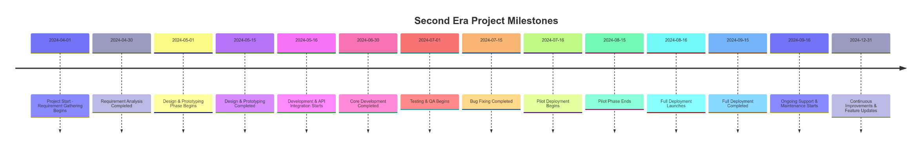
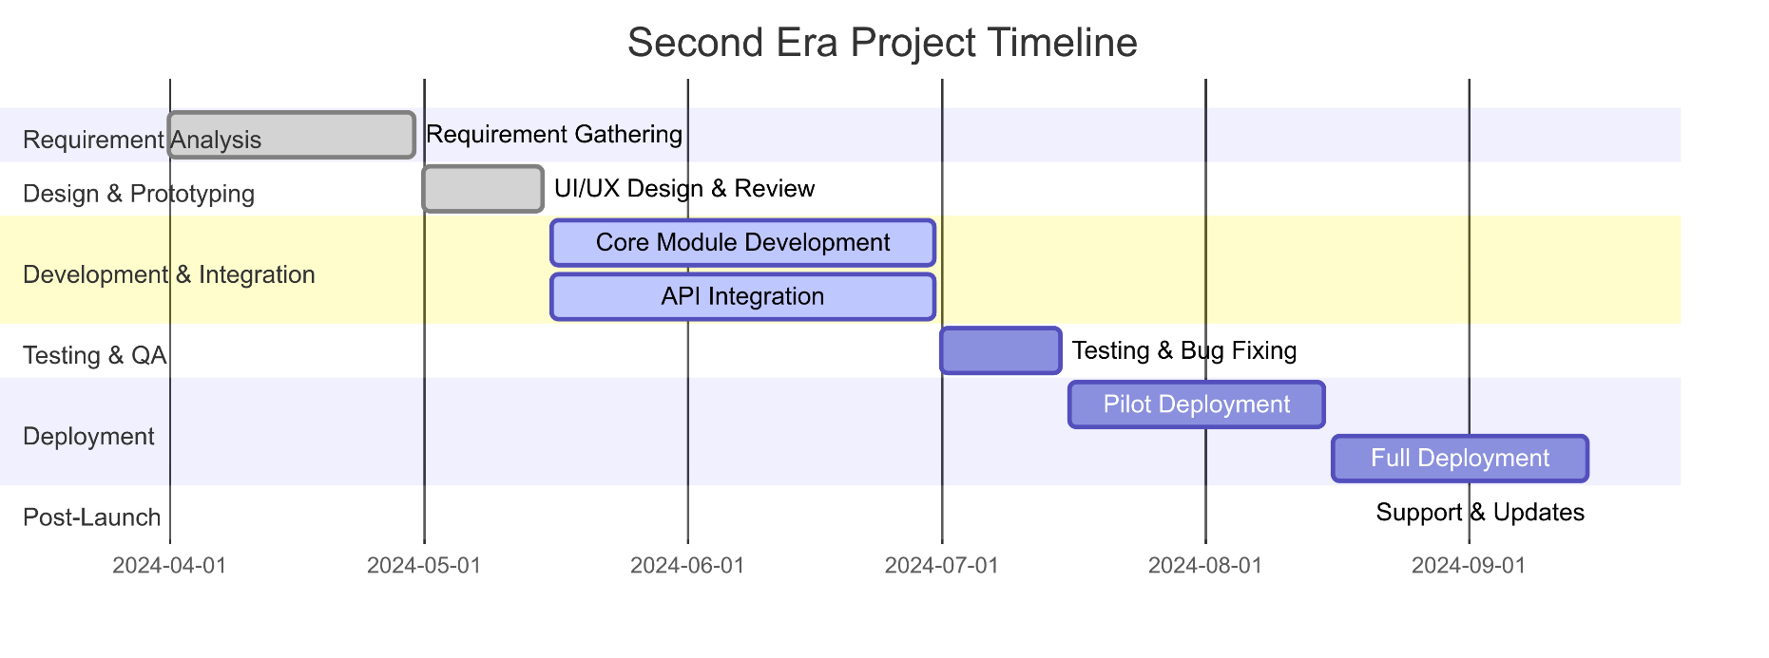
Figure 1. Project Milestone
Figure 2. Project Timeline

C h a p t e r T w o

- Bussnies Plan
- Executive Summary.
- Vision & Mission.
- Business Idea & Market
- Marketing Plan.
- Legal Form.
- Start-up Capital & Sources of Start-up Capital.
- Financial Plan.

Chapter Two: Bussnies Plan

2.1 Executive Summary
Name Of Business: “Second Era”
Legal Form: General partnership
Contact Address:
Tel: 01152293752
E-mail: sec.era@info.com
Website: Secound-Era.com
Type of Business: EdTech, service
Brief Description of the business idea:
Our business idea is to collaborate with companies in the market to provide new graduates and final-year university students with the practical experience and knowledge that typical college courses often lack. We offer courses and hands-on assessments designed to enhance their skills, ultimately reducing both the duration and cost of internships at the companies they aspire to join.
Customers: Students, Fresh Graduate, Companies
Owner(s):
- Ali Yasser (CEO)
- Ziad Ramadan (Operations Manager)
- Abanoub Hanna (Marketing Specialist)
- Ahmed Nasser (Customer Support Representative)
- George Wasim (Content Developer)
- Mohamed Abd El-Kader (IT & Platform Administrator)
Number of jobs to be created: 8
Start-Up Capital:
- Investment: 200,000 EGP
- Working Capital: 700,000 EGP
- Total: 900,000 EGP
Source of Capital:
- Own Savings: 100,000 EGP
- Partner: 150,000 EGP
- Family: 50,000 EGP
- Loan: 100,000 EGP
- Bank Loan: 300,000 EGP (5% interest Rate)

2.2 Vision & Mission

2.2.1 Our Vision
“To envisions a world where young people can reach their full potential through education and training.”

2.2.2 Our Mission
“Second Era empowers young people to achieve their full potential by providing them with access to high-quality educational and training programs that are tailored to their needs. We strive to provide an educational and training environment that encourages continuous learning and enables young people to build a promising and bright professional future.”

2.2.3 Our Values
Continuous Learning: We believe in the importance of continuous learning as the basis for personal and professional development.
Excellence: We always strive to provide a distinguished educational and training experience that meets the aspirations and needs of young people.
Cooperation: We work as an integrated team and encourage cooperation and participation between young people, trainers, experts, and companies in the labor market.
Personal Development: We strive to promote the personal development of young people and empower them to achieve their personal and professional goals.
Positive Impact: We aim to create a positive impact on the lives of young people by empowering and inspiring them to achieve their full potential and obtain the best job opportunities that suit their abilities.
Innovation: We encourage creative thinking and the development of new solutions that contribute to improving the performance of companies and individuals.
Contribution To Success: We strive to be an essential part of the success of the companies that we cooperate with by empowering and developing young people and recent graduates and preparing them for work.

2.3 Business Idea & Market
Description of the business idea:
Our business idea is to collaborate with companies in the market to provide new graduates and final-year university students with the practical experience and knowledge that typical college courses often lack. We offer courses and hands-on assessments designed to enhance their skills, ultimately reducing both the duration and cost of internships at the companies they aspire to join.
Second Era is a leading provider of innovative educational and training solutions that aim to achieve excellence in skill development and empower young people to achieve their full potential. Founded with a clear vision to provide a distinguished and stimulating educational experience that helps young people grow personally and professionally,
Second Era is an innovative educational and training initiative that aims to empower young people to acquire the skills and knowledge necessary to enter the labor market and succeed in it. This platform is considered a comprehensive educational environment that combines specialized educational content with practical training, which enables young people to develop their personal and professional skills and achieve excellence in various fields.
Second Era also provides professional training and workshops, which are essential elements in the journey of skill development and performance improvement in multiple fields. These two processes are related to providing individuals with the knowledge and skills necessary to succeed in the competitive labor market.

What We Offer:
- Variety Of Educational Programs:
We offer a variety of courses, workshops, and training in different fields, starting from academic specializations to modern practical and professional skills that the labor market needs inside and outside Egypt.

- Interactive Educational Experience:
We believe that the best learning comes from interactive educational experiences, so we offer rich and exciting content that includes live and indirect lectures and interactive materials.

- Expert And Professional Trainers:
We collaborate with a team of expert and professional trainers who combine academic knowledge with practical and professional experience to ensure the provision of high-quality content and increase job opportunities.

- A Space for Communication and Sharing:
We provide an interactive environment that enables subscribers to communicate and interact with each other and with trainers, which contributes to the exchange of knowledge and experience.

Why We Are Unique:
- Customization Of Programs
We offer customized programs according to the individual's needs, whether it is to improve current skills or acquire new skills.

- The Balance Between Theoretical and Practical
We always strive to achieve a perfect balance between theoretical content and practical application to give subscribers a deep understanding and immediate practical skills.

- Sustainable Learning
We are interested in promoting sustainable learning as we help individuals continue developing their skills after the end of the programs through resources, guidance, and training.

2.4 Marketing Plan

2.4.1 Competitor Analysis

1. Edraak Platform
Summary:
Edraak is an Arab-based online platform that offers free courses in collaboration with renowned universities and academic institutions. Its primary focus is on delivering academic educational content and professional training across a wide range of disciplines. It aims to facilitate access to quality education in the Arab world.
Strengths:
- Majority of courses are offered free of charge, making education accessible to a broad audience.
- Strong partnerships with leading international universities and institutions, ensuring credible and high-quality content.
- Dedicated support for academic content in Arabic, promoting inclusivity and regional accessibility.

Weaknesses:
- Heavy emphasis on theoretical and academic knowledge, resulting in limited practical, hands-on training opportunities.
- Less diversity in fields that require applied skills, such as modern technology sectors (e.g., AI, cybersecurity), which demand experiential learning and real-world applications.
- Limited focus on soft skills and professional development that are crucial in the current labor market.

2. MaharaTech (Skills Platform)
Summary:
Managed under the supervision of the Egyptian Ministry of Communications, MaharaTech offers training courses designed to equip learners with digital and technical skills needed in the evolving job market. It provides both free and paid courses focusing mainly on technical competencies.
Strengths:
- Specialized in high-demand technological skills, including programming, artificial intelligence, and data analysis.
- Government backing enhances credibility and trust among users and stakeholders.
- Focus on skills directly aligned with labor market requirements.

Weaknesses:
- Predominantly technical focus, with minimal emphasis on soft skills such as leadership, communication, or interpersonal skills.
- Lack of integration of broader professional development modules or personalized pathways tailored to individual career goals.
- Limited content diversity outside core technical fields.

3. Al-Tahrir Academy
Summary:
Al-Tahrir Academy provides free online educational content, emphasizing life skills, personal development, and some academic subjects. Its goal is to foster holistic growth through engaging and accessible content.
Strengths:
- Offers comprehensive educational resources that include self-improvement and essential life skills.
- Features an interactive and engaging teaching style, making learning accessible and appealing.
- User-friendly platform tailored to a broad demographic, including youth and early professionals.
Weaknesses:
- Content scope is somewhat limited in specialized, practical, and professional fields relevant to current market demands.
- Insufficient focus on applied skills and industry-specific competencies required for immediate employability.
- Needs expansion in technical, vocational, and career-oriented training modules.

4. Udemy
Summary:
A global e-learning platform providing a vast array of paid courses across numerous disciplines. Its flexibility, affordability, and extensive course catalog make it a popular choice in Egypt and worldwide.
Strengths:
- Extensive variety of courses covering almost every field, from arts to technology.
- Affordable pricing models and frequent discounts make courses accessible.
- Self-paced learning with on-demand access enhances flexibility.

Weaknesses:
- Limited Arabic-language content, which may hinder accessibility for non-English speakers in the region.
- Course quality varies, and content is not always tailored to local market needs or industry standards.
- Insufficient focus on practical, hands-on training, especially in emerging fields that require experiential learning.

5. Rwaq Platform
Summary:
Rwaq is an Arabic platform offering free courses across various fields, with a particular emphasis on open education. It aims to make quality education accessible to Arab learners through diverse disciplines.
Strengths:
- Provides free courses in multiple fields, promoting educational inclusivity.
- Content available in Arabic facilitates user engagement and regional relevance.
- Wide range of disciplines, from academic to professional fields.

Weaknesses:
- Limited focus on practical applications and skills training necessary for immediate employment.
- Courses tend to be more theoretical, with less emphasis on modern, industry-relevant competencies.
- Needs to incorporate more experiential learning modules and industry partnerships.

2.4.1.2 Strategic Recommendations Based on Competitor Insights
- Prioritize Practical, Applied Training:
Develop tailored workshops and hands-on programs in high-demand sectors like fintech, software development, cybersecurity, and essential soft skills such as leadership, negotiation, and problem-solving. These should be designed to address the gap between theoretical knowledge and real-world application.
- Forge Strategic Partnerships with Companies:
Establish collaborations with local and international firms to facilitate internships, practical training, and employment pathways for learners. This will enhance the platform’s attractiveness by directly linking education to employment opportunities.
- Personalized Learning Pathways:
Leverage AI and data analytics to offer customized curricula based on continuous assessments. This approach ensures learners receive targeted guidance aligned with their career aspirations and skill gaps, increasing engagement and success rates.
- Enhance Interactive and Immersive Content:
Utilize innovative technologies such as virtual reality, gamification, and interactive simulations to foster active participation. This addresses the current gap in experiential learning and creates a more engaging user experience.
- Support Continuous Education:
Provide ongoing support, updates, and free content post-training to promote lifelong learning and professional growth, encouraging learners to stay updated and competitive even after program completion.

2.4.2.2 Potential Challenges and Mitigation Strategies
- Pricing and Accessibility:
Given that competitors like Edraak and Rwaq offer free content, it is essential to balance free and paid offerings strategically. Consider free foundational modules complemented by premium, specialized workshops to generate revenue while maintaining accessibility.
- Building Trust and Brand Recognition:
Effective marketing campaigns and establishing credibility through partnerships, certifications, and success stories are vital to gain trust among youth and employers.
- Aligning Content with Market Needs:
Continuous market research and industry engagement will ensure our offerings remain relevant and responsive to evolving labor market demands.

2.4.2.3 Conclusion
To successfully compete in the regional online education landscape, our platform should focus on delivering practical, interactive, and personalized learning experiences that bridge the gap between education and employment. Building strategic alliances with industry players and leveraging innovative pedagogical techniques will position us as a leader in equipping youth with the skills they need to thrive in the modern workforce.

2.4.2 Description of the market

2.4.2.1 PESTLE Analysis
Political Factors
- Government Education Initiatives: Egypt’s government has been pushing for reforms in higher education and vocational training. Collaborating with Egyptian ministries, universities, and tech hubs could provide funding opportunities and legitimacy for our platform.
- Regulatory and Licensing: Online education and training services may require approval from Egypt’s Ministry of Higher Education or partnerships with accredited institutions. Ensuring compliance early will help avoid regulatory issues.
- Political Stability & Economic Policies: Egypt has been attracting foreign direct investment (FDI) in education and tech. Our startup could benefit from grants, incubators, and accelerators that support educational technology (EdTech).
- Digital Education Policies: The growth in e-learning during the COVID-19 pandemic highlights government support for digital education, reflecting a commitment to building infrastructure that facilitates technology use in education. [1]
- Empowering Target Groups: Supportive policies aimed at increasing educational participation among various demographics—especially women in Upper Egypt—demonstrate e-learning's potential as a tool for political empowerment. [2]
- Impact of Political Stability: A stable political environment strengthens the government's ability to implement effective long-term educational policies, fostering confidence in the sustainability of digital education efforts.
- Regulations and Legislation Clarity: The establishment of clear laws regarding e-learning, including quality standards and data protection, enhances user trust and promotes institutional adoption.
- International Relations Influence: Trade policies and international relationships can significantly impact your ability to collaborate with global e-learning platforms and access external educational content, broadening the scope of resources available to learners.

Understanding these factors will be essential for navigating the EdTech landscape in Egypt and leveraging current government initiatives for growth and impact.

Economic Factors
- Youth Unemployment & Demand for Skills: Egypt has a high youth unemployment rate (~24%), making job-ready training programs highly attractive to graduates. Companies also seek cost-effective hiring solutions, which aligns with our startup’s mission.
- Subscription Pricing & Affordability: The average income level in Egypt means pricing should be affordable. Offering tiered pricing, installment plans, or corporate-sponsored training could attract more students.
- Startup Funding & Investors: The Egyptian EdTech and startup ecosystem is growing, with investors interested in education and workforce development. Consider joining incubators like Flat6Labs or Falak Startups for funding and mentorship.
- Economic Crises and Inflation: Currency devaluation and inflation have increased costs for training materials and certifications, affecting affordability for consumers and businesses.
- Informal Economy: A significant portion of the workforce is employed in the informal sector, where traditional training and certification hold less perceived value, complicating the marketability of training programs.
- Global Economic Trends: The importance of sectors like tourism and manufacturing necessitates a focus on specific skill sets, while global economic downturns can influence demand for training services in Egypt.
- Market Size & Growth:
  - EdTech market value: $3.5B (2023)
  - Projected CAGR: 16.5% (2024-2028)
  - Private education spending: 4.1% of GDP

- Foreign Investment Impact:
  - FDI in education sector: $250M (2023)
  - International partnerships increasing by 25% annually.
  - Currency fluctuation affecting pricing strategies.

Social Factors
- Shift Toward Practical Education: Growing demand for hands-on, career-focused learning (e.g., internships, certifications) as students prioritize employability over theoretical knowledge. Second Era aligns with this trend by offering real-world training and assessments.
- Language Preferences: While English dominates professional education, offering Arabic-language courses and subtitles can broaden accessibility, especially for students from non-elite universities or rural areas.
- Population Growth & Youth Bulge: Egypt’s high youth population (60% under 30) and rising university enrollment create a competitive job market. Second Era helps graduates stand out with job-ready skills.
- Age Distribution: The target audience (ages 20–28) is career-driven and digitally native, preferring flexible, tech-enabled learning formats.
- Degree vs. Skills Debate: While some employers still prioritize degrees, students increasingly value skills. Positioning Second Era as an “Internship Accelerator” (complementing, not replacing degrees) helps balance traditional and modern expectations.
- Proactive Career Mindset: Students actively seek direct pathways to employment. Second Era’s industry partnerships and structured training cater to this demand.
- Cost Sensitivity: Many students face financial barriers to unpaid internships. Second Era reduces reliance on costly, prolonged corporate training, offering a budget-friendly alternative.
- Work-Life Balance: Students prioritize flexible learning models (online/hybrid courses) to maintain mental health and productivity. Second Era’s adaptable formats support this preference.
- Digital Connectivity: Tech-savvy students expect seamless digital experiences. Second Era’s platform aligns with their preference for self-paced, interactive learning.
- Demand for Job-Ready Talent: Companies increasingly value practical skills over academic credentials. Second Era bridges this gap by delivering graduates pre-trained in tools like CRM, SEO, and sales pipelines.

- Educational Demographics:
  - University enrollment: 3.1M students
  - Female participation: 51.8%
  - Online learning adoption: 65% growth post-COVID
- Cultural Considerations:
  - Family influence on educational decisions
  - Social media impact on learning preferences
  - Professional networking culture

Technological Factors
- Digital Learning Adoption: Egypt’s internet penetration rate (71%) and growing mobile usage make an online platform highly viable. However, ensuring mobile-friendly learning experiences is crucial.
- AI & Gamification in Learning: Many EdTech platforms use AI-powered personalized learning and gamified assessments to improve engagement. Implementing automated skill tracking and certificates could differentiate our service.
- Integration with Hiring Platforms: Collaborating with LinkedIn, Wuzzuf, or local job portals could make Our platform a direct pipeline for employment, boosting our value proposition to both students and employers.
- Alignment with ICT 2030 Strategy: The initiatives outlined in Egypt's Vision 2030, particularly in developing ICT infrastructure, fostering digital inclusion, and transitioning to a knowledge-based economy, offer strong support for Our business.
- Digital Egypt's Pillars: Focusing on digital transformation, improving digital skills, and fostering innovation aligns well with our business objectives. Support from the government in building digital infrastructure and a conducive legislative framework enhances our potential for growth.
- Digital Infrastructure:
  - 5G rollout status and coverage
  - Cloud service availability
  - Cybersecurity landscape

- Emerging Technologies:
  - VR/AR adoption in education
  - Blockchain for credentials
  - IoT integration possibilities

- Key Advantages for Our Business:
  - Strong government support for tech development aligns with Our goals.
  - Contribution to national objectives enhances Our value proposition.
  - Encouragement of new learning methodologies contributes to skill development across various sectors.

By capitalizing on these factors, our business can effectively contribute to Egypt's digital transformation while navigating the evolving educational landscape. Emphasizing partnerships, leveraging technology, and aligning with national strategies will be crucial for success. [1, 2, 3]

Legal Factors
- Educational Regulations:
  - Higher Education Law No. 72/2019
  - E-learning regulatory framework
  - Quality assurance requirements

- Business Operations:
  - Company registration requirements
  - Tax implications for EdTech.
  - Employment law compliance

- Intellectual Property:
  - Copyright protection for educational content
  - Trademark registration process.
  - Patent considerations for technology.

- Data Protection:
  - Personal Data Protection Law requirements (similar to GDPR)
  - Cross-border data transfer regulations
  - Student privacy requirements
- Accreditation & Certification Requirements: Egypt has specific regulations around educational training providers. Ensure our certifications are recognized or partnered with reputable companies for credibility.
- Employment & Internship Regulations: Companies may have legal obligations regarding internships and trainee programs. Partnering with firms that see our platform as a pre-internship preparation tool can help navigate these challenges.
Environmental Factors
- Sustainability Initiatives:
  - Green technology adoption in education
  - Environmental certification requirements
  - Sustainable business practices

- Infrastructure Challenges:
  - Power grid stability
  - Internet connectivity issues
  - Digital divide between urban/rural areas

- Climate Considerations:
  - Impact on physical infrastructure
  - Energy consumption management
  - Environmental policy compliance

- Green Technology:
  - Energy-efficient data centers
  - Sustainable device policies
  - Carbon footprint reduction strategies
- Sustainability in Education: Online learning reduces paper waste and commuting emissions, which could be a CSR selling point for companies looking to improve their environmental impact.
- Energy & Connectivity Challenges: Some areas in Egypt experience power outages or slow internet speeds. Offering offline content downloads or lightweight mobile apps can improve accessibility.

2.4.2.2 SWOT Analysis
(Bridging the Skills Gap for Egyptian Graduates)
Figure 3. SWOT

Strengths (Internal)
- Unique Value Proposition:
  - Combines practical training with academic theory, reducing internship costs for companies and accelerating employability for students.
  - Customizable programs and a balance of theoretical/practical learning.

- Strategic Partnerships:
  - Collaboration with industry experts, companies, and universities ensures a job-relevant curriculum and credibility.

- Government Alignment:
  - Aligns with Egypt’s Vision 2030 and ICT strategies, opening doors to grants and institutional partnerships.

- Technological Edge:
  - Plans to integrate AI, gamification, and partnerships with job portals (e.g., Wuzzuf) for personalized learning and direct hiring pipelines.

- Social Impact Focus:
  - Targets youth unemployment (24%) and empowers women in underserved regions (e.g., Upper Egypt).

Weaknesses (Internal)
- Regulatory Hurdles:
  - Requires compliance with Egypt’s strict educational licensing (Ministry of Higher Education) and data privacy laws.

- Dependence on Partnerships:
  - Relies heavily on corporate partnerships for internships and university collaborations for accreditation.

- Resource Constraints:
  - As a startup, limited funding and brand recognition compared to established EdTech competitors.

- Informal Economy Challenge:
  - Certifications may hold less value in Egypt’s informal sector (40% of workforce).

Opportunities (External)
- Market Growth:
  - Egypt’s EdTech market is growing at 16.5% CAGR ($3.5B in 2023), driven by 3.1M university students.
- Government Support:
  - Access to grants (e.g., Digital Egypt Innovators Initiative) and incubators (Flat6Labs, Falak Startups).
- Arabic-Language Demand:
  - Localized Arabic content can tap into non-elite universities and rural areas.
- Tech Adoption:
  - Rising internet penetration (71%) and 5G rollout enable scalable online/hybrid learning.
- Corporate CSR Trends:
  - Companies seek ESG-compliant partners; Second Era’s online model reduces carbon footprint (paperless learning).

Threats (External)
- Economic Volatility:
  - Inflation (36% in 2023) and currency devaluation may reduce student affordability.
- Competition:
  - Rivalry from global EdTech platforms (Coursera, Udemy) and traditional universities expanding online programs.
- Regulatory Risks:
  - Changing e-learning laws (e.g., Higher Education Law No. 72/2019) could increase compliance costs.
- Infrastructure Gaps:
  - Power outages and low internet speeds in rural areas may limit accessibility.
- Cultural Bias:
  - Some employers still prioritize degrees over skills, undermining Second Era’s “Internship Accelerator” positioning.

2.4.2.3 STP

Segmentation
Student Segmentation

Demographic:
  - Age: 20–28 years (final-year students and recent graduates).
  - Education: Pursuing or holding degrees in business, IT, marketing, or related fields.
  - Income: Students from middle-income households (monthly household income: 5,000–25,000 EGP) or self-funded through part-time jobs.
  - Career Stage: Actively seeking internships/jobs in customer service, digital marketing, sales, or tech.

Psychographic:
- Attitudes:
  - Frustrated by the gap between academic theory and workplace skills.
  - Motivated to upskill for competitive job markets.
- Lifestyles:
  - Juggling part-time jobs (e.g., customer service roles) with studies.
  - Active on professional platforms (LinkedIn, Wuzzuf).
- Personality Traits:
  - Ambitious, pragmatic, and anxious about job readiness.
  - Prefer hands-on learning over theoretical coursework.
Geographic:
- Primary: Greater Cairo (Cairo, Giza, 6th of October City).
- Secondary: Alexandria and Mansoura (cities with high university density and corporate presence).

Behavioral:
- Learning Habits: Seek short, practical courses (4–8 weeks) with certifications.
- Job-Seeking Behavior: Actively apply for internships but lack technical skills (e.g., CRM tools, SEO, sales pipelines).
- Price Sensitivity: Willing to pay for programs with guaranteed internship opportunities.

Company Segmentation
Demographic:
- Industry:
  - High-demand sectors: Customer service (e.g., telecom, e-commerce), digital marketing agencies, tech startups.
- Company Size:
  - Mid-sized firms (50–500 employees) with structured internship programs.
  - Startups (3+ years old) scaling rapidly and needing cost-effective talent.

- Revenue: Companies with annual budgets for training/L&D (1M+ EGP revenue).

Psychographic:
- Attitudes:
  - Value ROI on employee development.
  - Frustrated by the time/cost of training interns.

- Innovation Orientation: Early adopters of new talent-sourcing models.

Geographic:
- Primary: Greater Cairo (corporate hubs like Nasr City, New Cairo).
- Secondary: Alexandria (growing tech/outsourcing ecosystem).

Behavioral:
- Hiring Patterns: High internship turnover (e.g., 10+ interns/year).
- Pain Points:
  - Spend 3–6 months training interns on basic skills.
  - Struggle to retain interns due to skill gaps.

Targeting
Student Targeting
- Primary Audience:
  - Final-year students and recent graduates in Cairo/Alexandria pursuing careers in customer service, digital marketing, or sales.
  - Part-time workers (e.g., Teleperformance employees) seeking to upskill for higher-paying roles.

- Secondary Audience:
  - University career centers looking to improve graduate employability.

Company Targeting
- Primary Audience:
  - Mid-sized e-commerce platforms, digital marketing agencies, and tech startups in Cairo struggling with internship costs.
  - Companies with recurring internship programs (e.g., telecom giants like Vodafone/Etisalat).

- Secondary Audience:
  - SMEs in Alexandria/Mansoura seeking ready-to-work talent.

Positioning
Student Positioning
Tagline:
“From Classroom to Career: Master Real-World Skills in 8 Weeks.”

Key Message:
“We equip you with the tools companies actually need—CRM software, sales pipelines, SEO—so you can skip the ‘training phase’ and start adding value on Day 1 of your internship.”

Company Positioning
Tagline:
“Cut Internship Costs by 50% with Job-Ready Talent.”
Key Message:
“Our graduates arrive pre-trained in your industry’s tools and workflows, reducing onboarding time and ensuring faster ROI on your internship programs.”

2.4.2.4 Marketing Mix (7Ps)

1. Product
- Core Offerings:
The main product is skill-enhancement training programs tailored for final-year university students and recent graduates, helping them bridge the gap between academic knowledge and professional skills. These programs focus on reducing the time and cost of internships for both students and companies.
- Key Features:
  - Customized Educational Programs:
    - Practical courses and hands-on assessments in fields like Business, IT, Marketing, and modern professional skills (e.g., CRM, SEO, sales pipelines).
    - Programs balance theoretical knowledge with real-world application, tailored to individual skill gaps.
  - Interactive Learning Formats:
    - Live lectures, gamified assessments, AI-powered skill tracking, and downloadable resources for offline access.
    - Workshops led by industry experts with academic and professional experience.
  - Job-Readiness Tools:
    - Certifications recognized by partner companies.
    - Direct integration with job platforms (e.g., LinkedIn, Wuzzuf) for seamless internship/job applications.
  - Sustainable Learning Ecosystem:
    - Post-program resources (e.g., mentorship, webinars) to ensure continuous skill development.
- Benefit to Customers:
  - For students: Faster employability, practical experience, and easier access to job-ready skills.
  - For companies: pre-trained potential employees, reducing time and cost associated with developing new hires through internships or corporate training programs.

2. Place
- Operating Model:
Second Era operates as an entirely online platform accessible to students across Egypt via desktop and mobile devices, ensuring flexibility and nationwide reach, especially for those in rural and underserved areas.
- Accessibility:
  - Providing a mobile-friendly platform that works effectively even in regions with slower internet speeds.
  - Option to download offline course materials for areas with connectivity issues.
  - Subtitled and localized Arabic content to cater to students in non-elite universities and remote regions.

- Collaborations:
Working with Egyptian universities, corporate companies, and government bodies to ensure greater market penetration and program credibility.
  - Examples: Partnering with hubs like Falak Startups or Flat6Labs and local job platforms like Wuzzuf for an employment pipeline.

- Our Office:

  - Cairo Festival City, North Investors, New Cairo City, Cairo.
Figure 4. Our Office
3. Price
- Competitive Pricing:
Pricing structures are affordable for students, considering economic volatility and the Egyptian market’s sensitivity to cost.
- Tiered Pricing Model:

  - Freemium Model: Free introductory courses with paid certifications.
  - Basic Plan: Includes recordings, materials, and self-paced learning (low-cost option).
  - Standard Plan: Includes live sessions, interactive assessments, and certification (mid-tier pricing).
  - Premium Plan: All-inclusive package with live instructor sessions, internships, and customized coaching (higher-tier pricing).

- Discounts & Sponsorships:

  - Offering corporate-sponsored training programs or discounts through partnerships with large companies looking to onboard pre-trained employees.
  - Discounts for early-bird subscriptions, group enrollments, or long-term packages.
  - Seasonal discounts during enrollment periods (e.g., pre-academic year).

- Installment Options:
Introducing flexible payment options or installment plans to accommodate students from middle-income households.
  - Installment plans (e.g., 3–6 months) via partnerships with digital wallets (e.g., Fawry, Vodafone Cash).
  - Income-share agreements (ISAs) for students: Pay a percentage of salary post-placement.

4. Promotion
Targeted Campaigns:
- Student-Focused:
  - Social media: TikTok/Instagram campaigns showcasing success stories, interactive quizzes, and influencer partnerships (e.g., Egyptian career coaches).
  - University Collaborations: Workshops and webinars promoted via student unions and email newsletters.
- Corporate-Focused:
  - LinkedIn Marketing: Case studies highlighting cost savings for companies (e.g., “Reduce internship costs by 40%”).
  - CSR Positioning: Highlight environmental benefits (e.g., paperless training) to align with corporate ESG goals.
- Government & Community Engagement:
  - Participate in national initiatives (e.g., Digital Egypt Youth Forum) for brand visibility.
  - Arabic-language radio ads and community workshops in rural areas.
- Branding Elements:
  - Tagline: “Bridge the Gap: From Classroom to Career.”
  - Testimonials: Video interviews with placed graduates and partner companies.
  - Gamified Referrals: Students earn discounts for inviting peers; companies get free trials for referrals.
- Partnership-Driven Promotion:
  - Co-branded campaigns with job portals (e.g., Wuzzuf) and tech firms (e.g., Microsoft Egypt).
  - Partnering with Egyptian universities to promote Second Era as a recommended training partner for final-year students.
  - Collaborating with career fairs, job portals (e.g., Wuzzuf, LinkedIn), and government-backed EdTech initiatives for broader visibility.
- Referral Programs:
  - Implementing a referral system offering discounts or incentives to existing users who recommend Second Era to their peers.
- Seasonal Offers:
  - Providing discounts during key enrollment seasons (e.g., university graduation or summer breaks) to attract more students.
5. Physical Evidence
Even though Second Era is a digital service, physical evidence reassures customers about quality, trust, and professionalism:
Tangible Elements to Reinforce Credibility:
- Online Platform Interface:
  - Professional, user-friendly design with interactive dashboards, progress trackers, and certification badges.
  - Mobile-responsive layout optimized for low-bandwidth areas.
- Certificates & Branded Materials:
  - Issuing digital and physical certificates co-branded with partner companies/universities.
  - Branded merchandise (e.g., notebooks, USB drives) for workshop participants.
- Partnership Logos & Testimonials:
  - Display logos of collaborating universities (e.g., Helwan University) and companies on the website/marketing materials.
  - Video testimonials from graduates employed at partner firms.
- Physical Training Centers (Future Expansion):
  - Pilot centers in Cairo and Alexandria with modern tech setups (e.g., VR labs) to showcase hands-on training quality.

6. People
Key Human Resources & Roles:
- CEO (Chief Executive Officer)
  - Tasks & Responsibilities: Leads strategic planning, investor relations, and major partnerships. Oversees all departments and ensures long-term growth.
  - Qualifications: 8+ years in business leadership, preferably in education or tech sectors.
- Operations Manager
  - Tasks & Responsibilities: Manages daily workflows, coordinates across departments, and ensures training delivery meets quality standards.
  - Qualifications: 5+ years in operations or program management; strong organizational and leadership skills.
- Marketing Specialist
  - Tasks & Responsibilities: Plans and executes digital campaigns, manages social media, and supports student recruitment.
  - Qualifications: 3–5 years in digital marketing, preferably in education or SaaS.
- Customer Support Representative
  - Tasks & Responsibilities: Provides multilingual (Arabic/English) support via chat, email, and phone. Assists with technical and enrollment issues.
  - Qualifications: Strong communication skills, customer service experience, and knowledge of EdTech platforms.
- Content Developer
  - Tasks & Responsibilities: Designs course materials, collaborates with instructors, and ensures pedagogical quality.
  - Qualifications: Background in instructional design or e-learning; familiarity with authoring tools and LMS.
- IT & Platform Administrator
  - Tasks & Responsibilities: Maintains the learning platform, ensures cybersecurity, troubleshoots technical issues, and supports updates.
  - Qualifications: 3–5 years in IT support or systems administration; experience with LMS and cloud services preferred.
- Expert Trainers: (Outsource)
  - Tasks & Responsibilities: Recruit industry professionals with 5+ years of experience in fields like IT, marketing, and business.
  - Qualifications: Continuous trainer development programs to align with market trends.

7. Process
The processes in delivering the service ensure smooth operation and customer satisfaction:
Efficient Service Delivery Systems:
- Enrollment & Learning Journey:
  - Simplified online registration with AI-driven skill assessments to recommend personalized programs.
  - Automated reminders for course deadlines, live sessions, and assessments.
  - Seamless access to live and recorded sessions, interactive assignments, and practical projects with continuous feedback.
  - Automated issuance of certificates after successful completion, with clear criteria and validity.
- Corporate Training Pipeline:
  - Streamlined B2B onboarding: Needs analysis → customized curriculum → progress reports for companies.
  - Post-training evaluations to measure skill improvement and internship readiness.
- Job Placement Process:
  - Integration with job portals (e.g., Wuzzuf) for one-click applications.
  - Monthly virtual career fairs connecting graduates with partner companies.
- Feedback & Improvement Loop:
  - Post-course surveys for students and companies to refine content and delivery.
  - Quarterly curriculum updates based on industry trends and employer feedback.
- CSR & Community Engagement:
  - Transparent process for companies to sponsor scholarships, tracked via dashboards.

2.5 Legal Form.
General partnership: is a business arrangement by which two or more individuals agree to share responsibilities, assets, profits, and financial and legal liabilities of a jointly owned business.
a general partnership, partners agree to be personally responsible for potentially unlimited liability.
Liabilities are not capped as they would be in, say, a partnership formed as a limited liability partnership or a limited liability company.
Partners are responsible for the debts, and the seizure of an owner's assets is a possibility. Furthermore, any partner may be sued for the business's debts.
Since a general partnership is a pass-through entity where income flows straight to the owners, each partner reports their share of partnership profits or losses on their personal tax returns. The partnership itself is not taxed.
Advantages of partnership:
- A general partnership is less expensive and easier to set up than a corporation or limited liability partnership.
- Less paperwork is involved. In the United States, filing partnership paperwork with a state is generally not required, though certain registration forms, permits, and licenses may be necessary at the local level.
- As a pass-through entity, the partnership pays no taxes.
- No external financial reporting/annual report is required.
- A general partnership is simple to dissolve.

2.6 Start-up Capital & Sources of Start-up Capital.

2.6.1 Start-Up Capital
Investment | 200,000 EGP
Working Capital | 700,000 EGP
Total | 900,000 EGP
Table 3. Start-up Capital

2.6.2 Sources of Start-up Capital
Source | Description | Amount (EGP)
1-Equity capital:
Own savings | Initial founder contributions to launch and stabilize. | EGP 100,000
Partner | 5 partners | EGP 150,000
2- Loan 1:
Family | Informal, low-pressure financial backing from relatives. | EGP 50,000
Angel Investors | Early-stage investors interested in EdTech and employability solutions. | EGP 200,000
3-Loan 2:
Credit cooperative | In-kind or co-funding support from educational institutions and companies. | EGP 100,000
Government scheme | Support from EdTech or youth empowerment initiatives (tax-reduce for one year). | 0.5%
Bank Loan (Optional) | Backup financing for expansion or infrastructure. | EGP 300,000
Total Funding |  | EGP 900,000
Table 4. Sources of Start-up Capital

2.7 Financial Plan

2.7.1 Organization and Staff
Position | Tasks & Responsibilities | Qualifications
CEO | Strategy, stakeholder relations | 10+ yrs leadership
Operations Manager | Daily operations, HR | 5+ yrs in operations
Marketing Specialist | Campaigns, sales funnel | 3+ yrs digital marketing
Customer Support Rep | Client assistance | Experience in customer service
Content Developer | Course content, assessments | EdTech background
IT & Platform Admin | Platform maintenance | IT degree, 3+ yrs
Trainer/Instructor | Deliver courses | Subject matter expert
Table 5. Organization and Staff
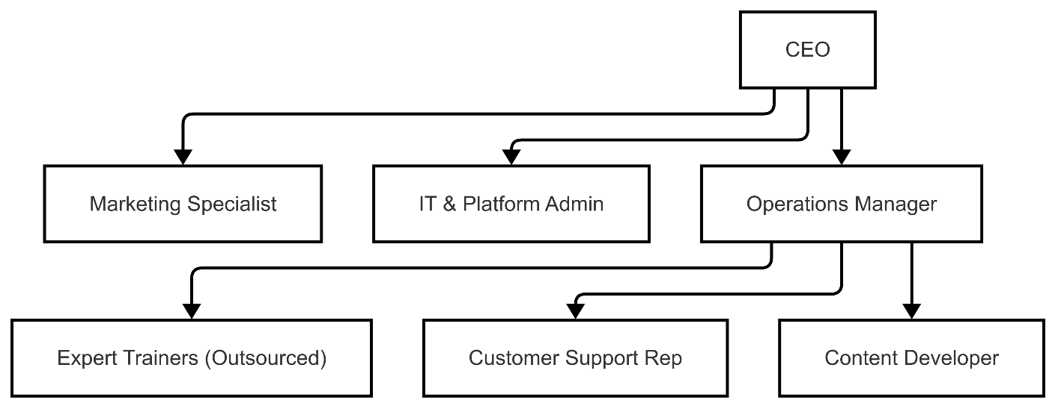
Figure 5. Company Hierarchy

2.7.2 Business Operation and Costs

Staff Positions
Position | Num | Social security | M | Y
CEO | 1 | 29.75% | 9,083 | 108,990
Operations Manager | 1 | 29.75% | 7,785 | 93,420
Marketing Specialist | 1 | 29.75% | 6,488 | 77,850
Customer Support Rep | 1 | 29.75% | 7,785 | 93,420
Content Developer | 1 | 29.75% | 5,190 | 62,280
IT & Platform Admin | 1 | 29.75% | 3,893 | 46,710
Trainer/Instructor | 2 | 29.75% | 41,520 | 498,240
Total | 8 |  | EGP 81,743 | EGP 980,910
Table 6. Business Operation and Costs

2.7.3 Expected Revenues

item/month | jan | feb | march | abril | may | june | july | aug | sep | oct | nov | dec | Total
Freemium Plan | 0 | 0 | 0 | 0 | 0 | 0 | 0 | 0 | 0 | 0 | 0 | 0 | EGP -
Basic Plan | 0 | 0 | 0 | 30000 | 35000 | 92000 | 109000 | 91000 | 96000 | 46000 | 53000 | 48000 | EGP 600,000
Standard Plan | 0 | 0 | 0 | 9000 | 15000 | 22500 | 399000 | 30000 | 4500 | 9000 | 28500 | 22500 | EGP 540,000
Premium Plan | 0 | 0 | 0 | 9000 | 6000 | 60000 | 69000 | 78000 | 180000 | 174000 | 45000 | 99000 | EGP 720,000
Annual Plan – Premium | 0 | 0 | 0 | 25000 | 35000 | 0 | 50000 | 15000 | 75000 | 25000 | 50000 | 25000 | EGP 300,000
Certification Fee | 0 | 0 | 0 | 5000 | 8000 | 12000 | 7800 | 19000 | 21200 | 10600 | 17600 | 18800 | EGP 120,000
Offline Access Kit | 0 | 0 | 0 | 3750 | 6250 | 7500 | 20000 | 2500 | 2250 | 4750 | 3000 | 10000 | EGP 60,000
Corporate Training (B2B) | 0 | 0 | 0 | 0 | 40000 | 52000 | 68000 | 80000 | 68000 | 60000 | 36000 | 76000 | EGP 480,000
Custom Workshop | 0 | 0 | 0 | 0 | 0 | 0 | 20000 | 40000 | 20000 | 36000 | 32000 | 32000 | EGP 180,000
Total | EGP - | EGP 6,000 | EGP 10,000 | EGP 75,750 | EGP 145,250 | EGP 246,000 | EGP 742,800 | EGP 350,500 | EGP 466,950 | EGP 365,350 | EGP 265,100 | EGP 326,300 | EGP 3,000,000
Table 7. Expected Revenues

item/month | Total
Freemium Plan | EGP -
Basic Plan | EGP 600,000
Standard Plan | EGP 540,000
Premium Plan | EGP 720,000
Annual Plan – Premium | EGP 300,000
Certification Fee | EGP 120,000
Corporate Training (B2B) | EGP 480,000
Custom Workshop | EGP 180,000
Offline Access Kit | EGP 60,000
total | EGP 3,000,000
Table 8. Expected Revenues (Summary)

Assumptions:
Parameter | Value / Details
Customer growth starting | Month 4
Monthly customer growth rate | 10% increase in new customers each month after month 4
Plan distribution (monthly new customers) | 50% Basic, 30% Standard, 20% Premium
Average plan prices | Basic: 1,000 EGP, Standard: 1,500 EGP, Premium: 3,000 EGP
Installment options | Only on annual plans, 3-month or 6-month installment plans
Installment uptake | 100% choose 12-month Plan
Revenue recognition | Spread evenly over the installment period (monthly)
Initial months (1–3) | Free trial, no revenue
B2B corporate training | 10 clients/month starting month 7, each 4,000 EGP, free for 6 months, then paid afterward
Other revenues | Certification, offline kits, etc. (assumed steady, optional for simplicity)
Table 9. Assumptions

2.7.4 Expected Expenses

 | Cost | Num |  | M |  | Y
F.C
Salries
CEO | 7,000 | 1 |  | 9,083 |  | 108,990
Operations Manager | 6,000 | 1 |  | 7,785 |  | 93,420
Marketing Specialist | 5,000 | 1 |  | 6,488 |  | 77,850
Customer Support Rep | 6,000 | 1 |  | 7,785 |  | 93,420
Content Developer | 4,000 | 1 |  | 5,190 |  | 62,280
IT & Platform Admin | 3,000 | 1 |  | 3,893 |  | 46,710
Trainer/Instructor | 16,000 | 2 |  | 41,520 |  | 498,240
Total Salries |  |  |  | EGP 81,743 |  | EGP 980,910
Rent Office | 10,500 | 1 |  | 10,500 |  | 126,000
Platform Hosting & Maintennce | 3,050 | 1 |  | 4,000 |  | 48,000
Utilities & Internet | 1,500 | 1 |  | 2,000 |  | 24,000
Others |  |  |  | 4,500 |  | 54,000
Total Expances |  |  |  | 21,000 |  | 252,000
Total F.C |  |  |  | EGP 62,520 |  | EGP 1,232,910
V.C
Marketing & Advertising | 20,000 | 1 |  | 20,000 |  | 240,000
Certification & Certification Fees | 1,666 | 1 |  | 1,666 |  | 19,992
Office supplies & Misc. | 4,050 | One time |  | 4,050 |  | 4,050
Software licenses & tools | 3,050 | One time |  | 4,050 |  | 4,050
Miscellaneous & Contingency | 4,000 | 1 |  | 4,000 |  | 4,000
Total V.C |  |  |  | EGP 33,766 |  | EGP 272,092
Total Cost |  |  |  | EGP 96,286 |  | EGP 1,505,002
Table 10. Expected Expenses

2.7.4 Income Statement

Item | Amount (EGP)
Revenue | 3,000,000
Cost of Goods Sold (COGS) | 564,000
Gross Profit | 2,436,000
Operating Expenses | 1,485,010
EBITDA | 950,990
Taxes (approx. 0.5%) | 47,550
Net Income | 903,441
Table 11. Income Statement

2.7.5 Cashflow

Source | Amount (EGP)
Inflow
Beginning Cash Balance | 0
Funding from Sources | 900,000
Monthly Revenue (from sales) | 3,000,000
Total Cash Inflows | 3,900,000
Outflow
Operating Expenses | 1,485,010
Cost of Goods Sold (COGS) | 564,000
Total Outflows | 2,049,010
Net Cash Flow (Inflows - Outflows) | 1,850,990
Ending Cash Balance | 1,850,990
Table 12. Cashflow

2.7.6 Balance Sheet

Asset Category | Amount (EGP) | Liability Category | Amount (EGP)
Current Assets |  | Current Liabilities
- Cash & Cash Equivalents | 1,850,990 | - Accounts Payable | 100,000
- Accounts Receivable | 250,000 | Total Current Liabilities | 100,000
- Prepaid Expenses | 50,000 | Long-term Liabilities
Total Current Assets | 2,150,990 | - Bank Loans / External Debt | 300,000
Non-current Assets |  | Total Long-term Liabilities | 300,000
- Equipment & Infrastructure | 100,000 | Total Liabilities | 400,000
- Intangible Assets | 50,000 | Equity Category | Amount (EGP)
Total Non-current Assets | 150,000 | Owner's Capital | 900,000
 |  | Retained Earnings | 1,000,990
 |  | Total Owner’s Equity | 1,900,990
Total Assets | 2,300,990 | Total Liabilities + Equity | 2,300,990
Table 13. Balance Sheet

2.7.7 Owner Equity

Owner’s Equity Statement
Item | Amount (EGP)
Beginning Capital | 900,000
Add: Net Profit for Year | 903,441
Ending Capital / Equity | 1,803,441
Table 14. Owner Equity

C h a p t e r T h r e e

- System Analysis
- Introduction (Aim of the chapter)
- User Requirements
    - Functional requirements
    - Non-functional requirements
- System Requirement
- System Diagrams
    - Use case diagram.
    - Sequence diagram
    - Activity diagram

Chapter Three: System Analysis

3.1 Introduction
In the analysis phase, the analyst determines the functional requirements of the new system. This chapter begins with a description of the analysis phase and its main output, the system proposal.
The analysis phase derives its name from the term "analysis", which involves breaking down a whole into parts with the aim of understanding the nature, function, and relationships of those parts. During this phase, collaboration between the system analyst and business users is promoted to better understand user needs and expectations.

3.2 User Requirements
The following are the user requirements:

3.2.1 Functional Requirements
Functional requirements are product features or functions that must be implemented by developers to enable users to accomplish their tasks. It is crucial to ensure clarity regarding these requirements for both the development team and stakeholders.
Typically, system behavior under specific conditions is described by functional requirements.
Example: An approval request is sent by the system after personal information is entered by the user. A search feature allows courses to be browsed across various categories, whether in line with the user's interests.

3.2.1.1 Student
Students interact with the system through a variety of features aimed at enhancing their user experience:
- Registration requires essential personal details.
- Login is done via email and password.
- A course-sharing feature allows students to upload completed courses for exchange.
- Students can review and rate courses they’ve taken.
- Courses can be purchased in digital or physical formats.
- Tickets for offline seminars can be purchased.
- Users may add favorite quotes from courses or instructors.
- A robust search feature supports category-based course exploration.
- Feedback submissions help improve the system and services.

3.2.1.2 Job
The Job entity represents employment opportunities provided by companies.
Purpose:
- Stores job listings.
- Manages application and selection processes for students.
- Allows companies to post jobs.
- Offers students a platform to apply for roles aligned with their qualifications and interests.

3.2.1.3 Course
The Course entity covers training and academic offerings.
Purpose:
- Stores and manages educational content.
- Tracks schedules, types, and course relationships.
- Integrates with registrations and assessments.
- Organizes curriculum, supports planning, and enables student progress tracking.

3.2.1.4 Instructor
The instructor entity represents educators responsible for delivering courses and evaluating performance.
Purpose:
- Manages teaching staff information.
- Ensures proper assignment of instructors based on specialization.
- Supports course planning and delivery through resource tracking.

3.2.1.5 Assessment
The Assessment entity manages student evaluations throughout their learning journey.
Purpose:
- Organizes course and job-related assessments.
- Supports structured evaluation design.
- Helps track performance and readiness for real-world roles.
- Enhances feedback and academic quality.

3.2.1.6 Company Representative
This entity includes authorized individuals representing external companies.
Purpose:
- Manages job listings.
- Reviews student applications.
- Facilitates secure and structured interactions with the platform.
- Ensures efficient recruitment and institutional communication.

3.2.1.7 Admin
The admin entity handles system-wide operations.
Purpose:
- Full access and control over platform functions.
- Manages users, content, job approvals, and configurations.
- Ensures data accuracy, rule enforcement, and overall system stability.

3.2.2 Non-functional Requirements
- Performance: Describes system responsiveness to user interactions.
- Security: Protects against unauthorized access to data.
- Availability: Measures system uptime and access reliability.
- Data Integrity: Ensures accuracy and consistency of data across its lifecycle.
- Reliability: Measures system function stability under defined conditions.

3.3 System Requirements
System requirements specify configurations necessary for optimal hardware and software performance. Failure to meet them may lead to installation or performance issues.

3.3.1 Software Requirements
- Server OS: Linux (Ubuntu 20.04+)
- Web Server: Apache 2.4+
- Backend: Python 3.12.5
  - With frameworks Flask
- Database: MySQL 8.0+
- Frontend: HTML5, CSS3, JavaScript
  - With Bootstrap for enhanced UX.
- Version Control: Git
- API Testing: Postman
- Security: SSL certificates, firewall, CAPTCHA, and optional 2FA

3.3.2 Hardware Requirements
- Server:
  - Quad-core processor (Intel Xeon or AMD Ryzen)
  - Minimum 32 GB RAM (64 GB recommended)
  - 2 Tera SSD
  - High-speed internet (16 Gbps)
- Client Machines (Users):
  - Intel i3 processor (or equivalent)
  - 4 GB RAM
  - 1366×768 screen resolution
  - Internet: Minimum 2 Mbps bandwidth
  - Browser: Chrome, Firefox, Edge, Safari
- Additional Needs:
  - Cloud storage (e.g., AWS S3 or Google Cloud Storage)
  - Backup hardware for large file handling

3.4 System Diagrams
The following are the system diagrams:

3.4.1 UML Use Case Diagram
- Describes main system functions (functional requirements)
- Identifies system users.
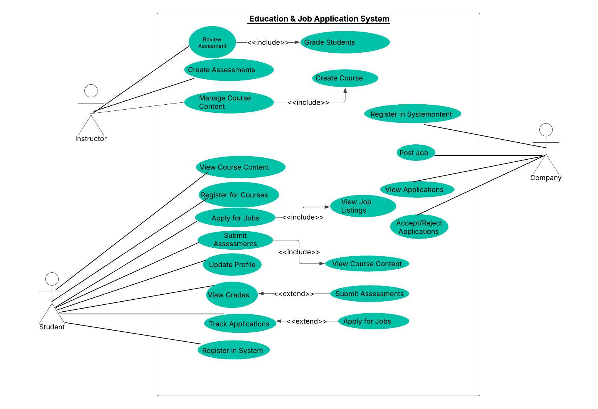
- Provides a high-level overview of system functionality and user interactions.
Figure 6. Use Case Diagram

3.4.2 UML Sequence Diagram
- Details how operations are executed through object interaction.
- Represents interaction order using a time axis.
- Entities: Student, Instructor, Assessment, Course, Job

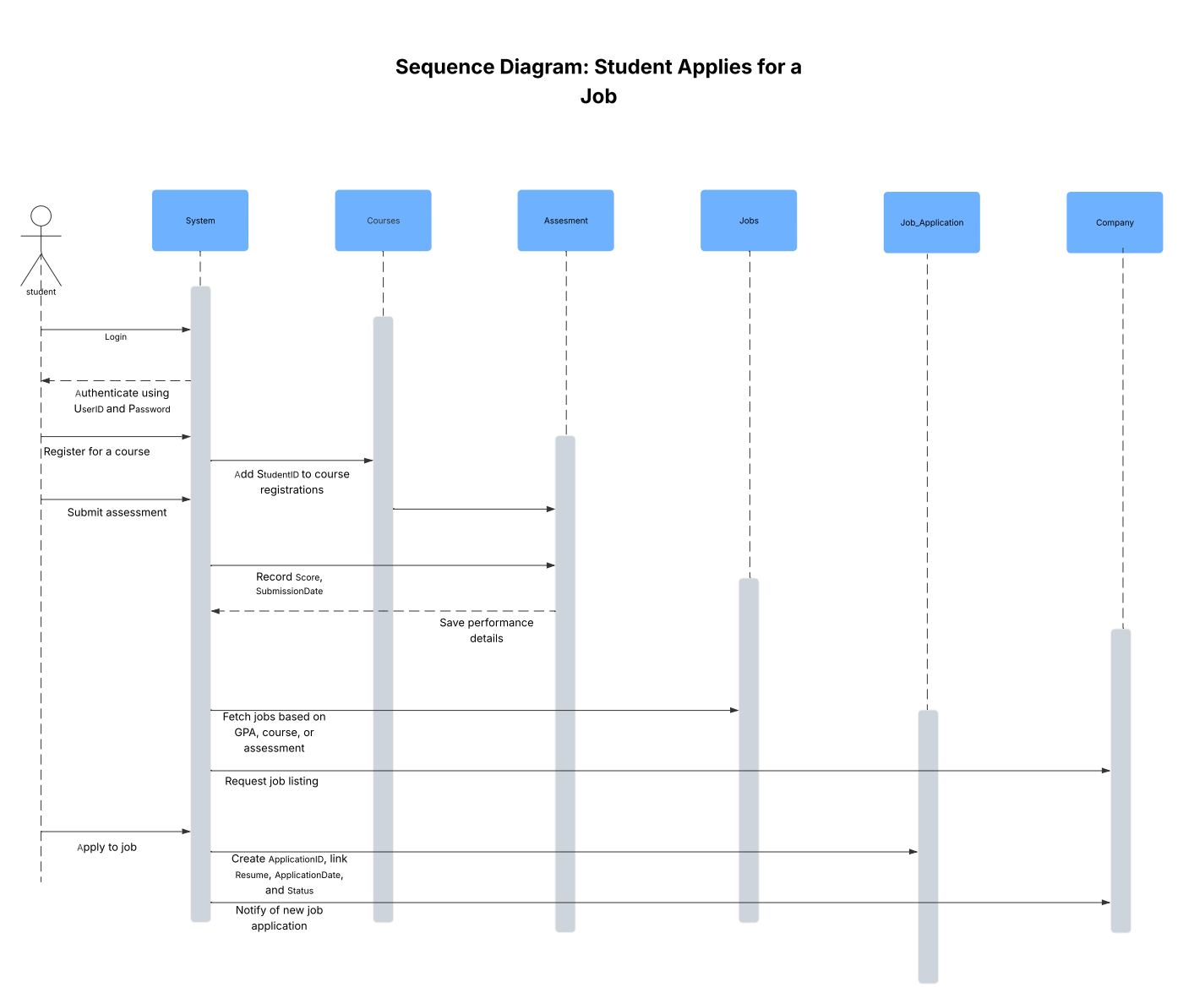
Figure 7. Sequence Diagram (Student)
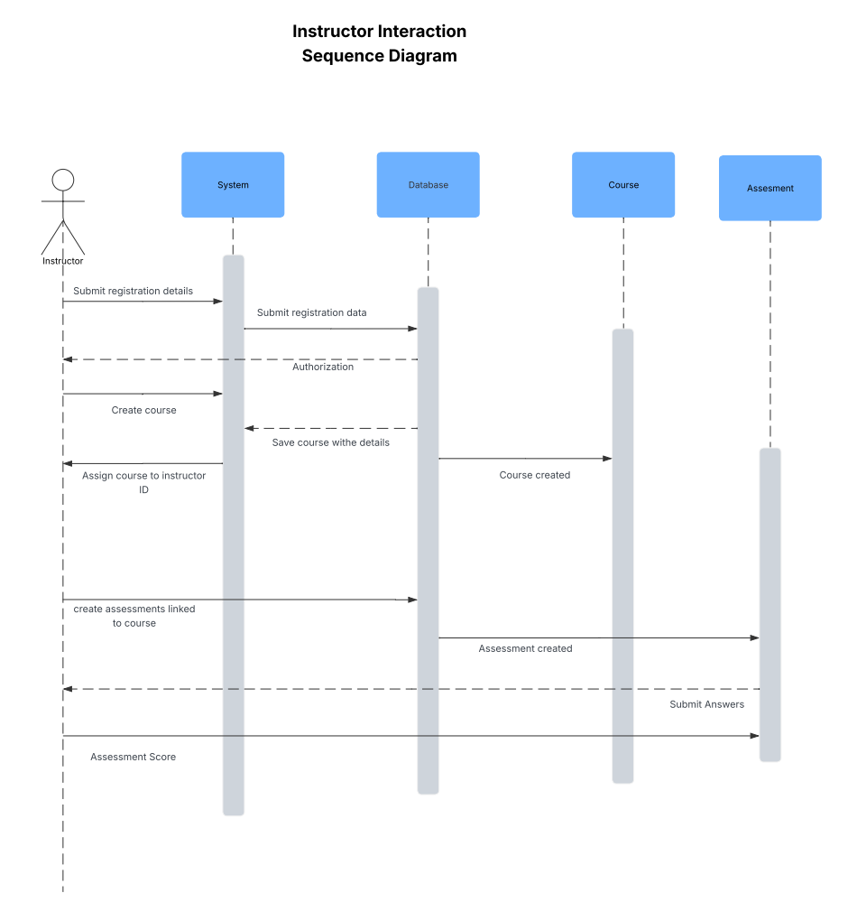
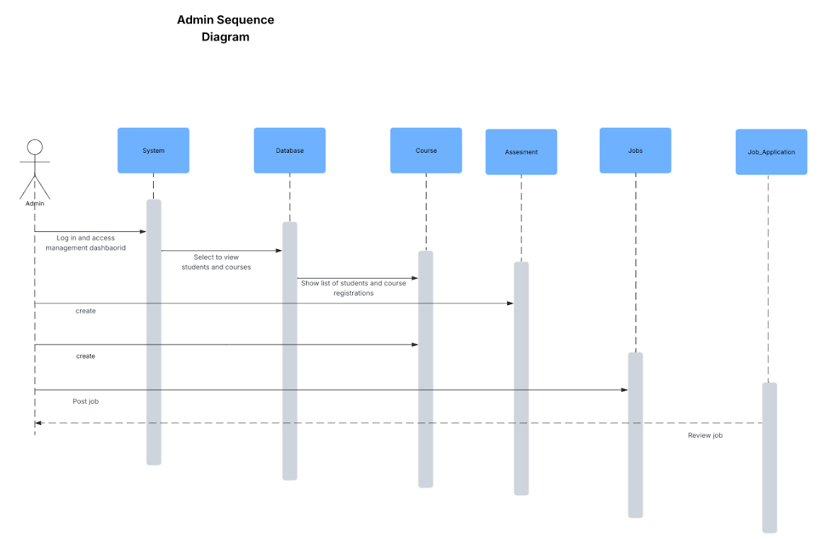
Figure 8. Sequence Diagram (Instructor)
Figure 9 Sequence Diagram (Admin)
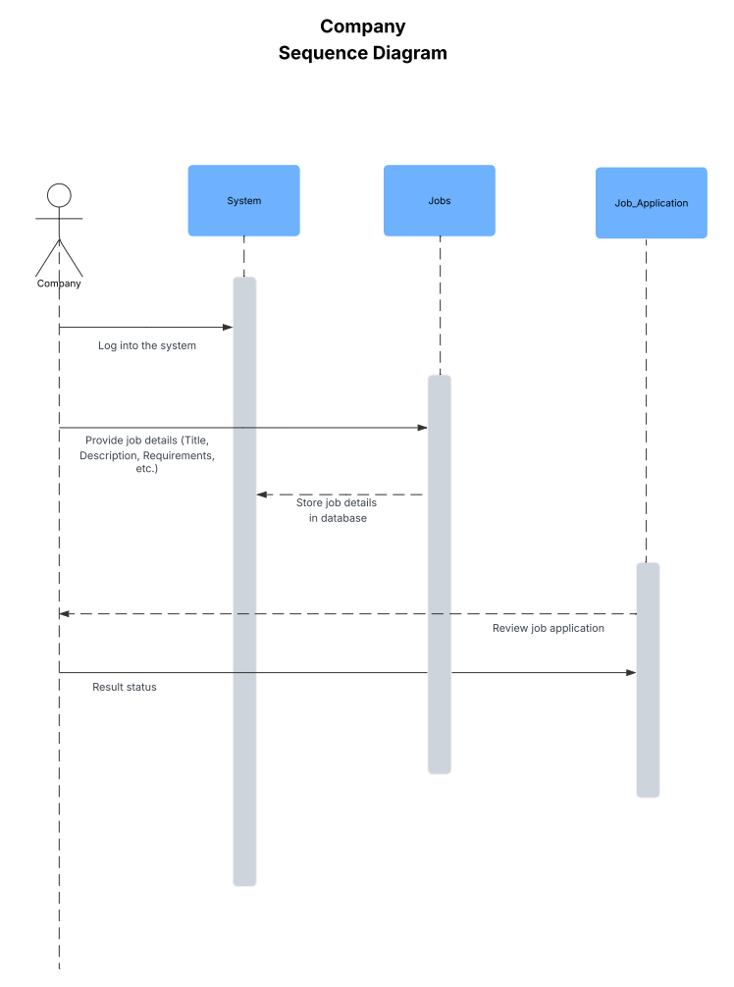
Figure 10. Sequence Diagram (Company)

3.4.3 UML Activity Diagram
- Advanced flowchart modeling transitions between activities
- Describes coordination of tasks to deliver services.
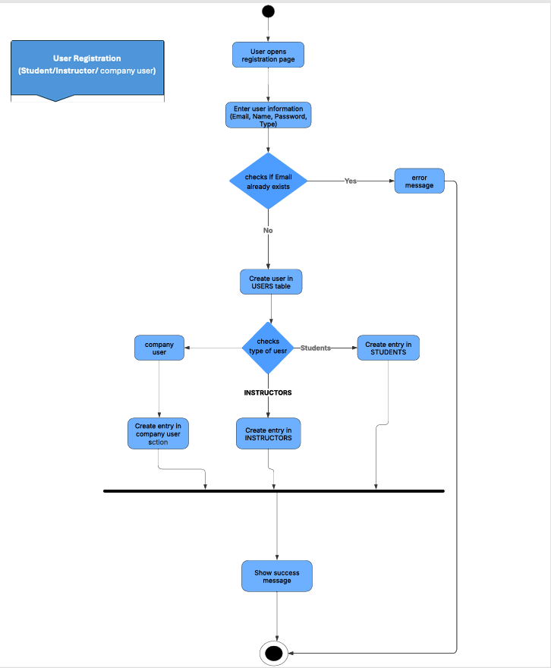
- Highlights event dependencies, overlaps, and business workflows across use cases.
Figure 11. Activity Diagram (Registration)
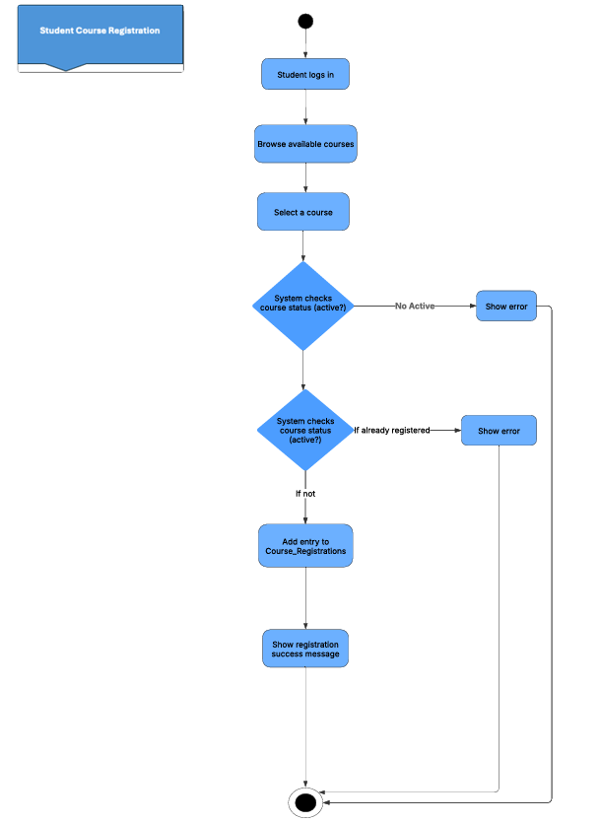
.
Figure 12. Activity Diagram (Course Registration)
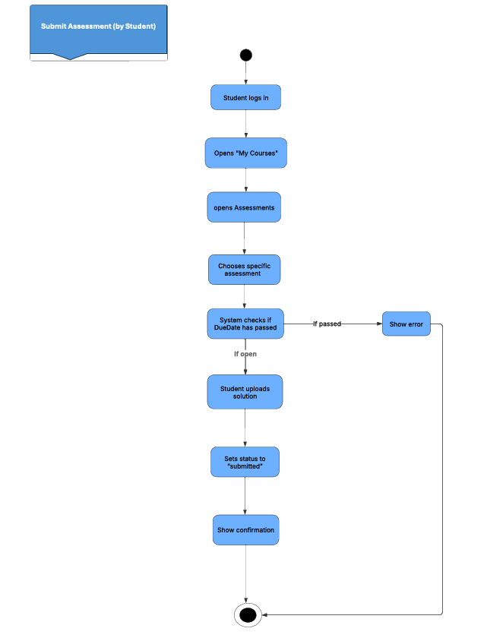
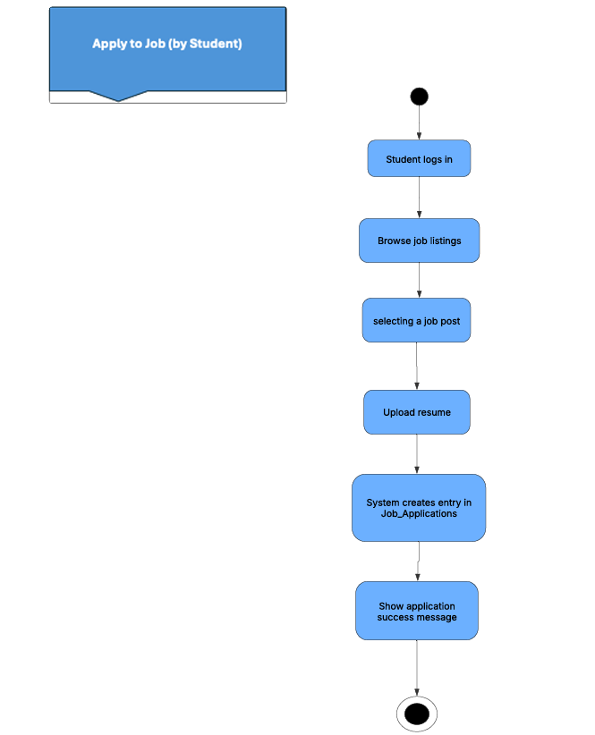
Figure 13. Activity Diagram (Submit Assignment)
Figure 14. Activity Diagram (Apply to job)
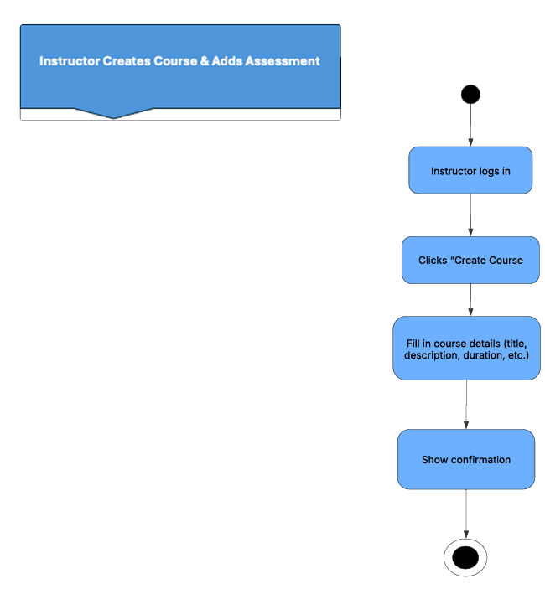
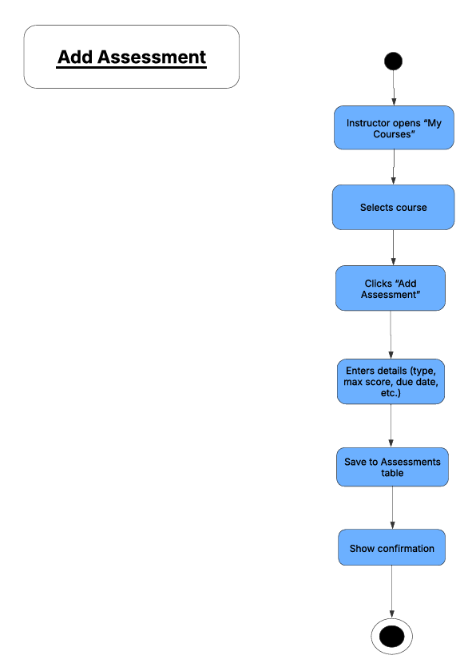
Figure 15. Activity Diagram (Create Course)
Figure 16. Activity Diagram (Add Assessment)

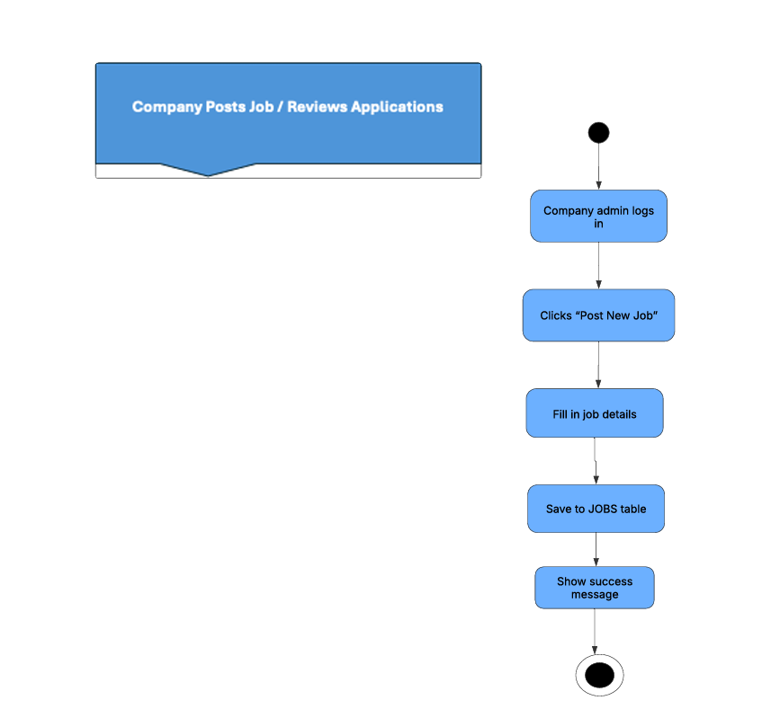
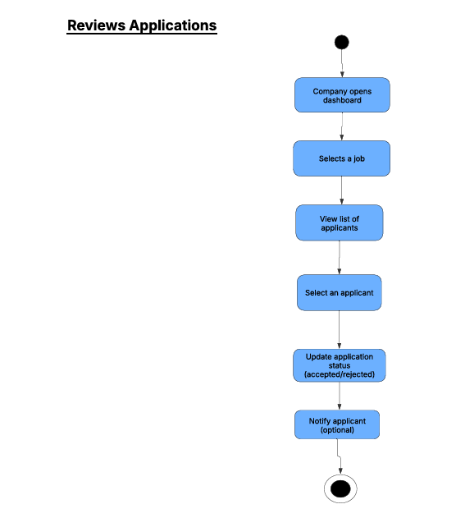
Figure 17. Activity Diagram (Post Job)
Figure 18. Activity Diagram (Review Job)

C h a p t e r F o u r

- SYSTEM DESIGN
- Introduction (Aim of the chapter)
- Class Diagram
- Database structure ERD
- Database Mapping

Chapter Four: System Design

4.1 Introduction:
Systems Design is the process of defining the architecture, components, modules, interfaces, and data for a system to satisfy specified requirements. It involves translating user requirements into a detailed blueprint that guides the implementation phase. The goal is to create a well-organized and efficient structure that meets the intended purpose while considering factors like scalability, maintainability, and performance.
Mastering Systems Design is crucial for anyone looking to build robust and scalable systems. Our comprehensive Systems Design course provides you with the knowledge and skills to excel in this area. Through practical examples and expert insights, you will learn how to effectively translate user requirements into detailed designs that can be successfully implemented.

4.2 Class Diagram:
Class diagrams are fundamental to the object modeling process and model the static structure of a system. Depending on the complexity of a system, you can use a single class diagram to model an entire system, or you can use several class diagrams to model the components of a system. Class diagrams are the blueprints of your system or subsystem. You can use class diagrams to model the objects that make up the system, to display the relationships between the objects, and to describe what those objects do and the services that they provide.
Class diagrams are useful in many stages of system design. In the analysis stage, a class diagram can help you to u. and the requirements of your problem domain and to identify its components. In an object-oriented software project, the class diagrams that you create during the early stages of the project contain classes that often translate into actual software classes and objects when you write code. Later, you can refine your earlier analysis and conceptual models into class diagrams that show the specific parts of your system, user interfaces, logical implementations, and so on.
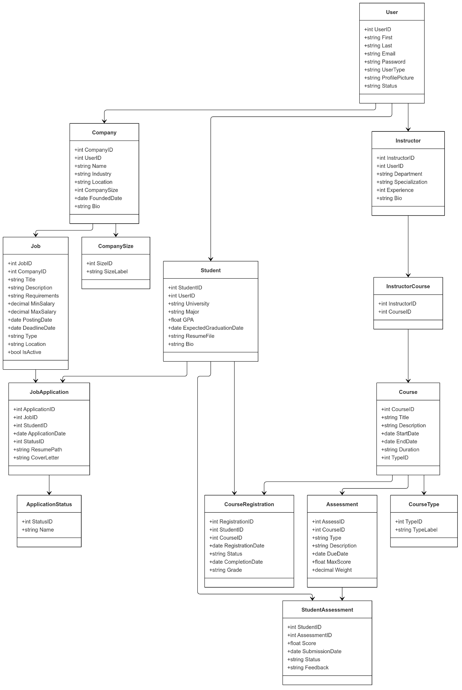
Figure 19. Class Diagram

4.3 Database Structure (ERD):
ERD stands for Entity Relationship Diagram. People also refer to these diagrams as ER diagrams or Entity Relationship Models.
An ERD visualizes the relationships between entities such as people, things, or concepts in a database. It often also depicts the attributes of these entities.
ER diagrams can help businesses document existing databases, which aids in troubleshooting logic or deployment problems, spotting inefficiencies, and improving processes—especially when undertaking business process re-engineering.
Additionally, ERDs are used to design and model new databases, ensuring engineers can identify any logic or design flaws before implementation in production.
- Document an existing database structure
- Debug, troubleshoot, and analyze
- Design a new database
- Gather design requirements
- Business process re-engineering (BPR)
When documenting a system or process, examining the system from multiple perspectives increases the overall understanding of that system.
ERD diagrams are commonly used alongside data flow diagrams to display the contents of a data store. They help visualize how data is connected in a general way and are particularly useful for constructing relational databases.
The traditional Chen ERD resembles a flowchart with connected symbols representing entities, relationships, and attributes. Since its introduction by Chen in the 1970s, various alternative cardinality notations have been proposed, but the basic symbols and their connections remain largely consistent.

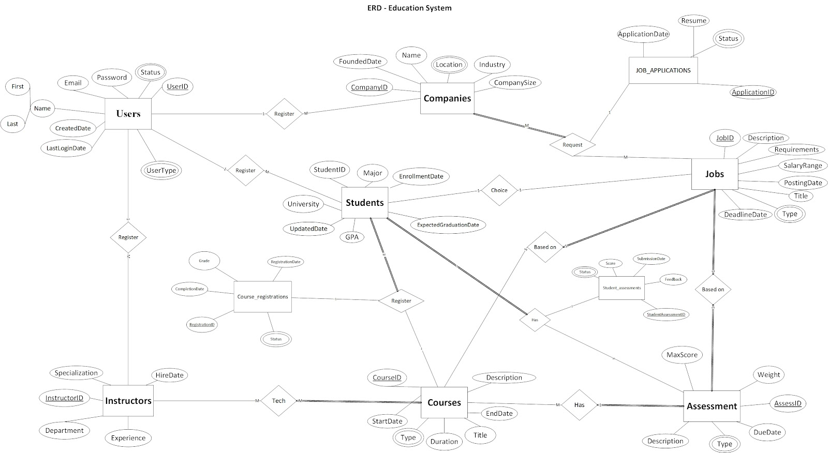
Figure 20. ERD

4.4 Database Mapping:
Data mapping is the process of matching fields from one database to another. It's the first step to facilitate data migration, data integration, and other data management tasks.
Data mapping is crucial to the success of many data processes. One misstep in data mapping can ripple throughout your organization, leading to replicated errors, and ultimately, to inaccurate analysis.
Nearly every enterprise will, at some point, move data between systems. Different systems store similar data in different ways, so to move and consolidate data for analysis or other tasks, a roadmap is needed to ensure the data gets to its destination accurately.
For processes like data integration, data migration, data warehouse automation, data synchronization, automated data extraction, or other data management projects, quality in data mapping will determine the quality of the data to be analyzed for insights.
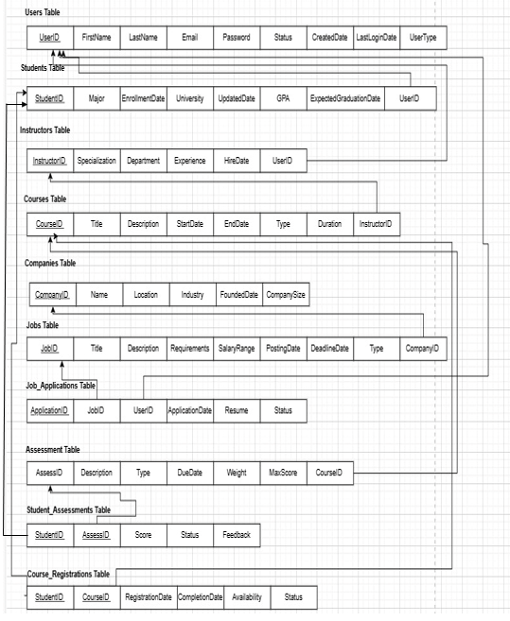
Figure 21. Mapping

C h a p t e r F i v e

- SYSTEM IMPLEMENTATION
- Introduction (Aim of the chapter)
- System Screenshots

Chapter Five: System Implementation

5.1 Introduction
The implementation plan facilitates the execution of a plan, idea, model, design, specification, or policy by presenting clear implementation steps that need to follow, after we have carefully planned our project and show you its business plan and system analysis, you will be ready to start the project implementation phase. The implementation phase involves putting the project plan into action which you can interact with.

5.2 System screenshots
the following are the system pages:

5.2.1 Home page
The home page consists of navigation bar, Hero section, Why Choose Our Platform? section, CTA section, and footer.

Figure 22. Home page (Hero Section)
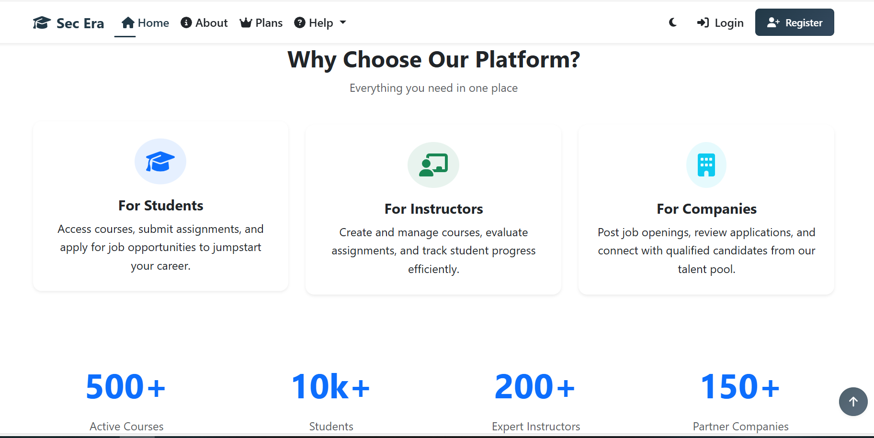
Figure 23. Home page (Info Section)

Figure 24. Home page (CTA Section, Footer)

5.2.2 About Page
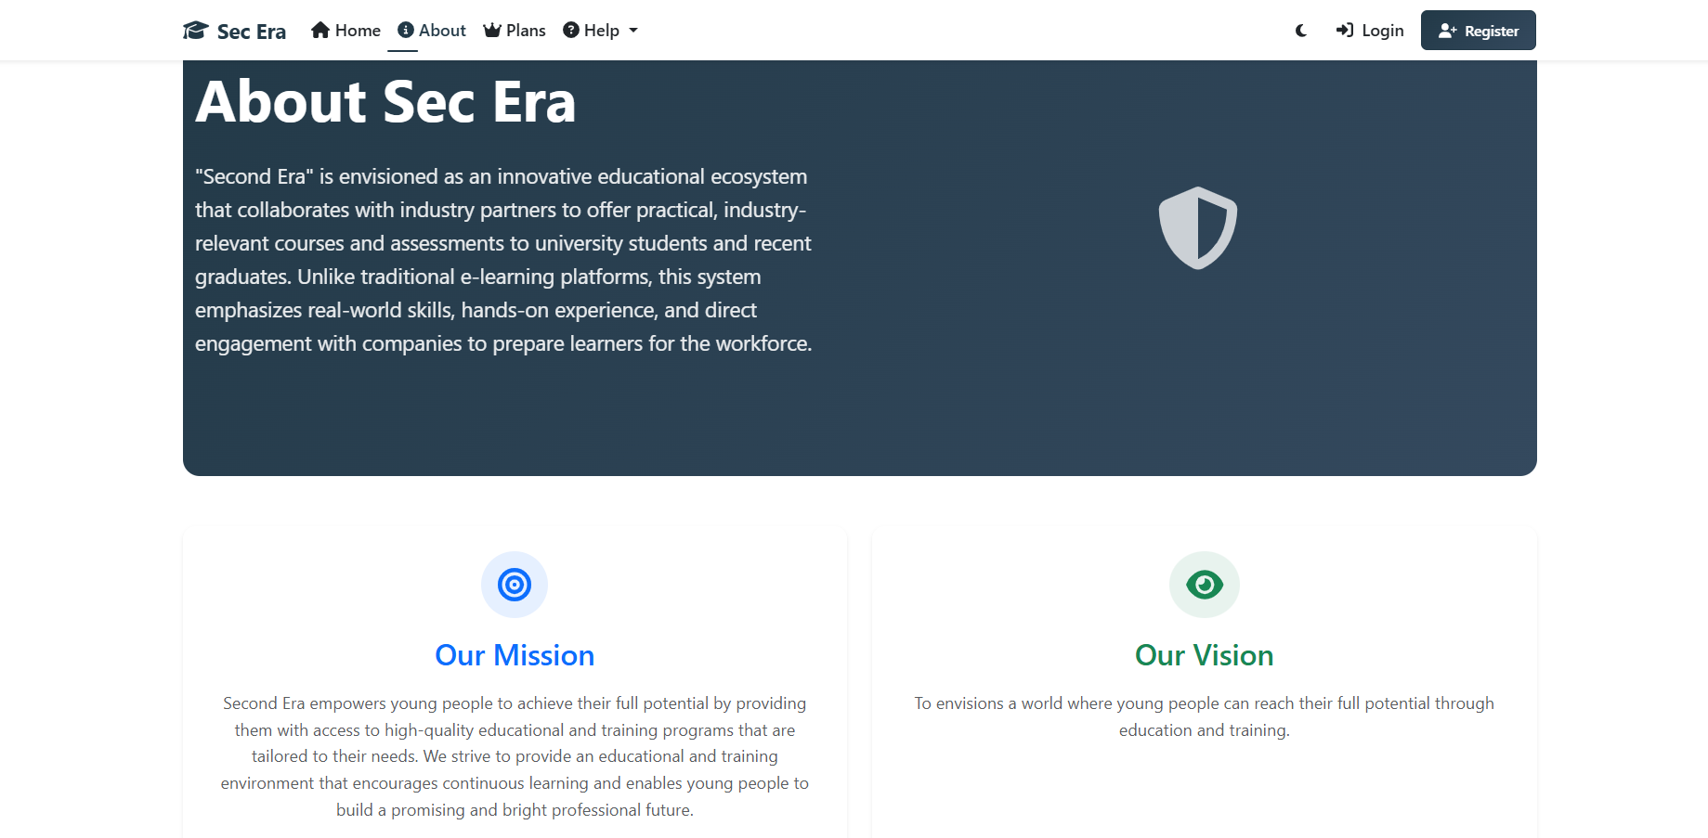
Figure 25. About Page (1)
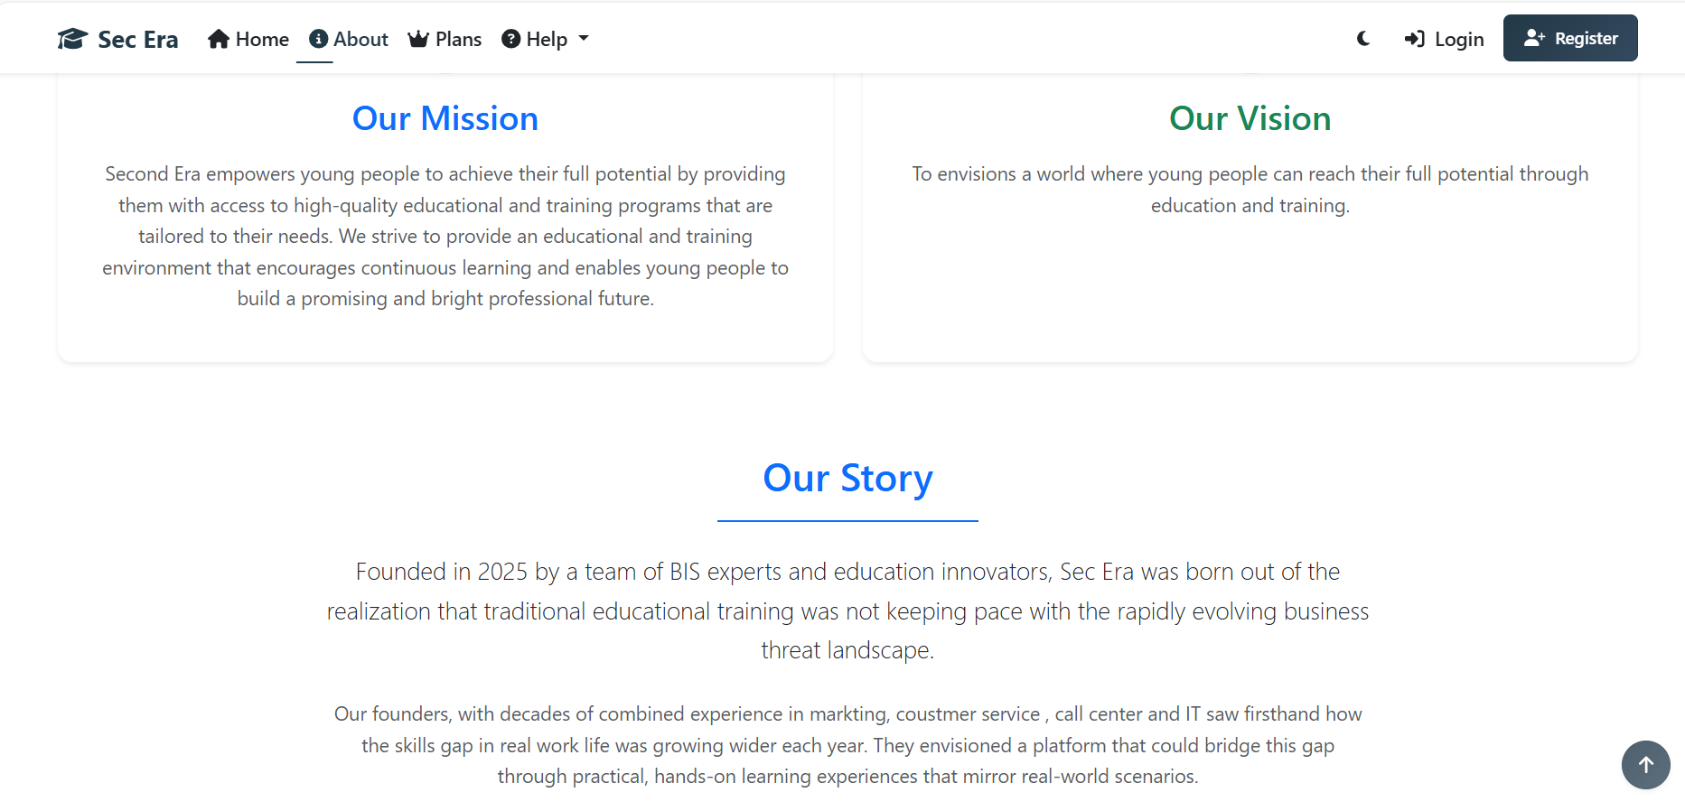
Figure 26. About Page (2)

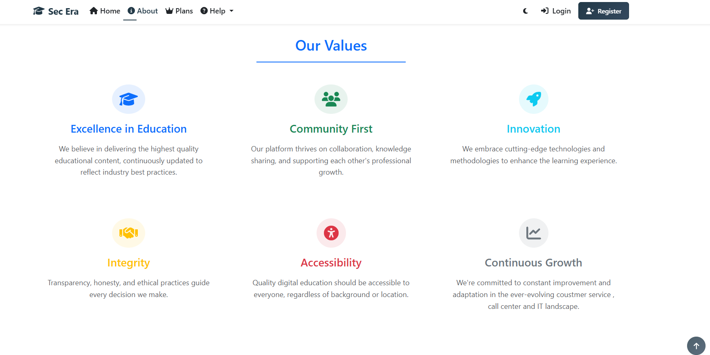
Figure 27. About Page (3)
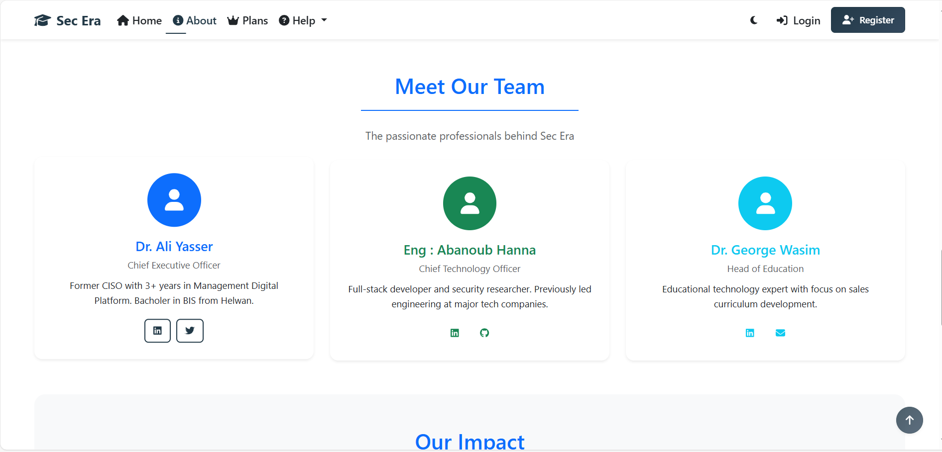
Figure 28. About Page (4)
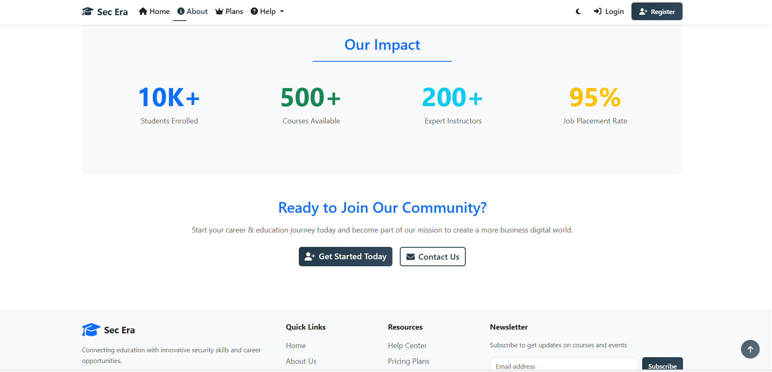
Figure 29. About Page (5)

5.2.3 Plans Page
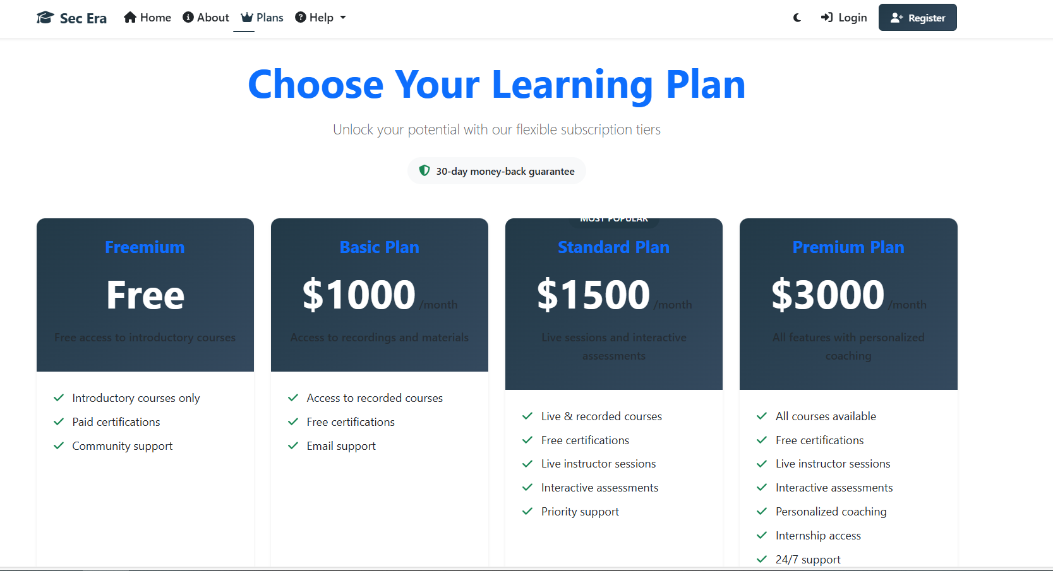
Figure 30. Plans Page (1)
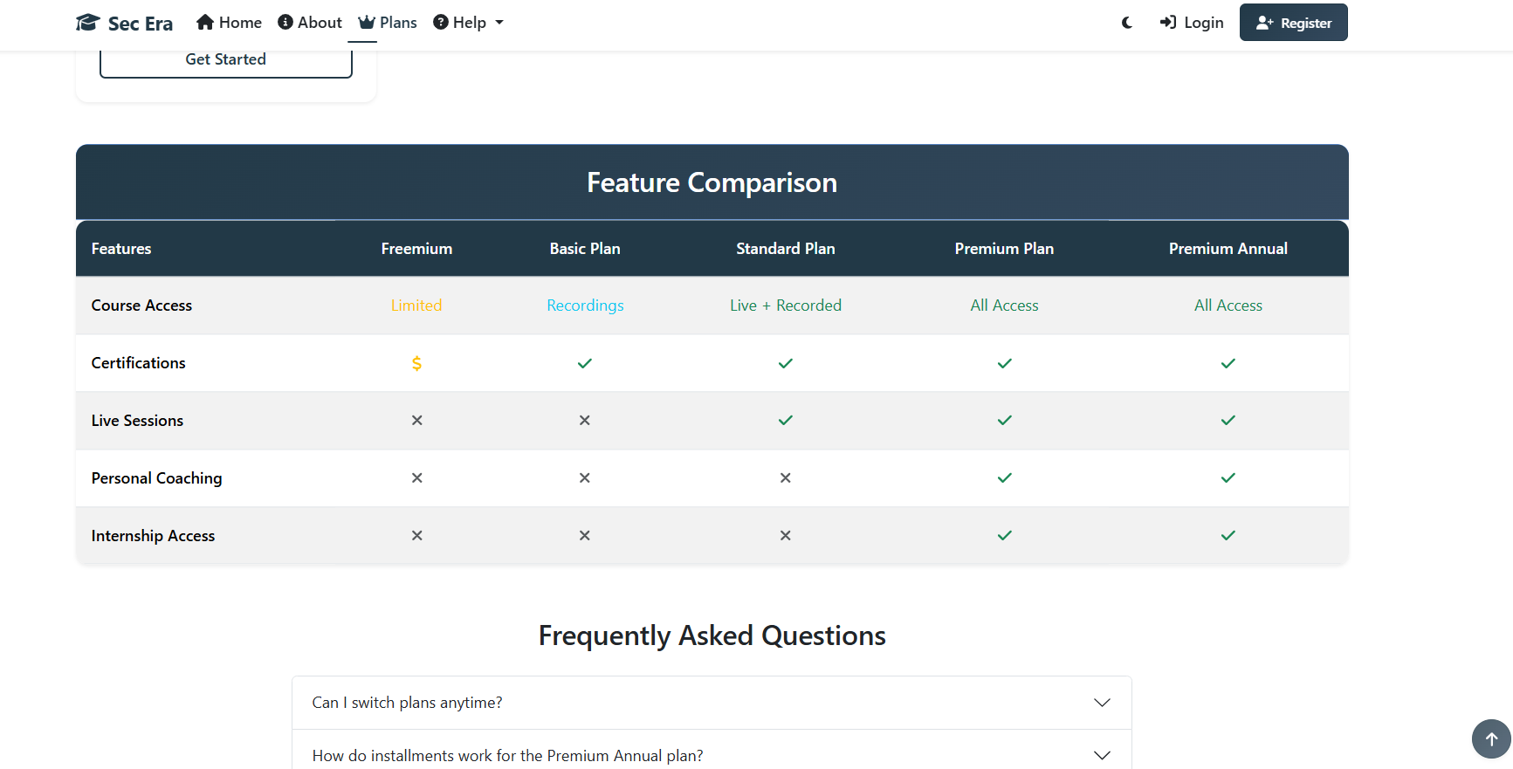
Figure 31. Plans Page (2)

5.2.4 Contact & Support Page
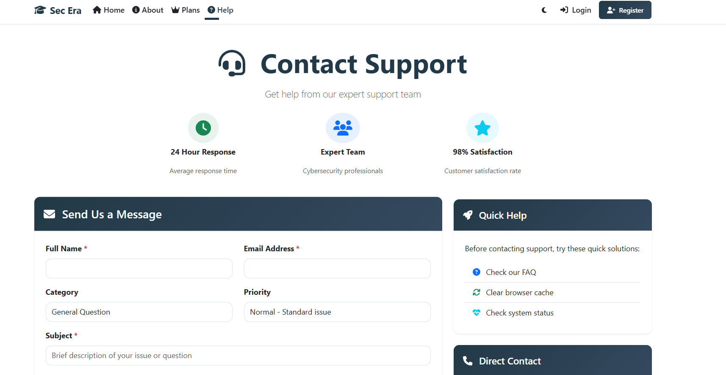
Figure 32. Contact & Support Page (1)
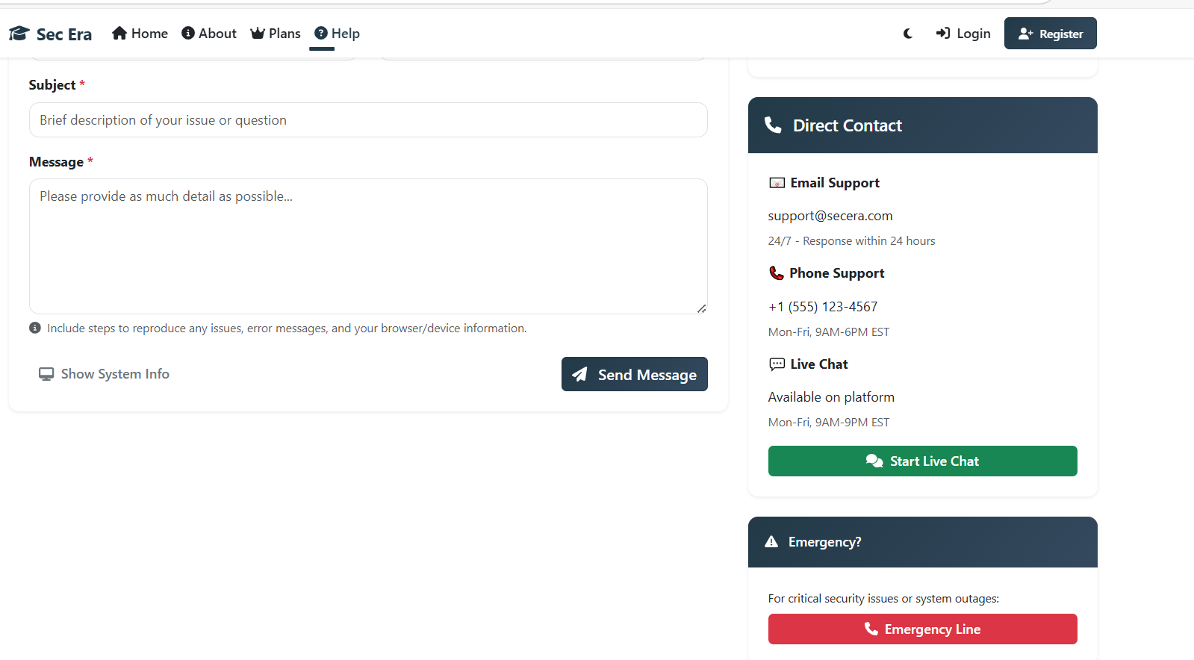
Figure 33 Contact & Support Page (2)

5.2.5 Help Page
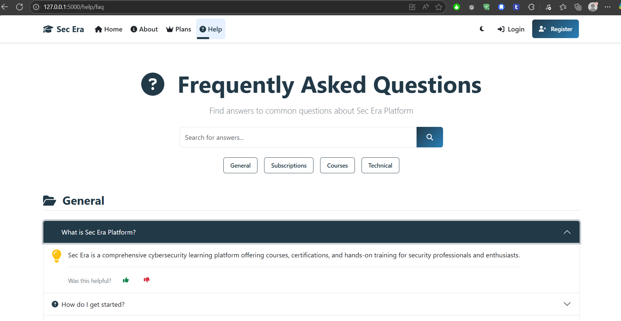
Figure 34. Help Page (FAQ)
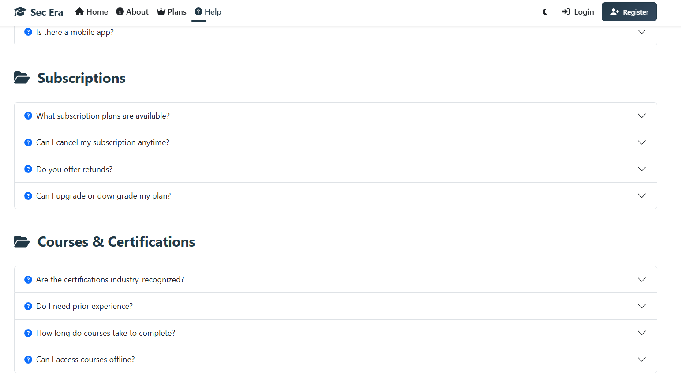
Figure 35. Help Page (FAQ)
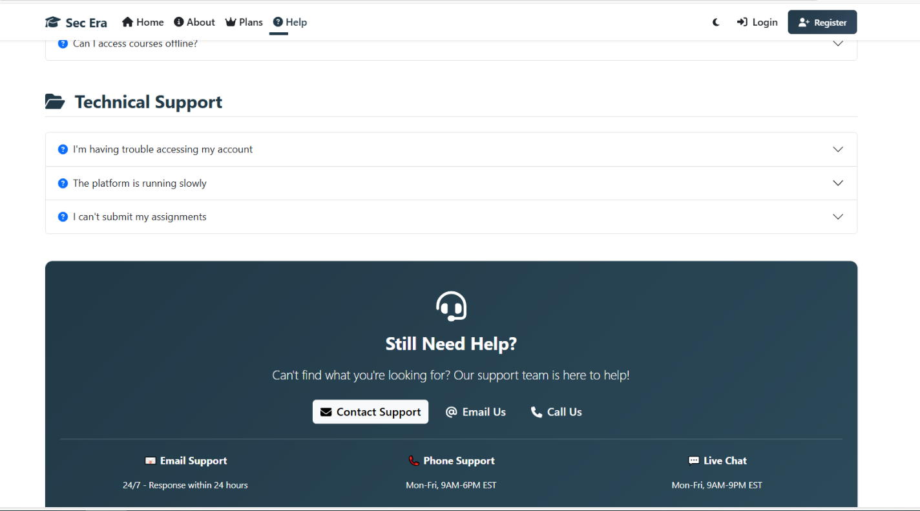
Figure 36. Help Page (FAQ)

5.2.6 Register Page
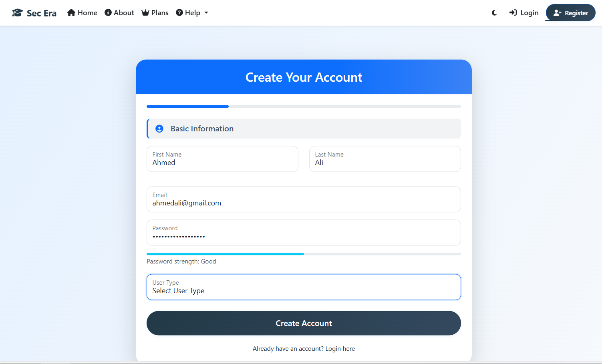
Figure 37. Register Page

5.2.6.1 Register as Student:
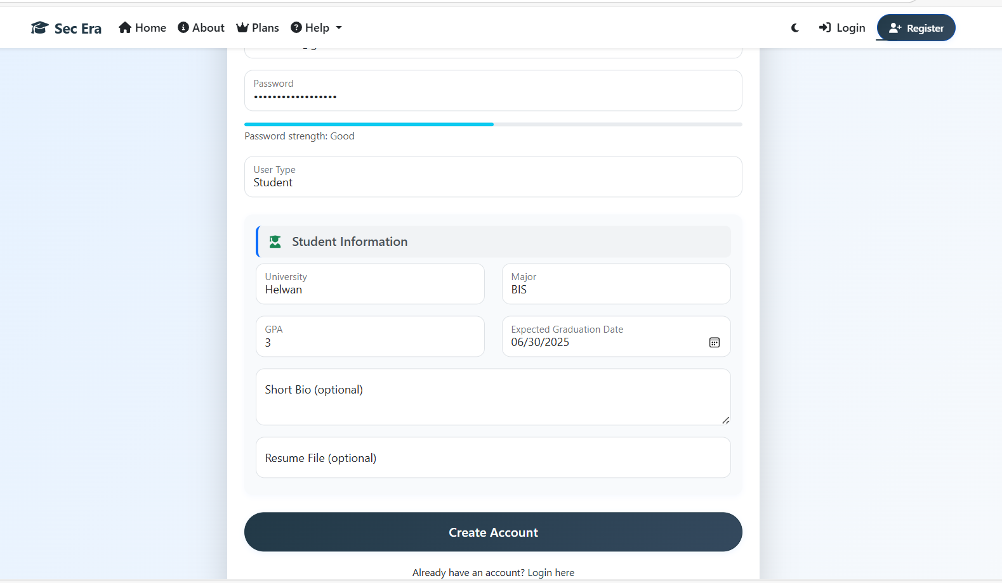
Figure 38. Register Page (Student)

5.2.6.2 Register as Instructor:
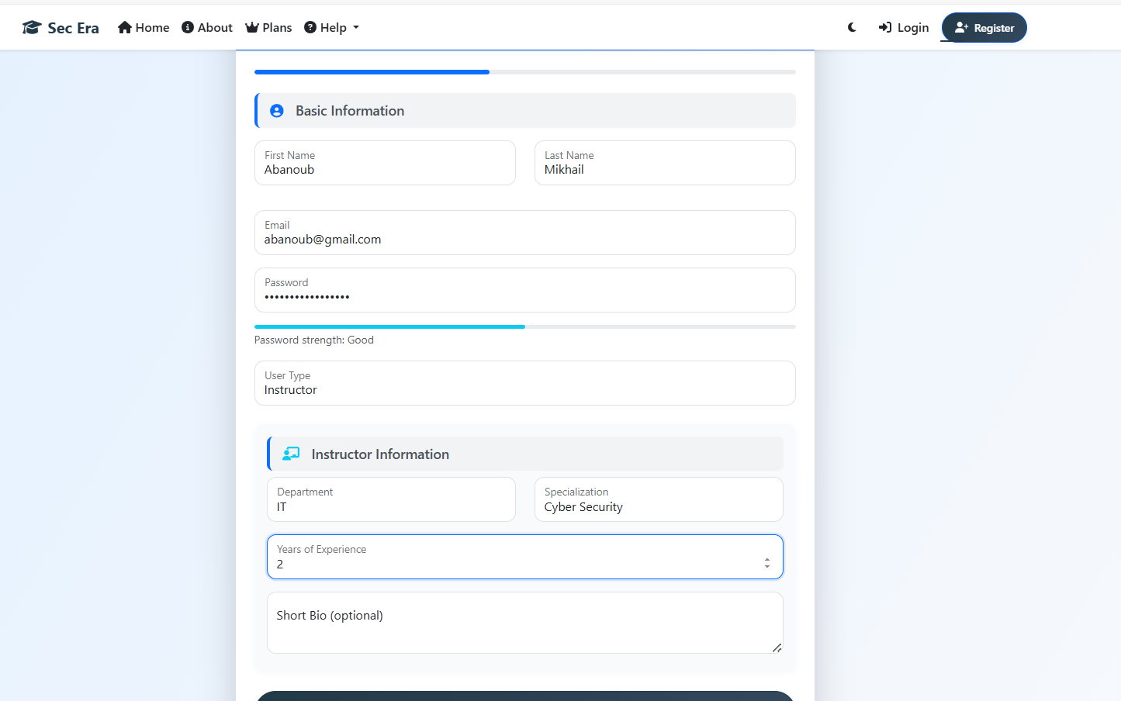
Figure 39. Register Page (Instructor)

5.2.6.3 Register as Company Representer:
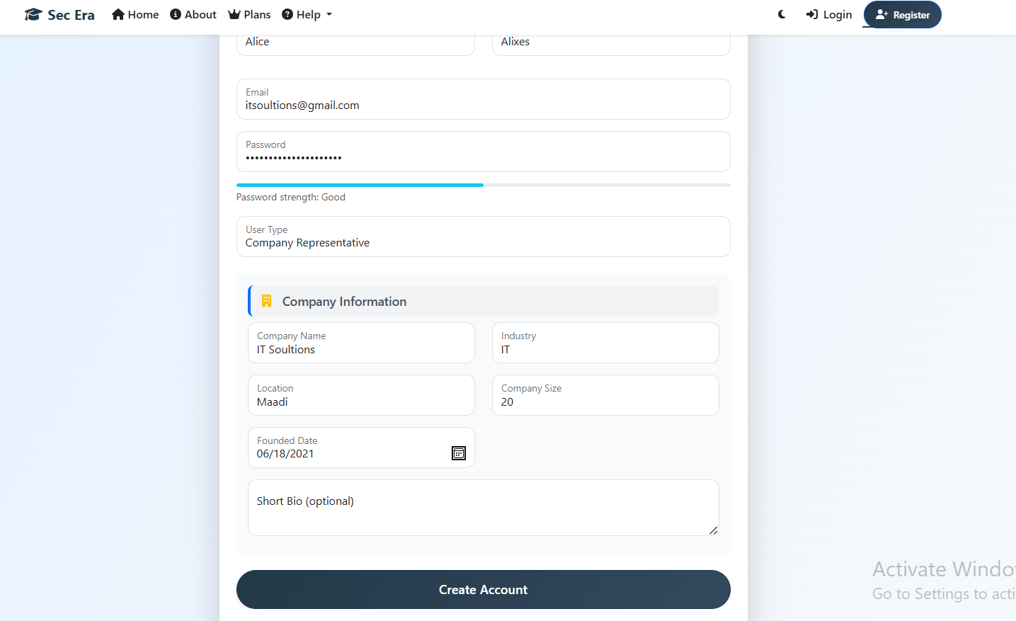
Figure 40 . Register Page (Company Representer)

5.2.7 login Page:

5.2.7.1 Public & student (After Registration)
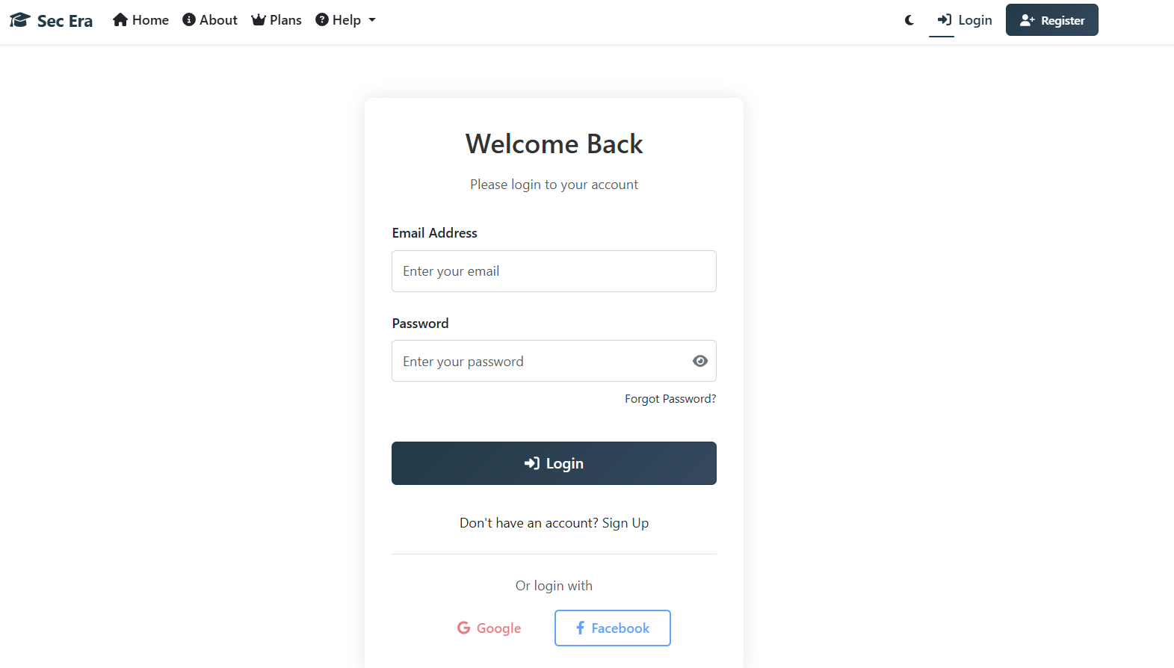
Figure 41. login Page (Public & student (After Registration))

5.2.7.2 Instructor & Company Representer (wait until admin approve) (After Registration)
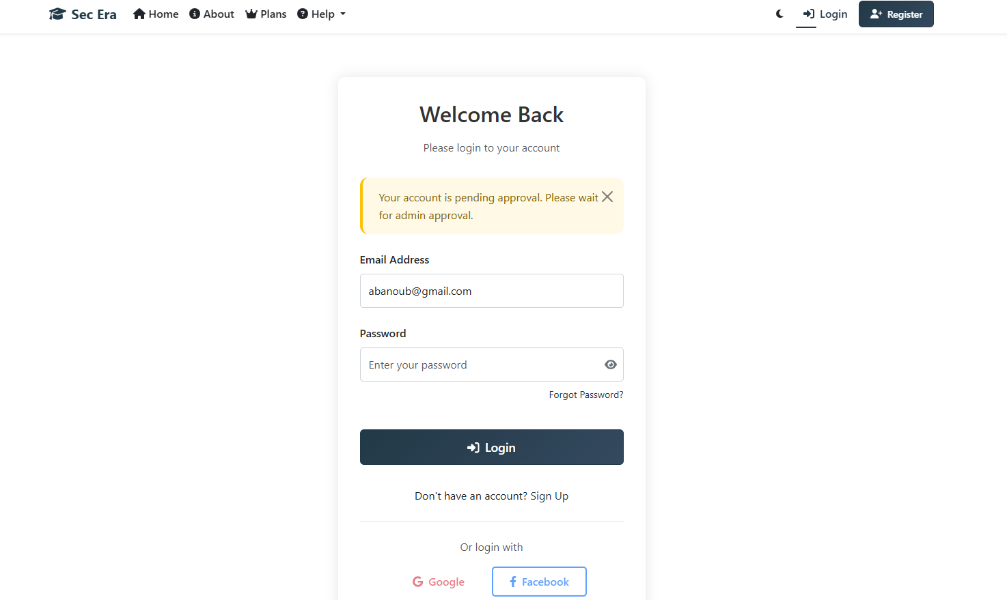
Figure 42. login Page (Instructor & Company Representer (wait until admin approve) (After Registration))

5.2.8 Dashboard Page:

5.2.8.1 Student
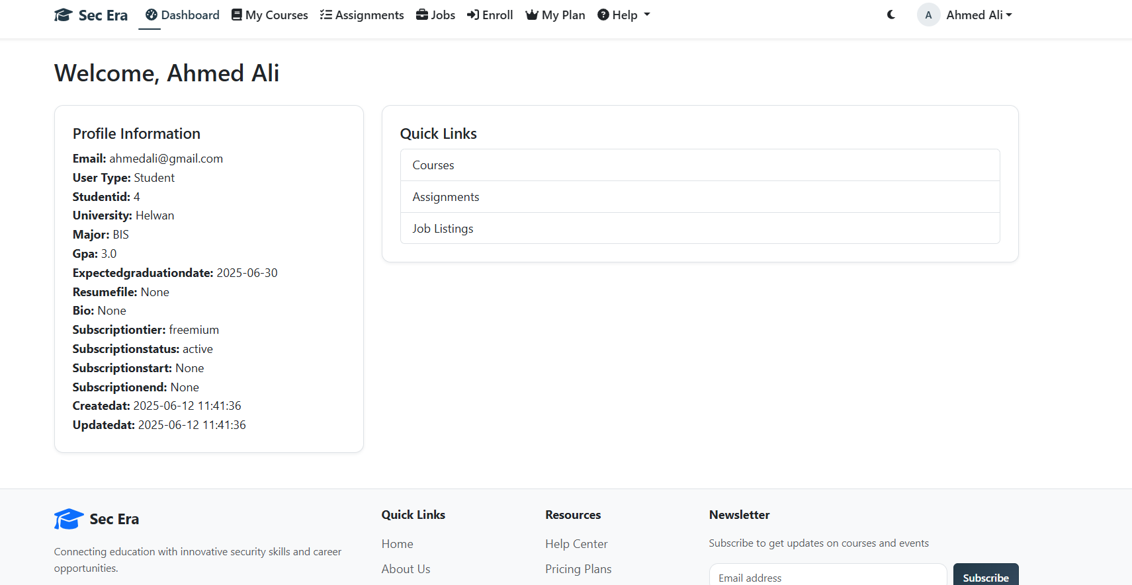
Figure 43. Dashboard Page (Student)

5.2.8.2 Instructor:
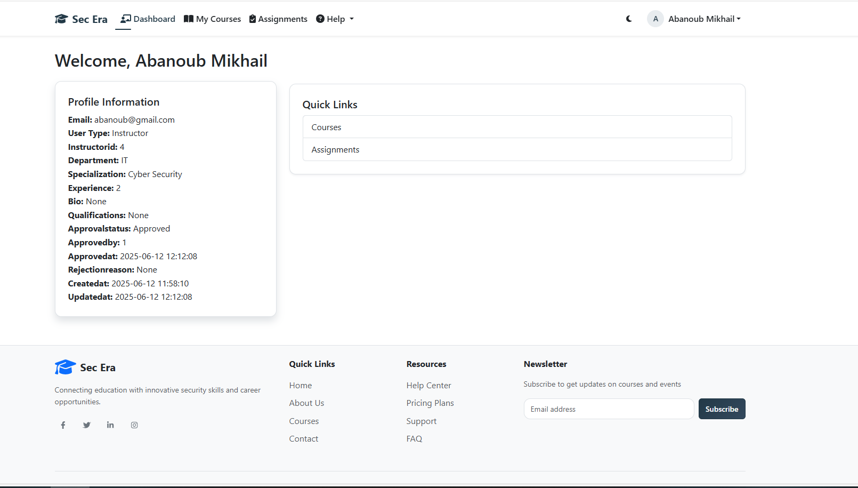
Figure 44. Dashboard Page (Instructor)

5.2.8.3 Company Representer:
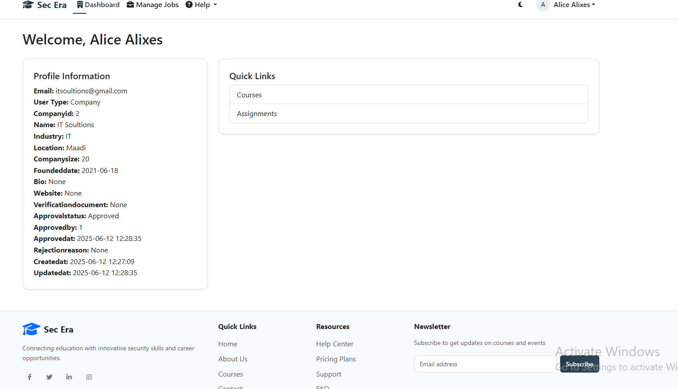
Figure 45. Dashboard Page (Company Representer)

5.2.9 Home Page (After Login):

5.2.9.1 Student
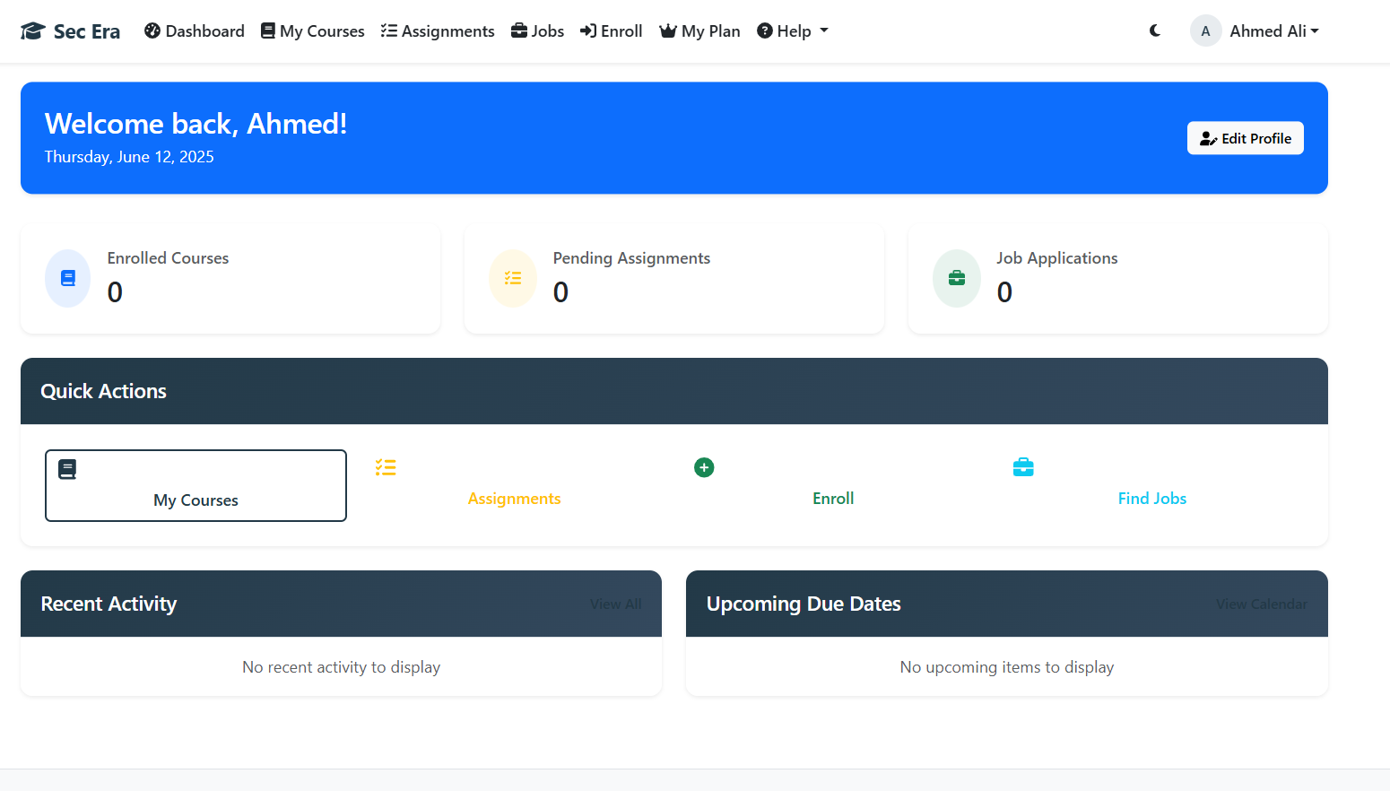
Figure 46. Home Page (After Login) (Student)

5.2.9.2 Instructor:
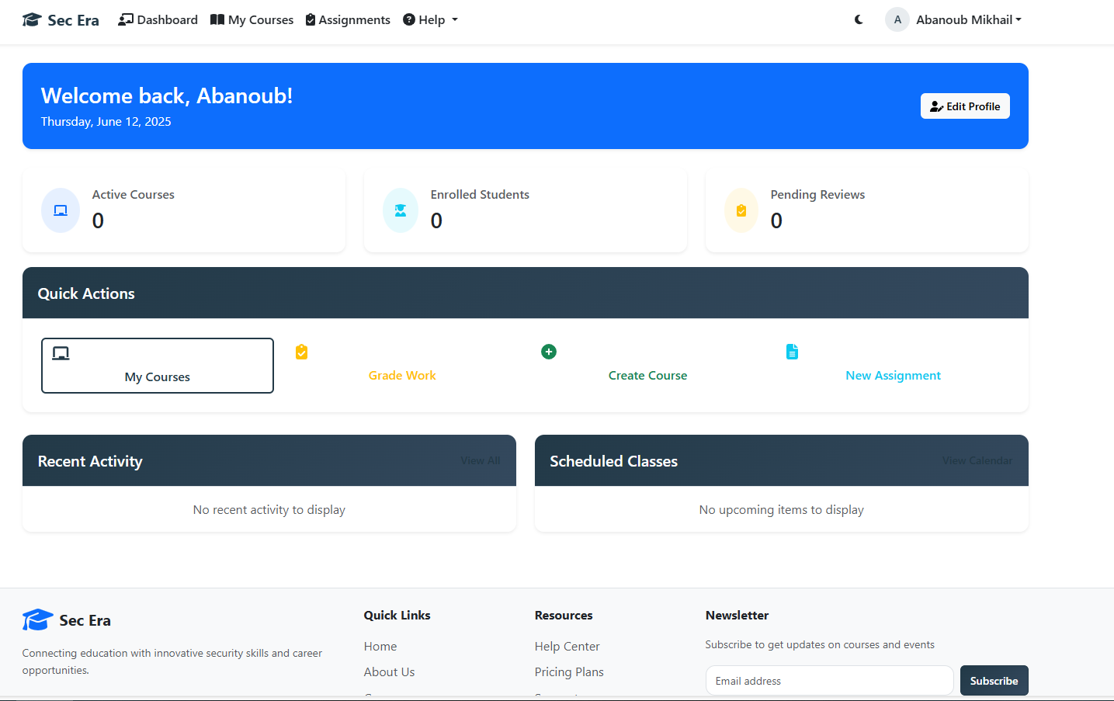
Figure 47. Home Page (After Login) (Instructor)

5.2.9.3 Company Representer:
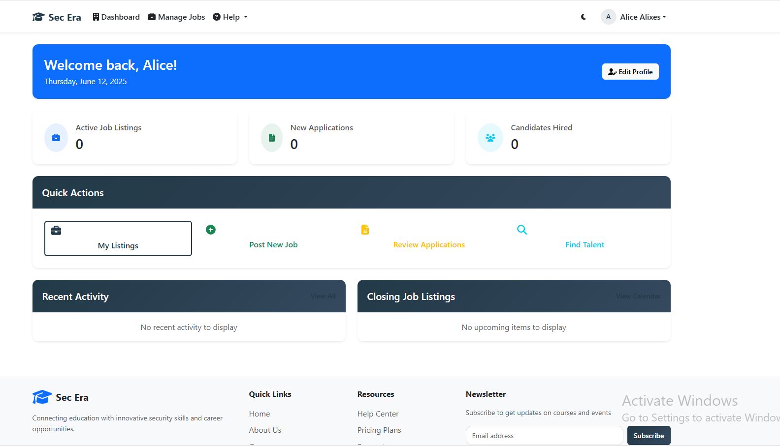
Figure 48. Home Page (After Login) (Company Representer)

5.2.10 Student Only Pages:

5.2.10.1 Enroll Page
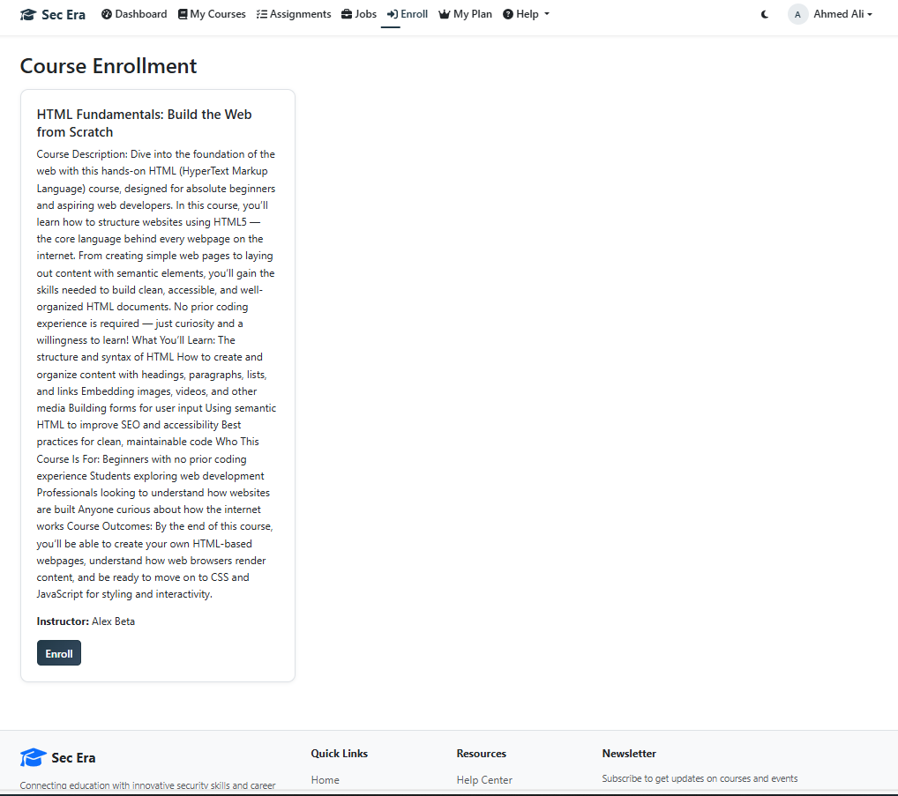
Figure 49. Enroll Page

5.2.10.2 My Courses Page:

Figure 50. My Courses Page

5.2.10.3 Course Details Page:

Figure 51. Course Details Page

5.2.10.4 Assessment Details Page:
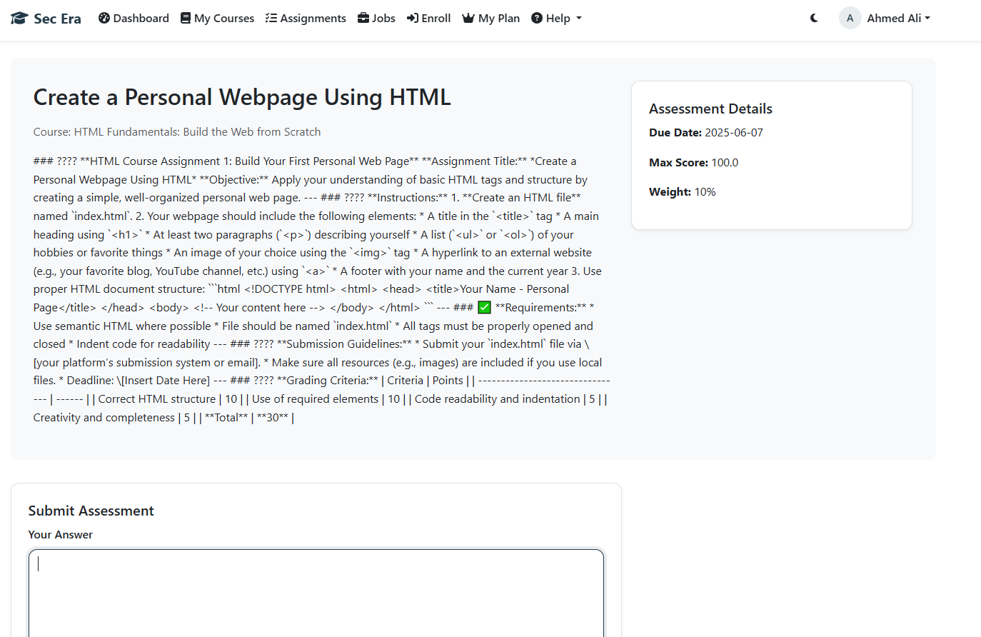
Figure 52. Assessment Details Page

5.2.10.5 Find Job Page
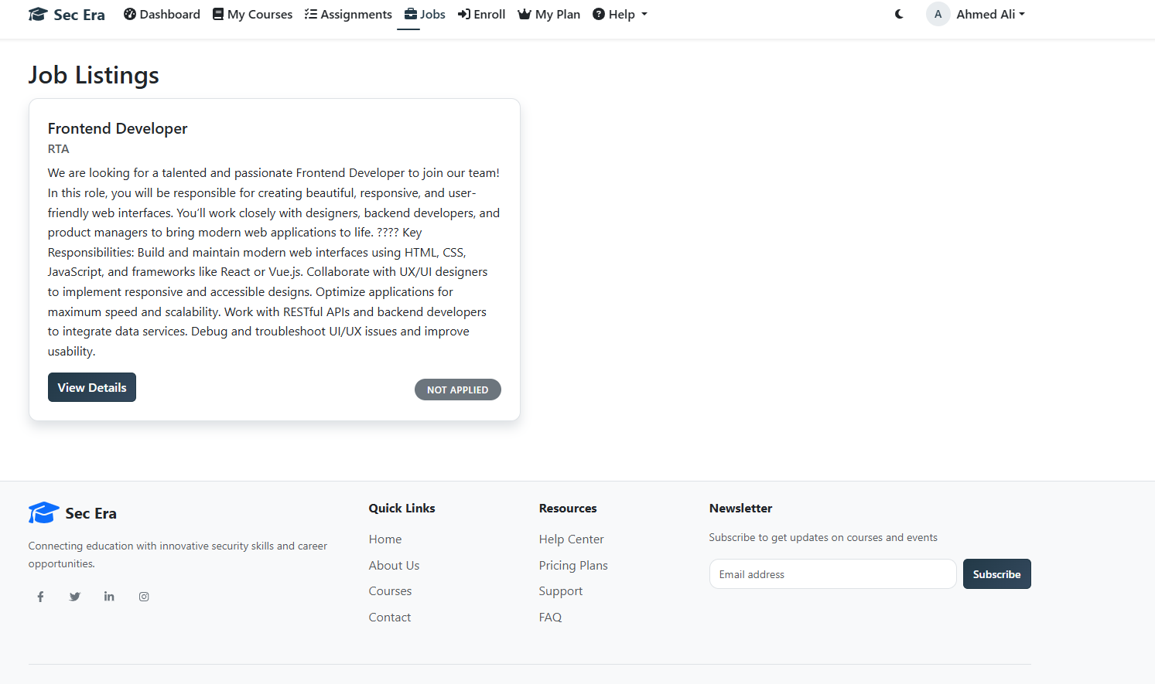
Figure 53. Find Job Page

5.2.10.6 Payment Page
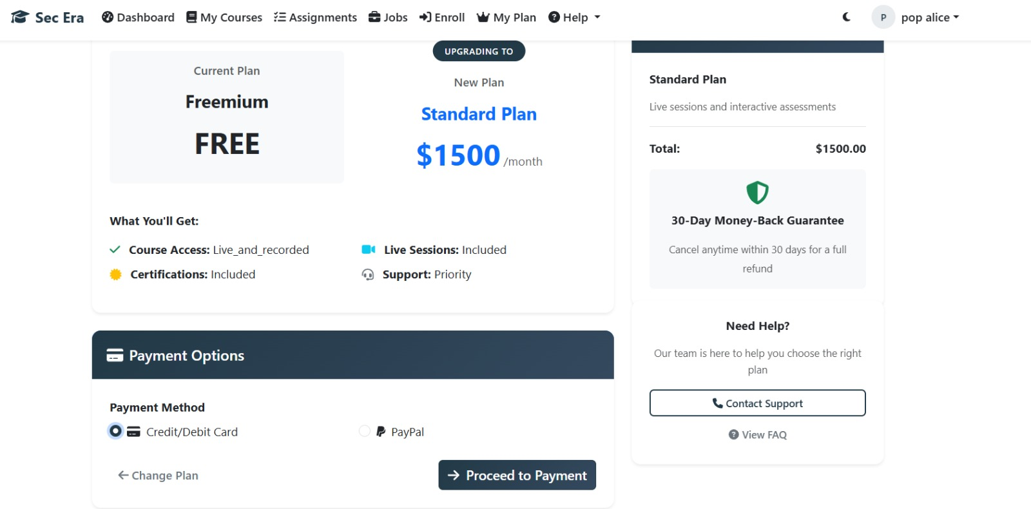
Figure 54. Payment Page

5.2.10.6 Job Details Page:
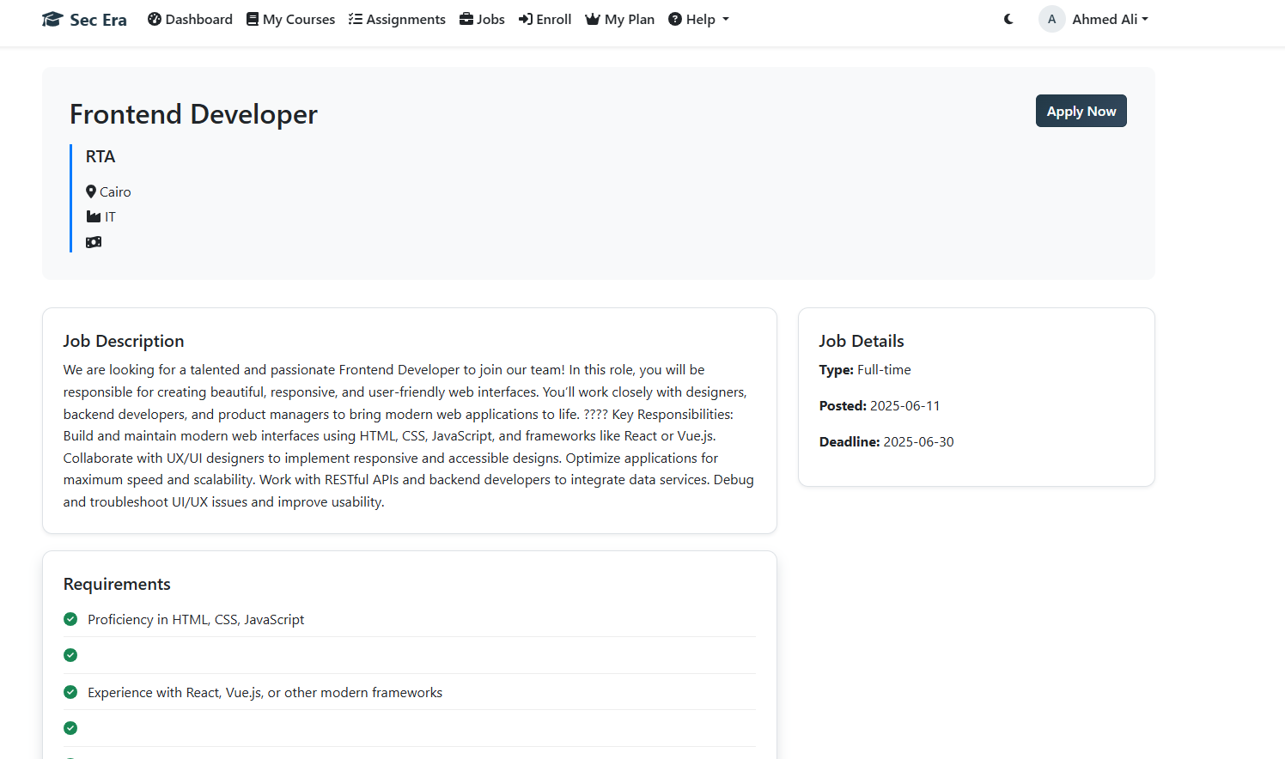
Figure 55. Job Details Page

5.2.10.6.1 Apply for Job Section:
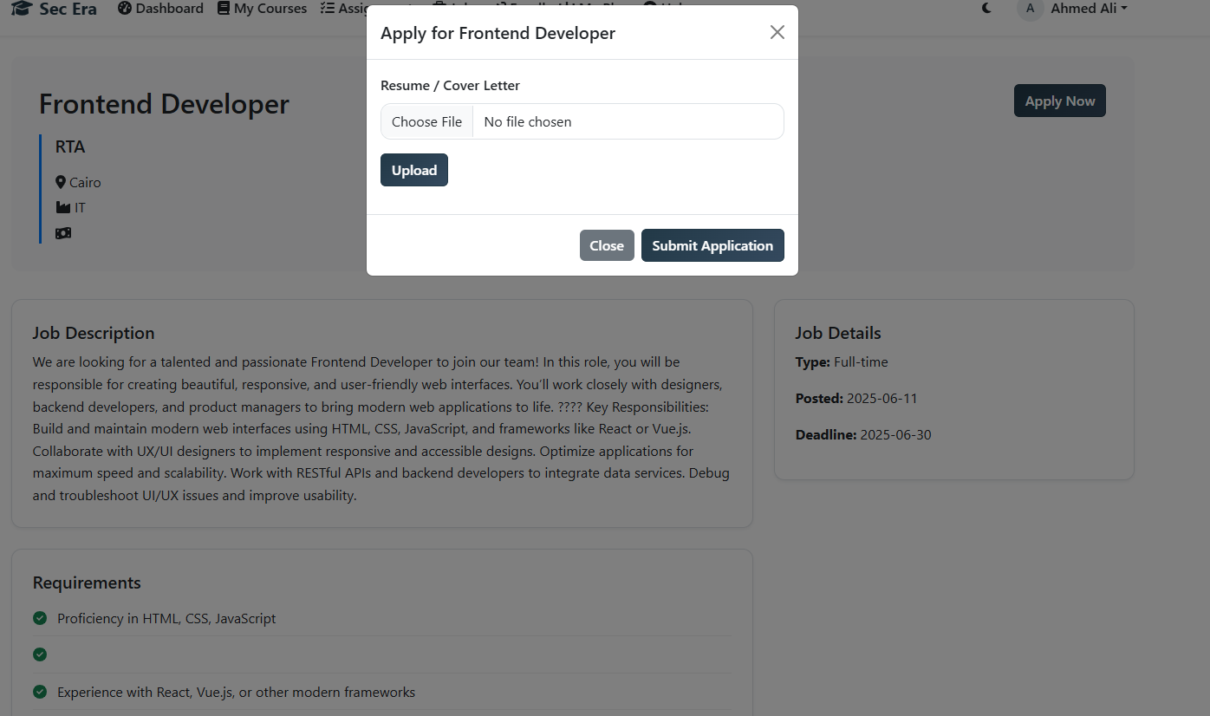
Figure 56. Apply for Job Section

5.2.11 Instructor Only Pages:

5.2.11.1 Create course page
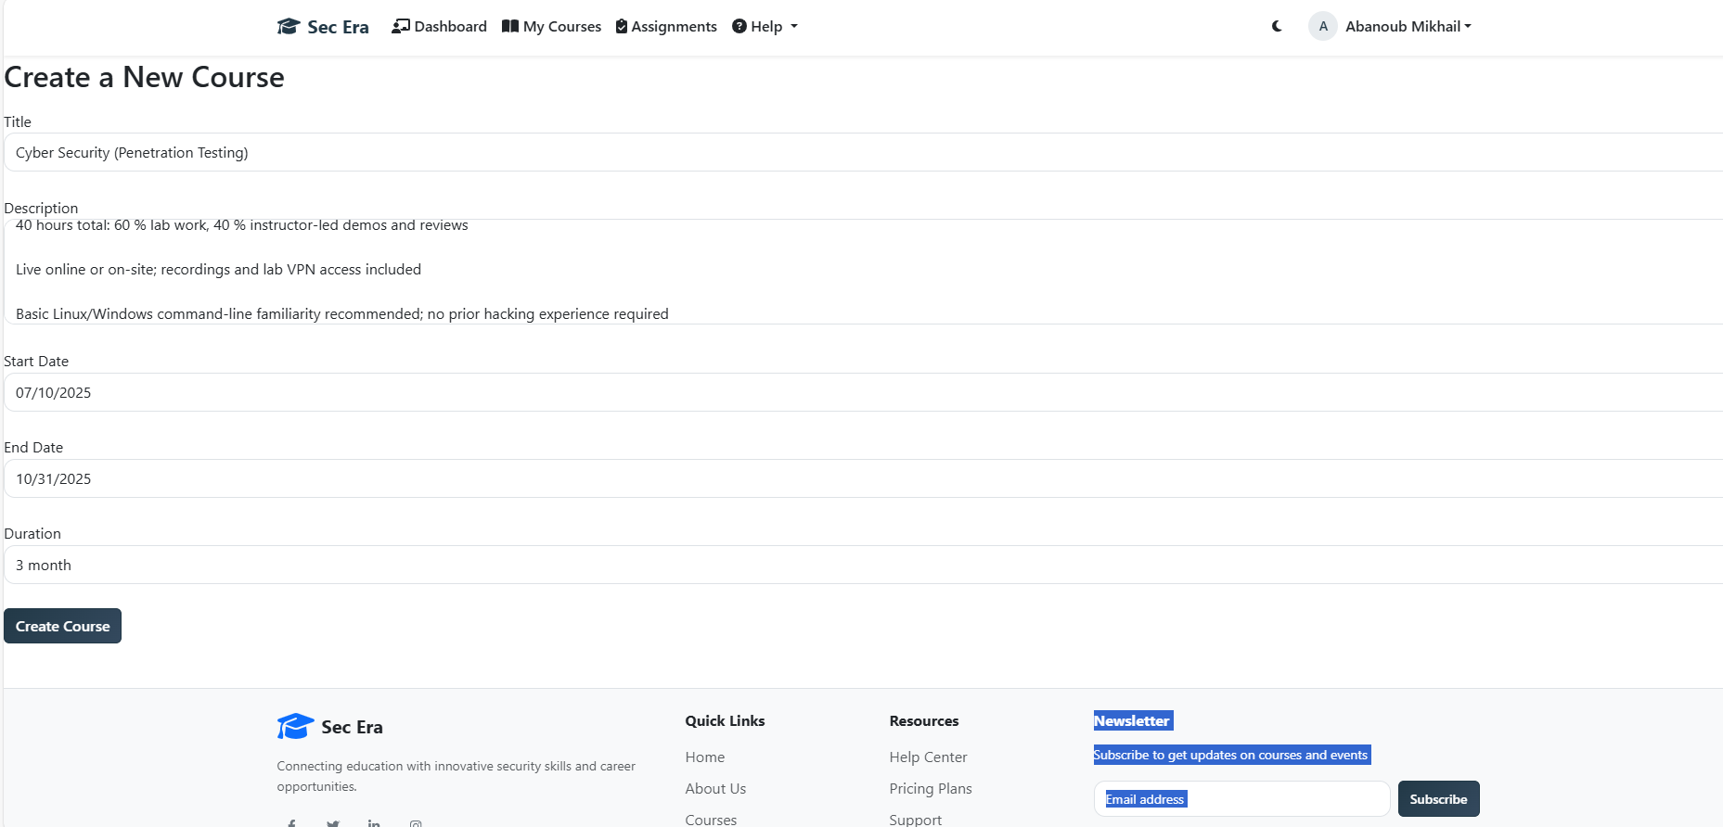
Figure 57. Create course page

5.2.11.2 My Courses Page:
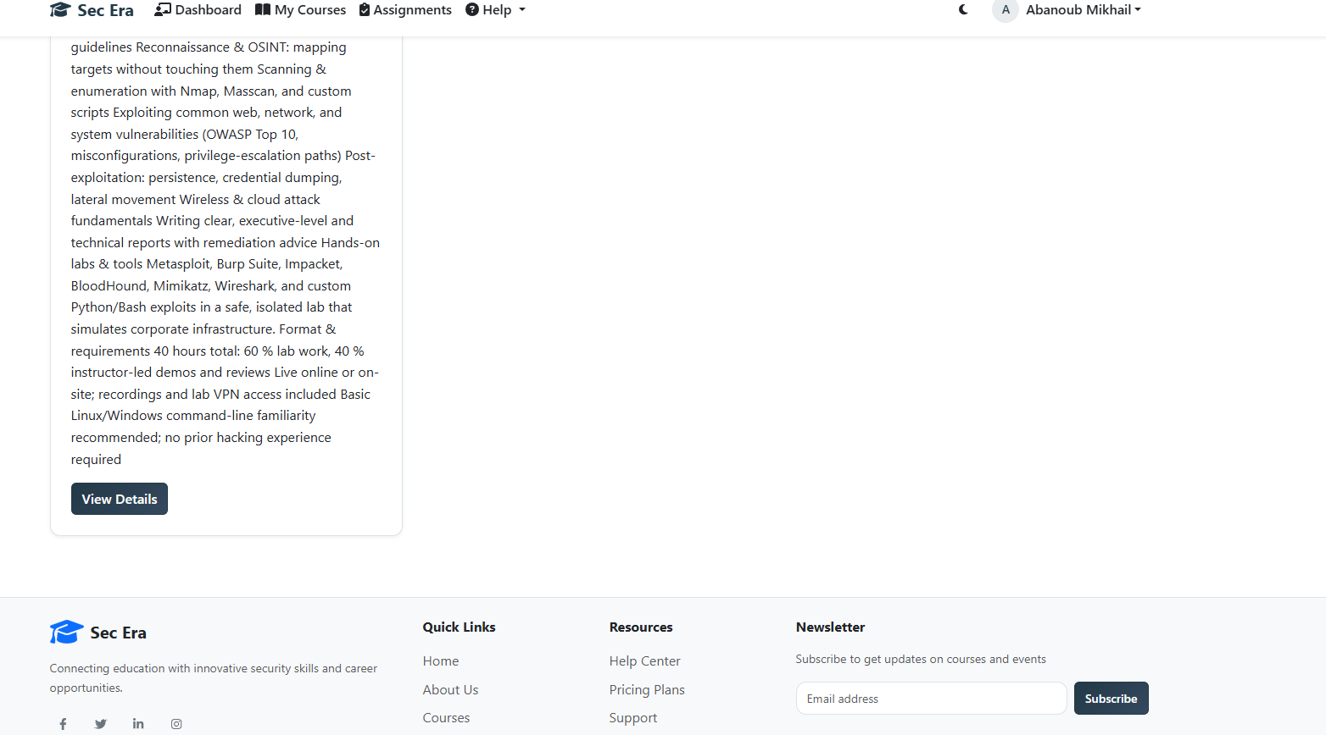
Figure 58. My Courses Page (Instructor)

5.2.11.3 New Assignment Page:
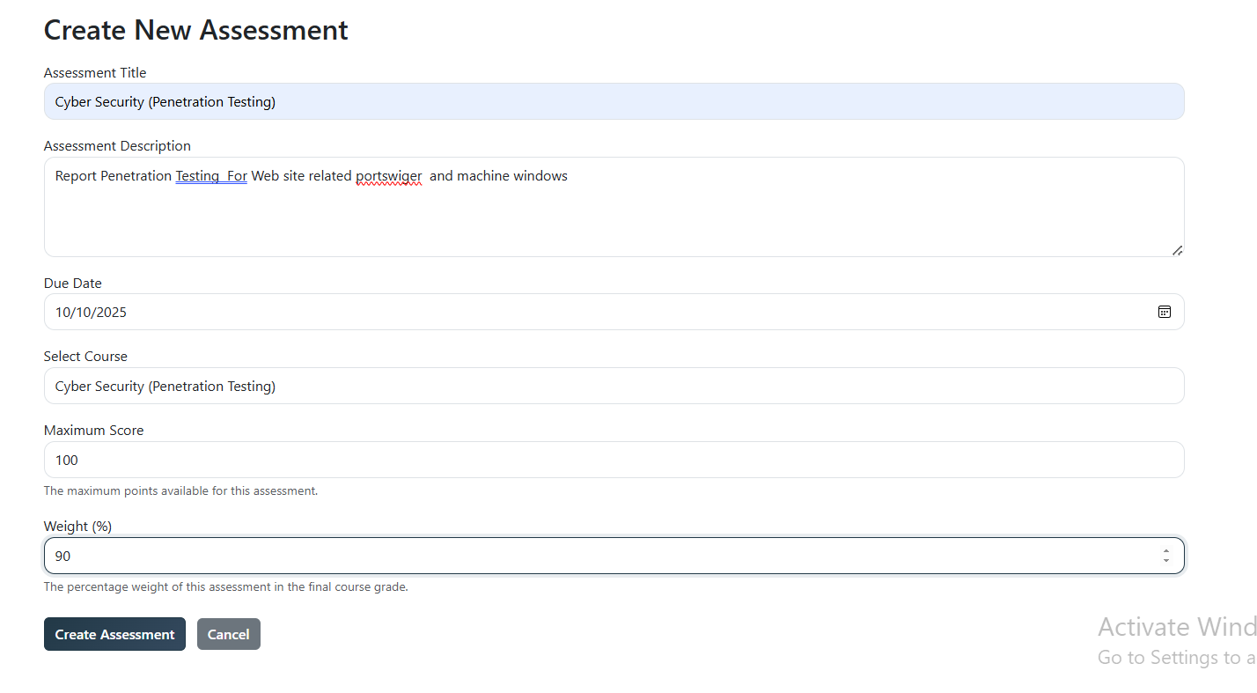
Figure 59. New Assignment Page
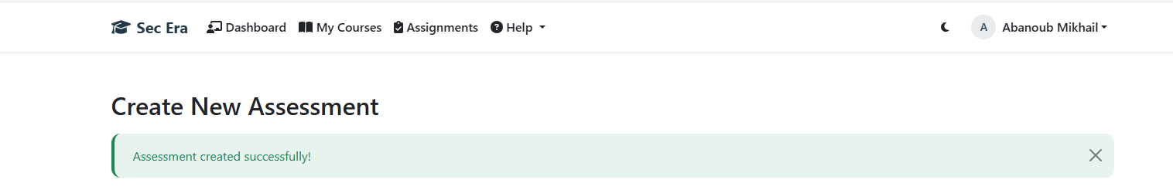
Figure 60. New Assignment Notification

5.2.11.4 Courses Details Page:
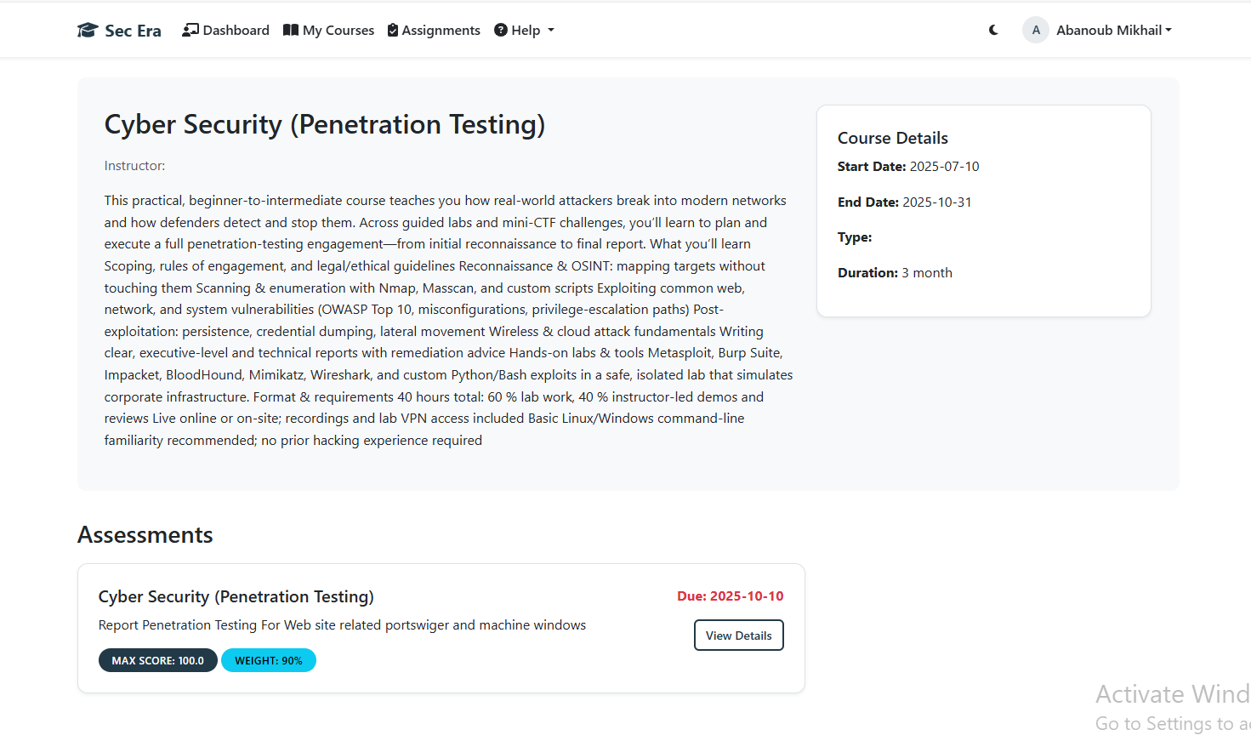
Figure 61. Courses Details Page (Instructor)

5.2.12 Company Representer Only Page:

5.2.12.1 Post New Job Page:
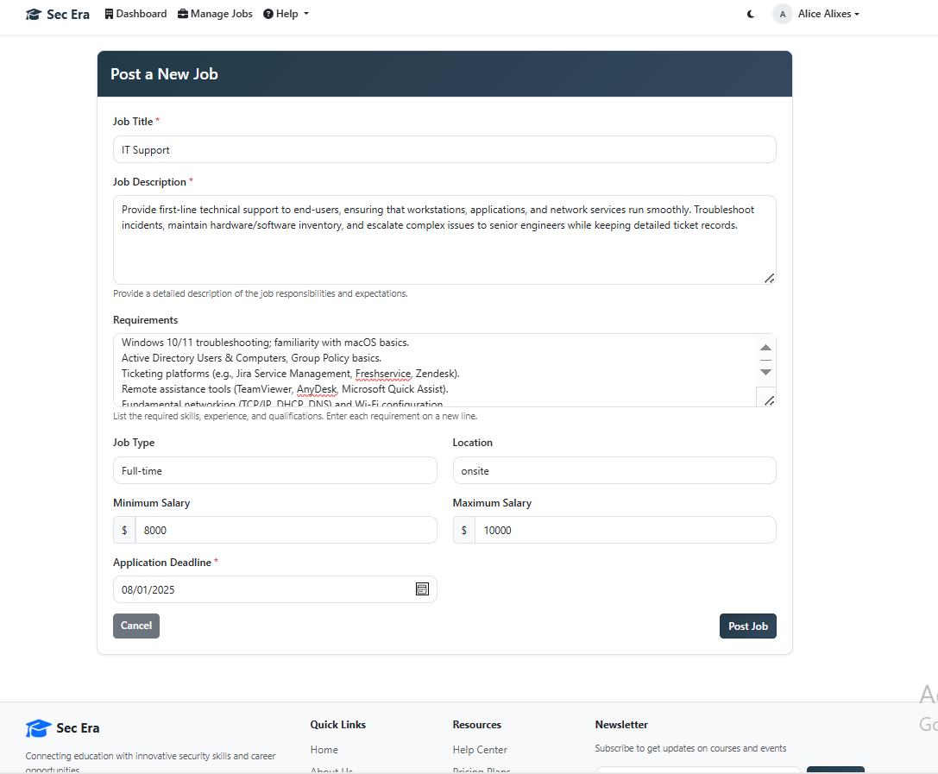
Figure 62. Post New Job Page

5.2.12.2 My Listing Job Page:
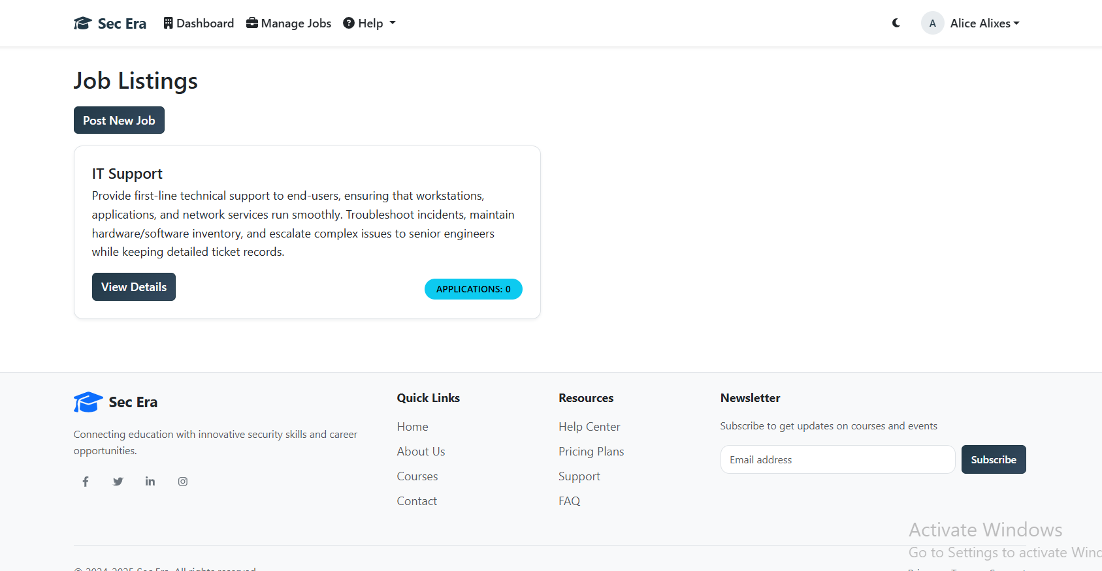
Figure 63. My Listing Job Page

5.2.12.3 View application jobs:
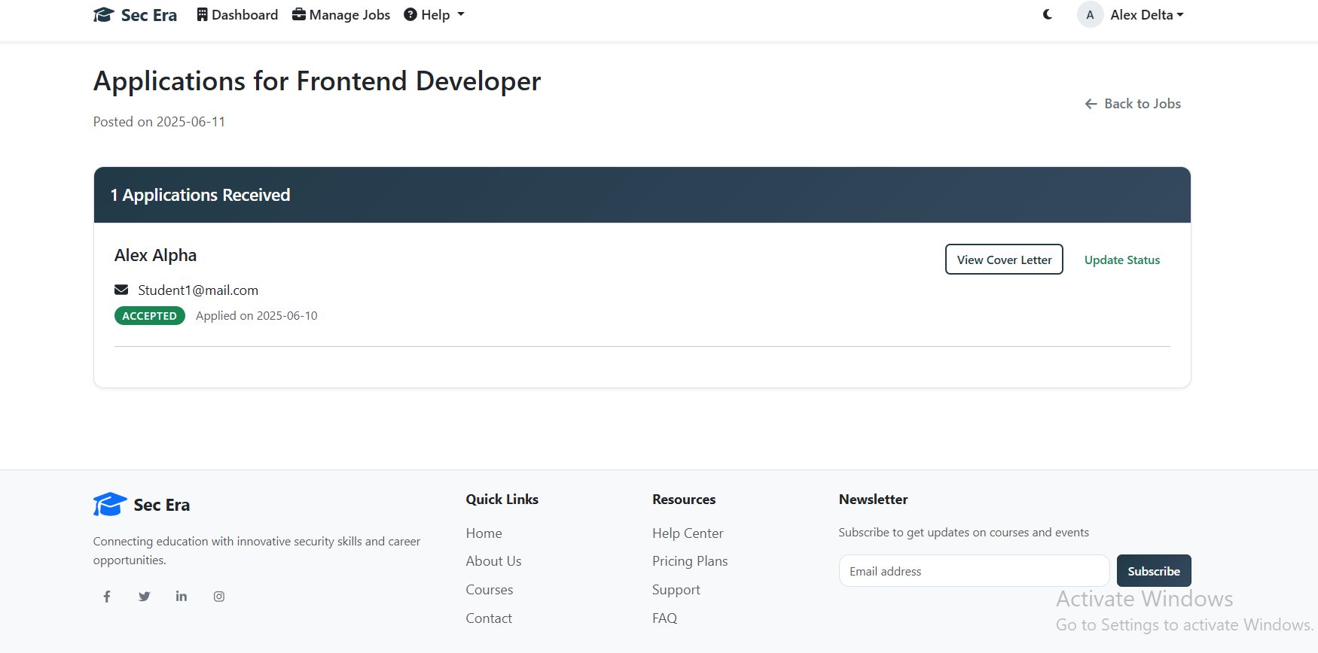
Figure 64. View application jobs

5.2.13 Admin Pages:

5.2.13.1 Dashboard
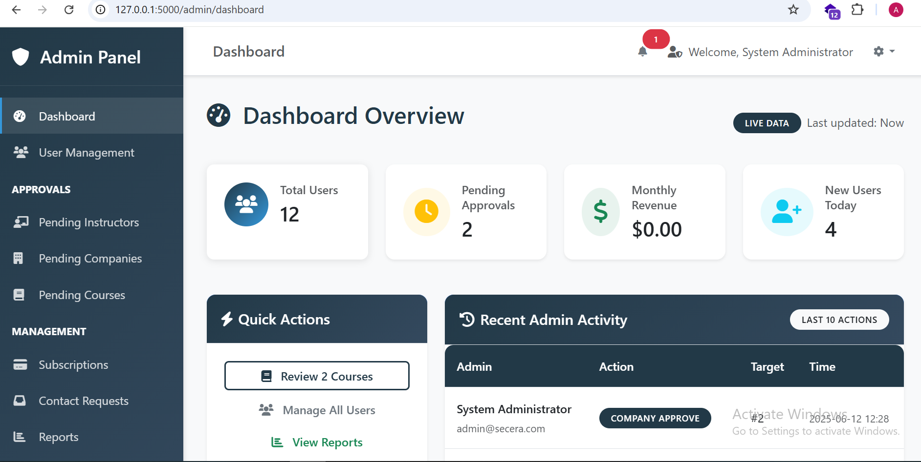
Figure 65. Admin (Dashboard)
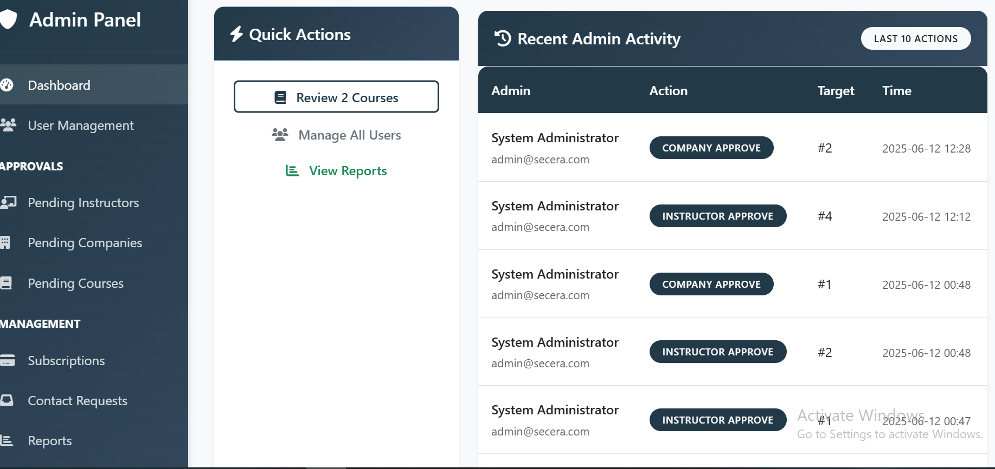
Figure 66. Admin (Dashboard)

5.2.13.2 Reports Page:

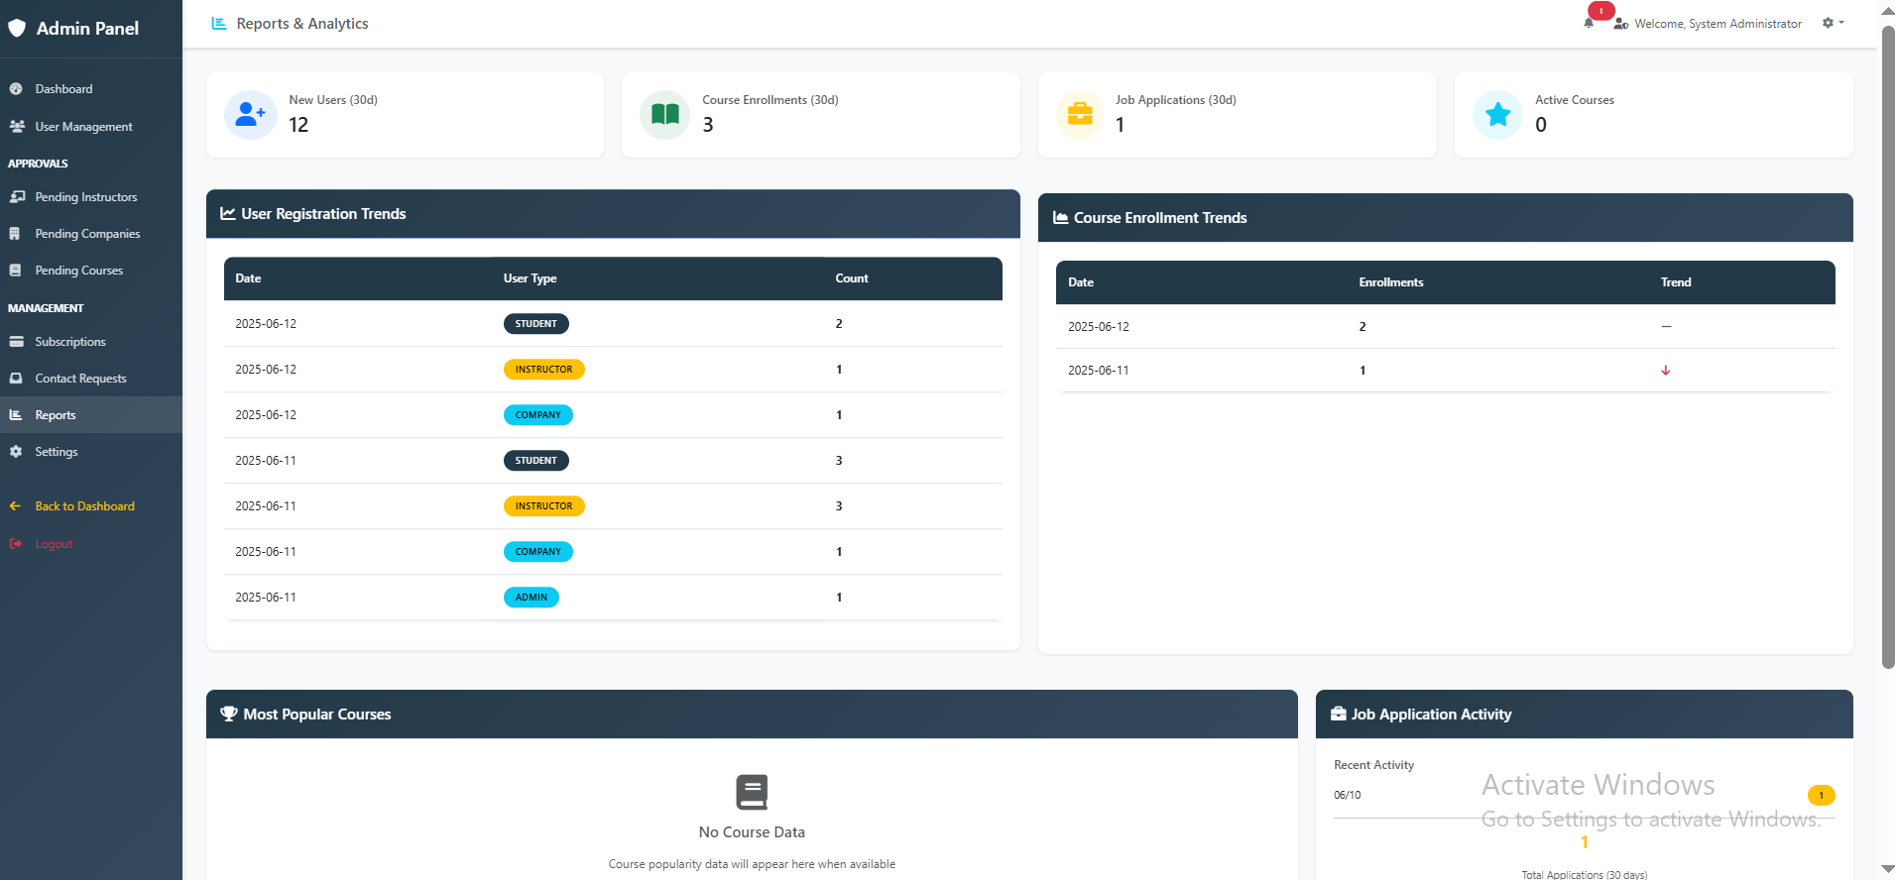
Figure 67. Admin (Reports Page)

5.2.13.3 User Management Page:
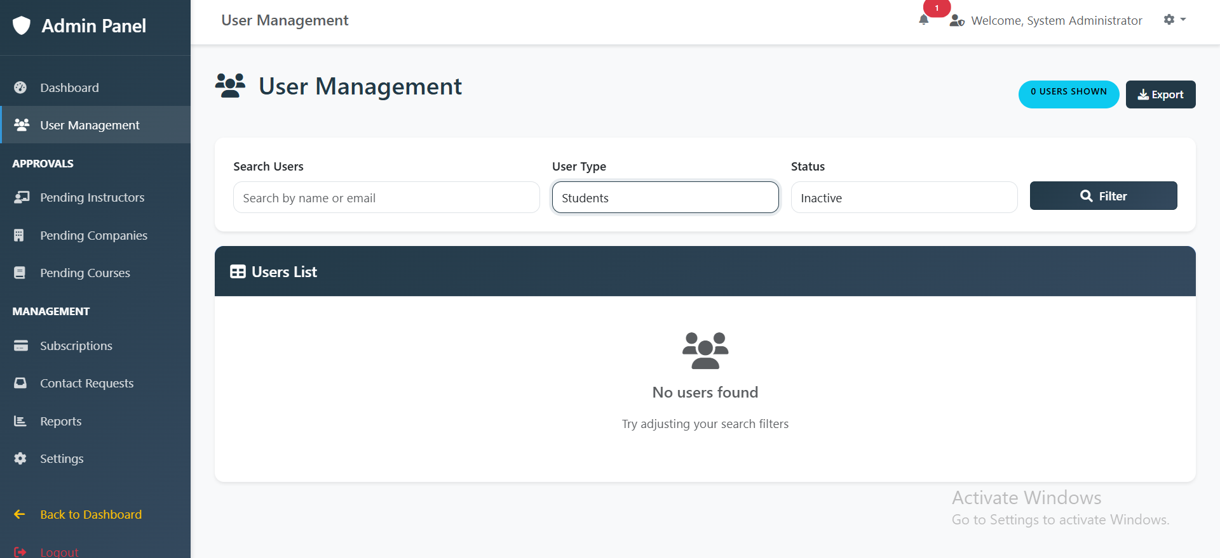
Figure 68. User Management Page
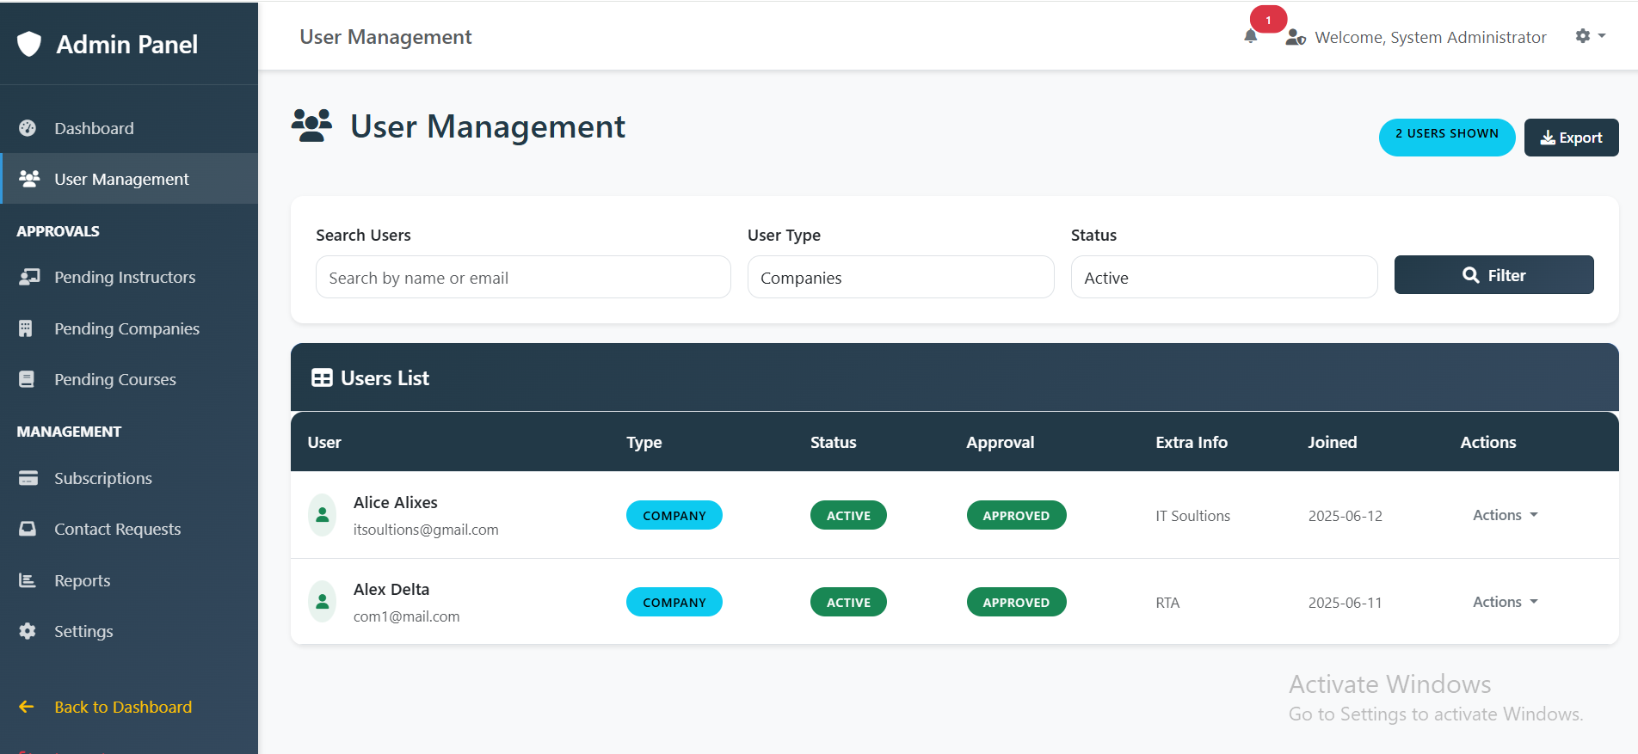
Figure 69. User Management Page

5.2.13.4 Subscription Page:
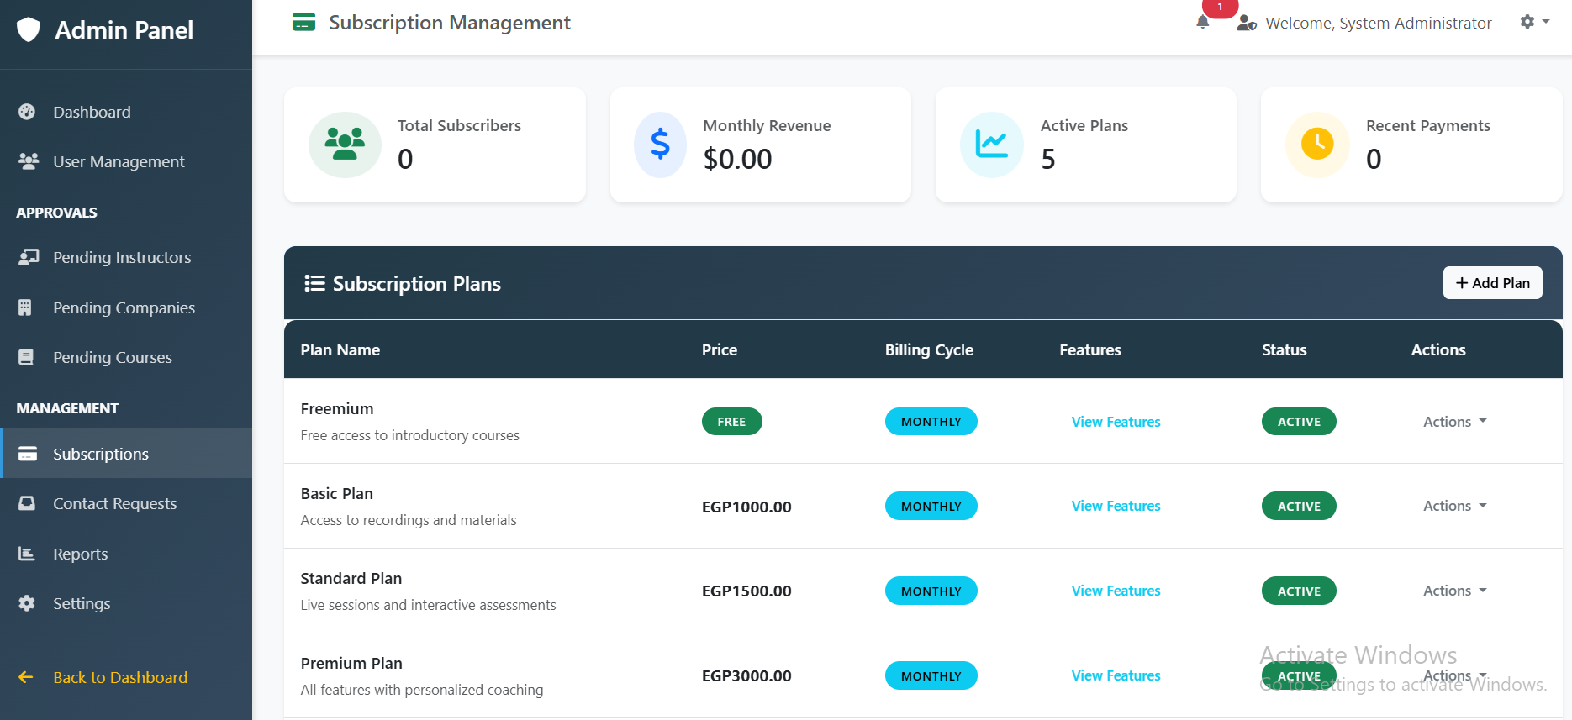
Figure 70. Admin (Subscription Page)

5.2.13.5 Pending Pages

5.2.13.5.1 Company Representer:
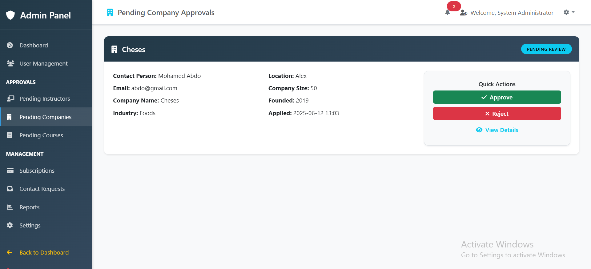
Figure 71. Pending Pages (Company Representer)

5.2.13.5.2 Instructor:
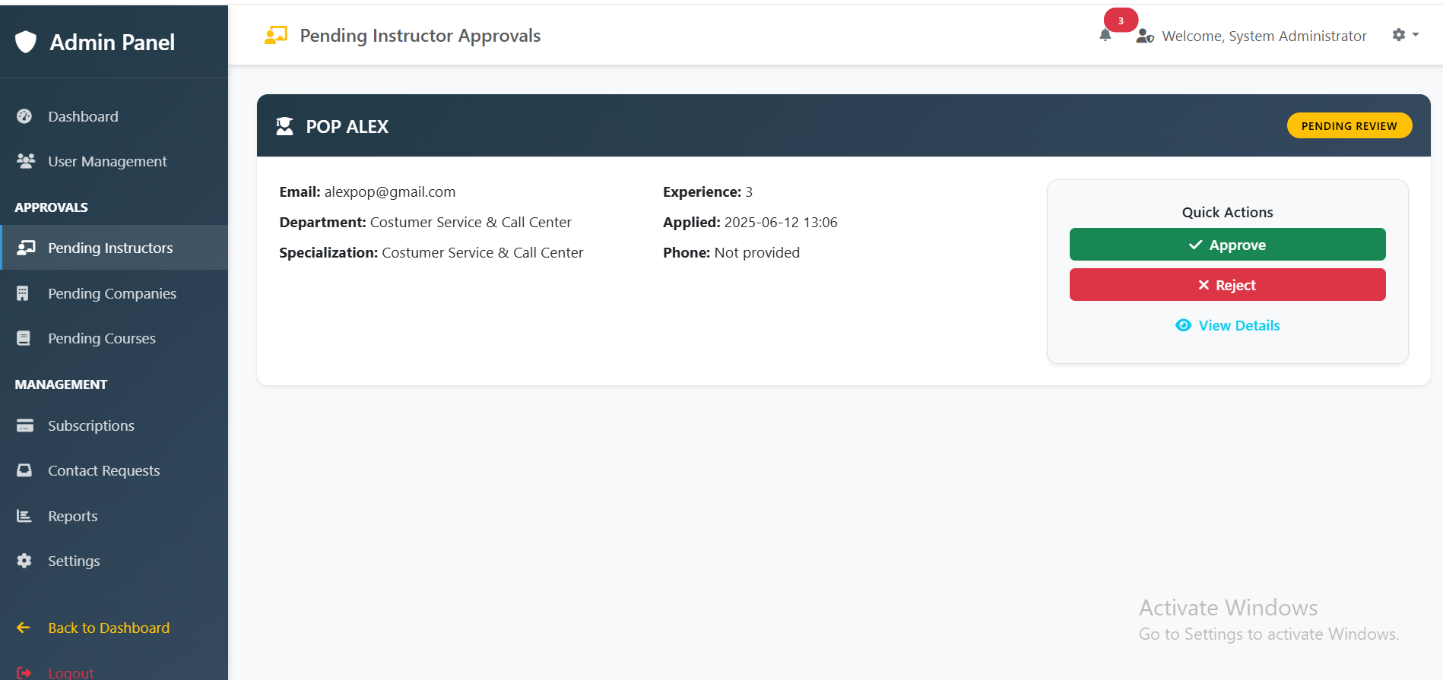
Figure 72. Pending Pages (Instructor)

5.2.13.5.2 Reject Section:
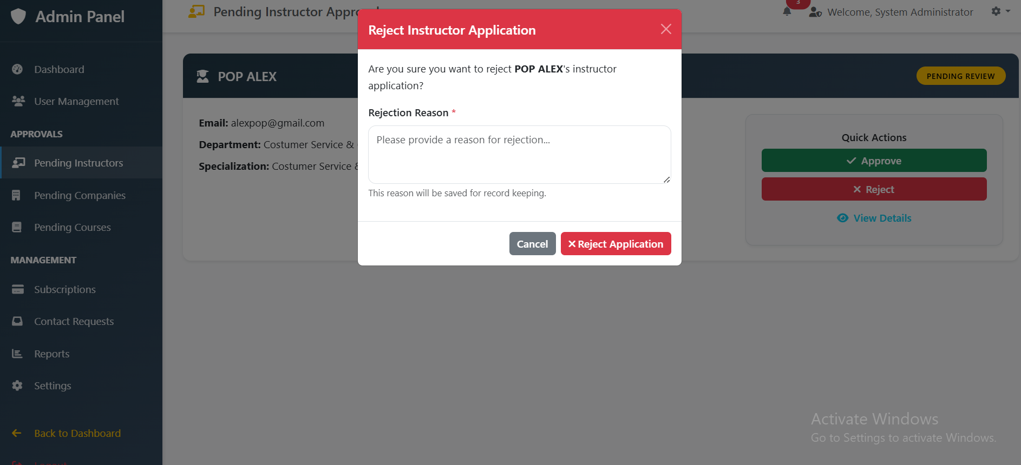
Figure 73. Pending Pages (Reject Section)

5.2.14 System code & database

5.2.14.1 Code backend
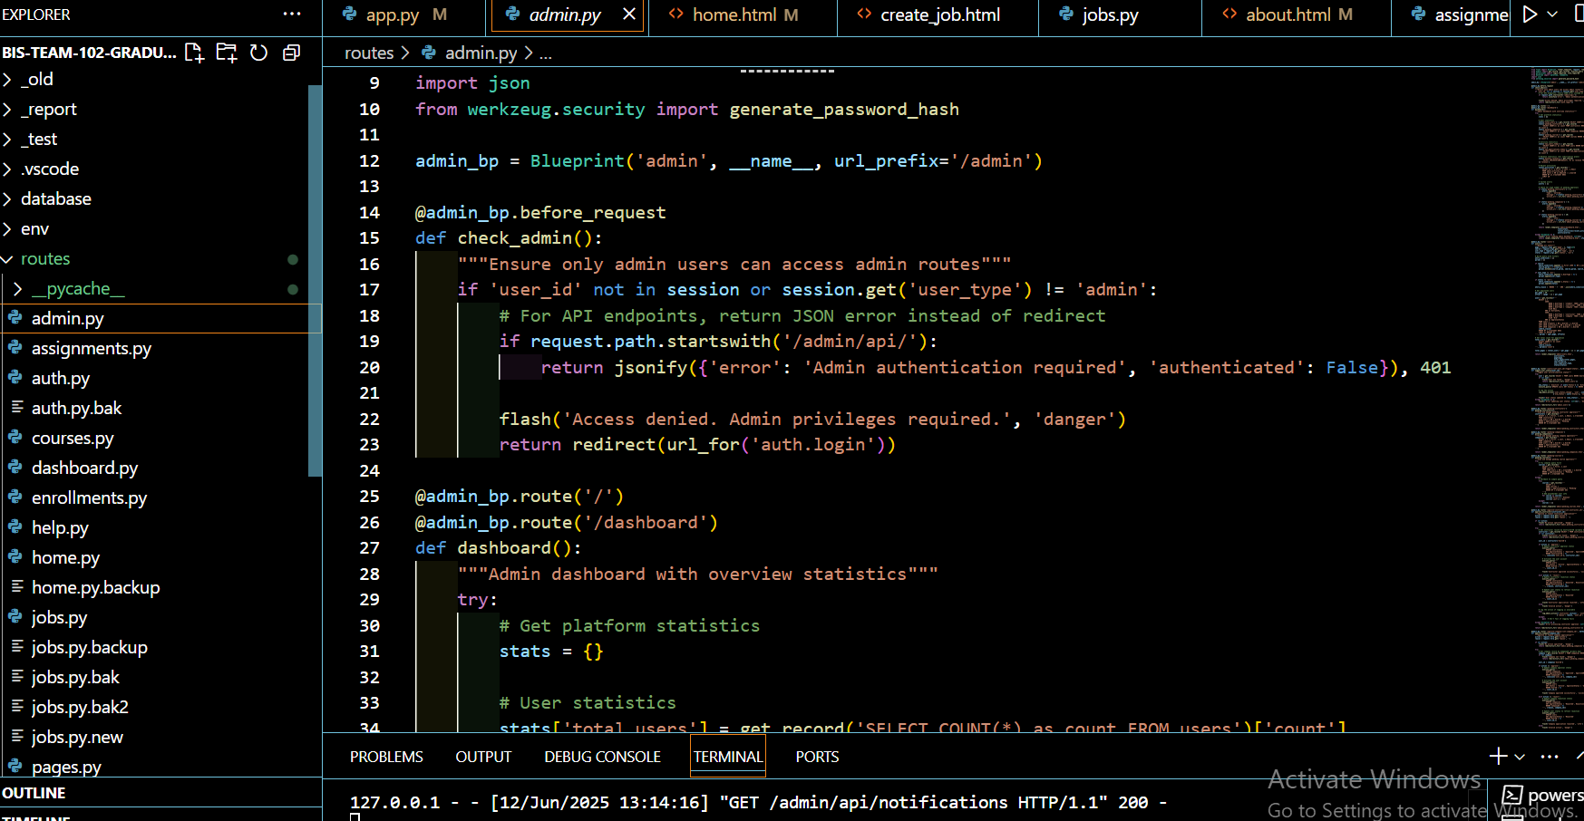
Figure 74. Code backend
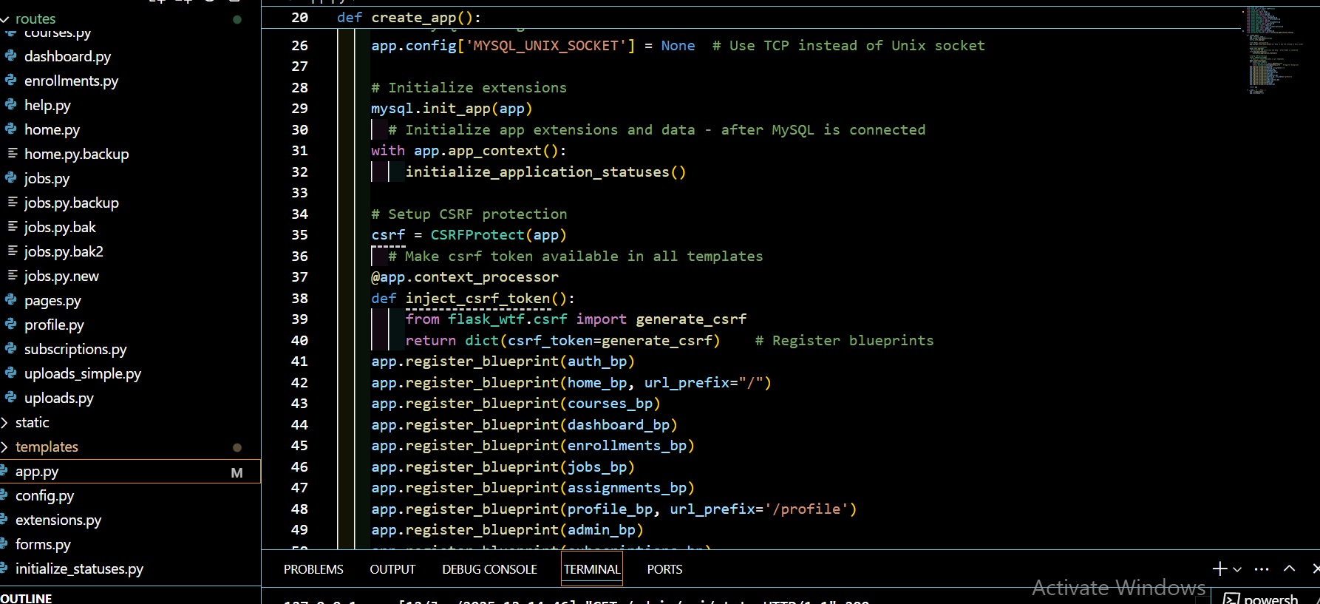
Figure 75 Code backend
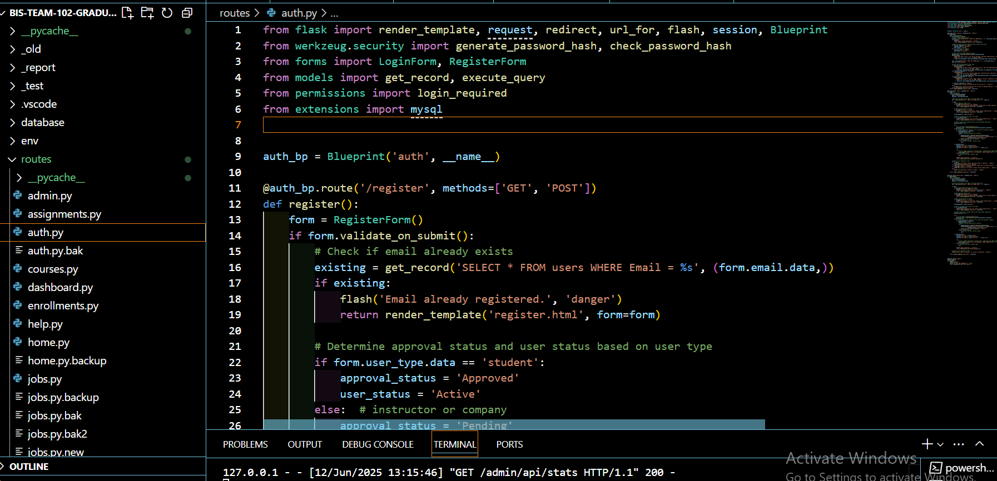
Figure 76 Code backend

5.2.14.2 Code frontend:
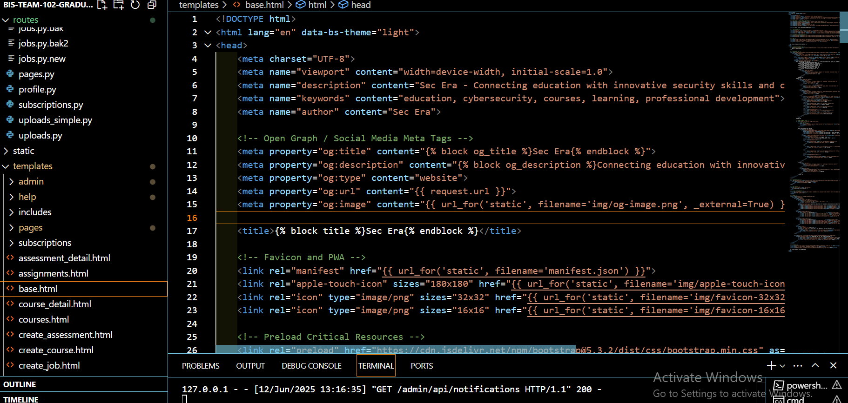
Figure 77 Code frontend
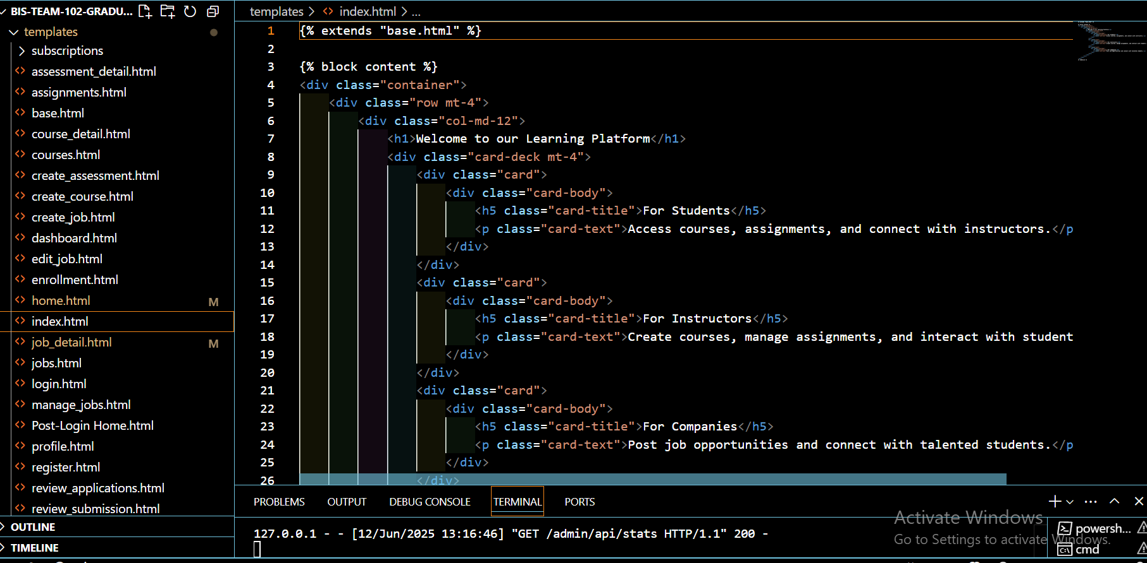
Figure 78 Code frontend
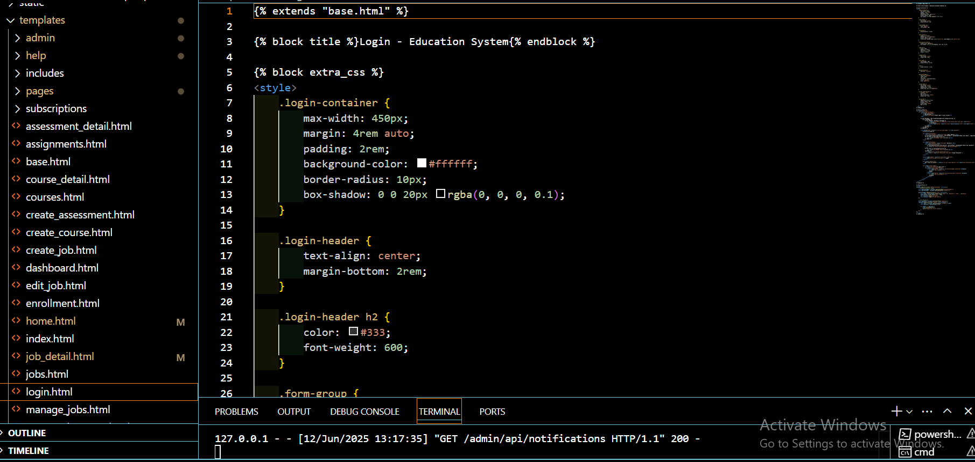
Figure 79 Code frontend

5.2.14.3 Database:
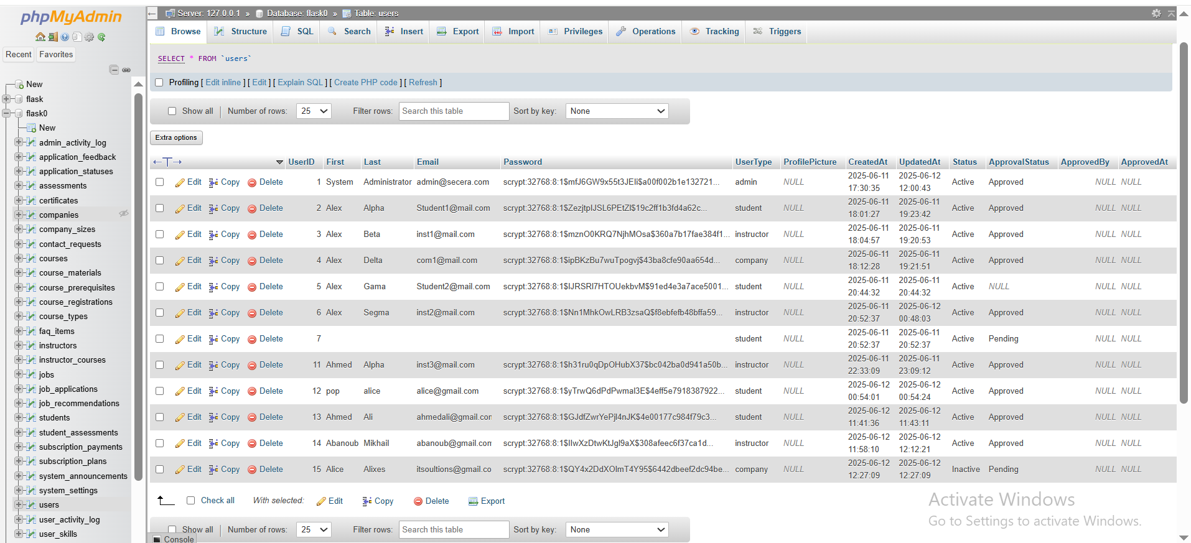
Figure 80. Database

C h a p t e r S i x

- TESTING METHODOLOGY
- Introduction (Aim of the chapter)
- Testing methodology
- Login validation
- Sign up validation
- Main functions validation

Chapter Six: Testing Methodology

6.1 Introduction
System testing is the level of testing that validates the complete and fully integrated software product. The purpose of a system test is to evaluate the end-to-end system specification. Usually, the software is only one element of a larger computer-based system. Ultimately, the software is interfaced with other software/hardware systems. System testing is a series of different tests whose sole purpose is to exercise the full computer-based system.
6.2 Testing Methodology
In this project, agile methodology for testing has been selected for the following reasons:
- An agile test is an incremental model where tests are executed at the end of each iteration or increment.
- It can cover the sphere of tests and software development, and marketing.
- The outcomes are better with agile methodology when an experienced and strong product manager can make rapid decisions.
- Besides, the complete app is ideally tested at the end of the project. There is a lesser threat in the development procedure with the agile technique as every team member understands what has or has not been completed.
- Use of server-side and client-side validations.
- Application of security measures like CSRF protection and password hashing.
- Implementation of data type validations and business logic constraints.
- Integration of database-level constraints supporting validation integrity.
- Use of enhanced frontend components for better user experience.

6.3 Login Validation
If the user enters a wrong email and password on the login page, a message indicating the wrong email and password will appear.

6.3.1 Validations related to the login process include:
- Form Validations (LoginForm):
  - email: DataRequired(), Email(), Length(max=255)
  - password: DataRequired()
- Authentication & Authorization Validations:
  - Server-side checks to confirm:
    - Email exists in database
    - Password verification (hashed comparison)
    - Account approval status (Pending/Approved)
    - Account activity status (Active/Inactive)
  - Permission decorators like @login_required ensure user authentication.
- Security Validations:
  - CSRF protection applied to login form.
  - Secure password handling with hashing.
- Frontend Validations:
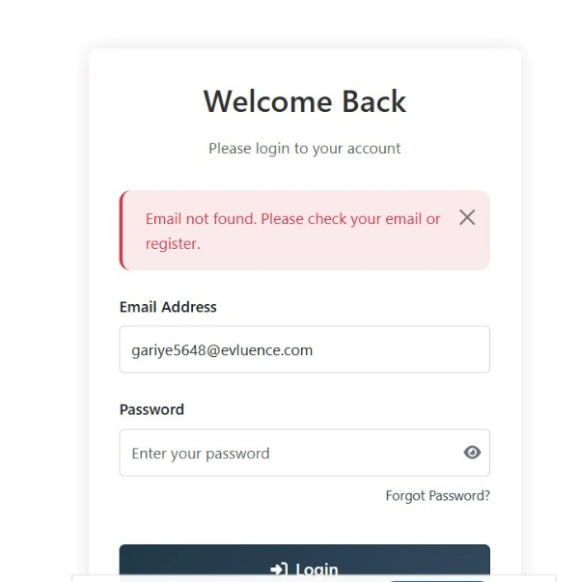
  - Real-time validation on email format and required fields.
Figure 81. Login Validation

Figure 82. Login Validation

6.4 Sign Up Validation

6.4.1 Validations covering the user registration process include:
- Form Validations (RegisterForm):
  - Common fields: first_name, last_name, email, password, user_type
  - Student-specific: university, major, GPA (0-4), expected graduation date, bio, resume
  - Instructor-specific: department, specialization, experience (≥0), bio, qualifications
  - Company-specific: company_name, industry, location, company_size (≥1), founded date, bio, website
- Business Logic Validations:
  - User-type specific validations ensure data relevance (e.g., GPA range for students, positive company size for companies).
- Security Validations:
  - Password minimum length enforced (≥6).
  - Passwords hashed securely.
  - Email formats strictly validated.
- Frontend Validations:
  - Conditional fields appear based on selected user type.
  - Real-time feedback for errors like invalid GPA or weak password.
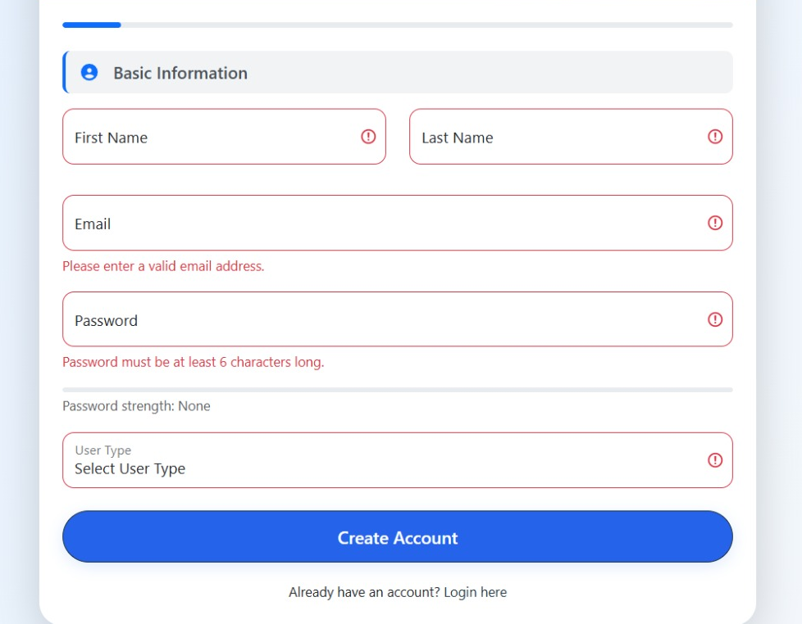
Figure 83. Sign Up Validation
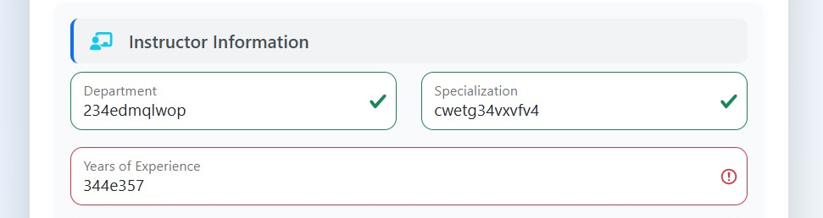
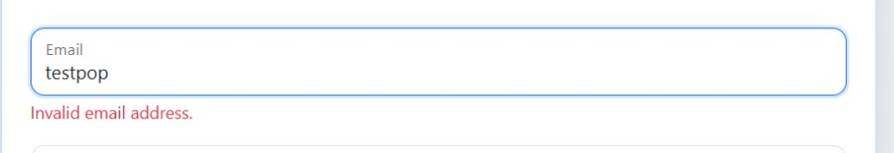
Figure 84. Sign Up Validation
Figure 85. Sign Up Validation

6.5 Main Function Validation
The following are the main function validations:

6.5.1 Validations encompassing core application features beyond login and sign up:
- Form Validations:
  - ProfileForm: Validates profile updates (name, email, bio).
  - PasswordChangeForm: Ensures new passwords meet security standards and confirmation matches.
  - CourseForm: Validates course details (title, dates with logical sequence, pricing positive).
  - JobForm: Checks job posting details (salary ranges with max ≥ min, experience).
  - AssessmentForm: Validates assessments (due dates in future, positive scoring).
  - ContactForm: Ensures all required contact fields are provided.
- Business Logic Validations:
  - Enforces constraints like salary range correctness, course date logic, and assessment scoring rules.
- Frontend Validations:
  - Real-time validations across all forms for immediate user feedback.
- Database Validation Layer:
  - SQL constraints to enforce data integrity supporting above validations.

6.5.2 Jumping Attack Validation
- A user cannot access website pages without logging in.
- A logged-in user cannot access the login page again; attempting to do so will redirect them to their respective home page (Student, Instructor, or Company Representer).
- If a non-logged-in user tries to access a restricted page, they will be redirected to the login page.

C h a p t e r S e v e n

- CONCLUSION AND FUTURE WORK
- Introduction (Aim of the chapter)
- Conclusion
- A summary of our key arguments and results.
- A short discussion of the implications of our research.
- Summarize and reflect on our research process
- Show what new knowledge we have contributed to our field.
- Future Work

Chapter Seven Conclusion and Future Work

7.1 Introduction (Aim of the Chapter)
This chapter aims to encapsulate the key achievements of the developed educational platform, reflect on the development process, and outline potential future enhancements. It highlights the significance of integrating practical training with academic learning and explores how the current system can evolve to better serve students, educational institutions, and industry partners.

7.2 Conclusion
The project successfully designed and implemented a comprehensive platform that bridges the gap between theoretical education and practical workplace skills. By collaborating with companies, the system offers final-year students and recent graduates specialized courses and hands-on assessments, effectively reducing internship durations and costs while enhancing their readiness for the labor market.
The key outcomes demonstrate that the platform can streamline skill development, facilitate effective collaboration between academia and industry, and provide a scalable solution adaptable to various educational fields. The system's features—such as user management for students, instructors, company representatives, and administrators—contribute to operational efficiency and improved user engagement.
Throughout the development process, careful analysis of user requirements, system design, and rigorous testing ensured the platform's reliability and usability. This project contributes to the field by illustrating an integrated approach to educational management systems that combine content delivery, practical assessments, and industry collaboration, aligning with modern trends in digital education.
The implications of this research emphasize the critical role of technology in transforming traditional education into a more practical, industry-relevant experience. It underscores the importance of continuous innovation to meet the evolving needs of students and industries, ultimately fostering a more competent and job-ready workforce.

7.3 Future Work
Building upon the current system, several enhancements are envisioned to expand its functionality and impact:
- Artificial Intelligence Integration: Incorporate AI algorithms to provide personalized learning paths, automate assessments, and generate detailed analytics for students’ performance and engagement, enabling more tailored educational experiences.
- Mobile Application Development: Develop a dedicated mobile app to increase platform accessibility for students, instructors, and industry representatives, facilitating learning and collaboration on-the-go.
- Expanded and Specialized Course Content: Introduce new courses in emerging fields such as Artificial Intelligence, Data Science, Cybersecurity, and Digital Marketing, aligning with industry demands.
- Real-Time Industry Collaboration Tools: Integrate live communication features like video conferencing, instant messaging, and collaborative document editing to enhance interaction between students and companies.
- Gamification and Certification: Implement gamified elements—such as badges, leaderboards, and achievement milestones—to motivate learners and provide recognized certifications that boost employability.
- Enhanced Data Privacy and Security: Strengthen security measures to ensure compliance with data protection laws and safeguard user information against potential breaches.
- Advanced Analytics Dashboard: Develop comprehensive dashboards for administrators and industry partners to monitor progress, engagement metrics, and outcome evaluations, supporting data-driven decision-making.
- Integration with Existing Educational Platforms: Explore options to connect with other Learning Management Systems (LMS) and industry databases to broaden the system’s interoperability and reach.
These future features aim to make the platform more dynamic, user-centric, and adaptable to the rapidly changing educational landscape and industry needs, ensuring its sustainability and scalability.

References
- https://www.trade.gov/country-commercial-guides/egypt-information-and-communications-technology-and-digital-economy
- https://itida.gov.eg/English/Programs/Industry-Outlook/Pages/default.aspx
- https://mcit.gov.eg/en/ICT_Strategy
- https://app.diagrams.net/
- https://laravel.com/docs/9.x/
- https://stackoverflow.com/
- https://www.w3schools.com
- https://www.mermaidchart.com/
- https://www.godaddy.com/en/domainsearch/find?domainToCheck=Second.Era
- https://tradingeconomics.com/egypt/social-security-rate
- https://taxsummaries.pwc.com/egypt/individual/other-taxes#:~:text=Social%20security%20contributions&text=The%20employee%20contribution%20percentage%20is,starting%20from%201%20January%202021.

